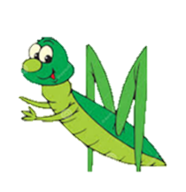

Knowing is Growing!

UNIT: The 7 Habits of Highly Effective Teens
Teacher Guide

Created by Biba S. Kavass

Course
Supply Chain Management Practicum (Work-based Learning)

Objectives
- Create positive relationships at home and at school
- Improve confidence and self-reliance
- Communicate and work well with others
- Enhance self-awareness and self-regulation skills
- Develop genuine listening skills
- Be proactive and take initiative
- Set goals, plan ahead, and prioritize daily responsibilities
- Create balance in their lives by doing activities that nourish the body, heart, mind, and soul

TN State CTE Standards
Communications and Professionalism #9
Practice effective verbal, nonverbal, written, and electronic communication skills for working with customers, employees, dispatchers, wholesalers, and retailers. Demonstrate the ability to listen attentively, speak courteously and respectfully, discuss client ideas/vision, resolve conflicts, and respond to customer objections or complaints to the customer’s satisfaction.

Grading
- Learning Packets will be graded individually based on assignments teacher requests are completed
- Online Journal is worth 100 points and will be graded using the Journal Reflection Rubric (copy attached)

Duration
Semester (one habit per 2 weeks)

ACTIVITIES
Assignment | Due  Date | Date Completed | Grade
Book - Habit 1 – Read pages 48-70
Complete Habit 1 Learning Packet
Book – Habit 2 – Read pages 74-103
Complete Habit 2 Learning Packet
Book – Habit 3 – Read pages 106 – 127
Complete Habit 3 Learning Packet
Book – Habit 4 – Read pages 146 – 161
Complete Habit 4 Learning Packet
Book – Habit 5 – Read pages 164 - 179
Complete Habit 5 Learning Packet
Book – Habit 6 – Read pages 182 - 201
Complete Habit 6 Learning Packet
Book – Habit 7 – Read pages 206 - 241
Complete Habit 7 Learning Packet

The 7 Habits
et accumsan et iusto odio dignissim qui blandit praesent luptatum zzril delenit augue duis dolore et feugiat nulla facilisis.
error sit voluptatem accusantium doloremque laudantium, totam rem aperiam eaque ipsa, quae ab illo inventore veritatis et quasi architecto beatae vitae dicta sunt, explicabo. nemo enim ipsam voluptatem, quia voluptas sit, aspernatur aut odit aut fugit, sed quia consequuntur magni dolores eos, qui ratione voluptatem sequi nesciunt, neque porro quisquam est, qui dolorem ipsum, quia dolor sit, amet, consectetur, adipisci velit, sed quia non numquam eius modi tempora incidunt, ut labore et dolore magnam aliquam quaerat voluptatem. ut enim ad minima veniam. Sed ut perspiciatis, unde omnis iste natus error sit voluptatem accusantium doloremque laudantium, totam rem aperiam eaque ipsa, quae ab illo inventore veritatis et quasi architecto beatae vitae dicta sunt, explicabo. nemo enim ipsam voluptatem, quia voluptas sit, aspernatur aut odit aut fugit, sed quia consequuntur magni dolores eos, qui ratione voluptatem sequi nesciunt, neque porro quisquam est, qui dolorem ipsum, quia dolor sit,amet, consectetur, adipisci velit, sed quia non numquam eius modi tempora incidunt, ut labore et dolore magnam aliquam quaerat voluptatem. ut enim ad minima veniam.

Sed ut perspiciatis, unde omnis iste natus error sit voluptatem accusantium doloremque laudantium, totam rem aperiam eaque ipsa, quae ab illo inventore veritatis et quasi architecto beatae vitae dicta sunt, explicabo. nemo enim ipsam voluptatem, quia voluptas sit, aspernatur aut odit aut fugit, sed quia consequuntur magni dolores eos, qui ratione voluptatem sequi nesciunt, neque porro quisquam est, qui dolorem ipsum, quia dolor sit, amet, consectetur, adipisci velit, sed quia non numquam eius modi tempora incidunt, ut labore et dolore magnam aliquam quaerat voluptatem. ut enim ad minima veniam. Sed ut perspiciatis, unde omnis iste natus error sit voluptatem accusantium doloremque laudantium, totam rem aperiam eaque ipsa, quae ab illo inventore veritatis et quasi architecto beatae vitae dicta sunt, explicabo. nemo enim ipsam voluptatem, quia voluptas sit, aspernatur aut odit aut fugit, sed quia consequuntur magni dolores eos, qui ratione voluptatem sequi nesciunt, neque porro quisquam est, qui dolorem ipsum, quia dolor sit, amet, consectetur, adipisci velit, sed quia non numquam eius modi tempora incidunt, ut labore et dolore magnam aliquam quaerat voluptatem. ut enim ad minima veniam.

Habit 1: Be Proactive
I am a responsible person. I take initiative. I choose my actions, attitudes, and moods. I do not blame others for my wrong actions. I do the right thing without being asked, even when no one is looking.

Habit 2: Begin with the End in Mind
I plan ahead and set goals. I do things that have meaning and make a difference. I am an important part of my classroom and contribute to my school’s mission and vision. I look for ways to be a good citizen.

Habit 3: Put First Things First
I spend my time on things that are most important. This means I say no to things I know I should not do. I set priorities, make a schedule, and follow my plan. I am disciplined and organized.

Habit 4: Think Win-Win
I balance courage for getting what I want with consideration for what others want. When conflicts arise, I look for a win-win solution.

Habit 5: Seek First to Understand, Then to Be Understood
I listen to other people’s ideas and feelings. I try to see things from their viewpoint. I listen to others without interrupting, I listen with my ears, my eyes, and my heart. I am confident in voicing my ideas.

Habit 6: Synergize
I value other people’s strengths and learn from them. I get along well with others, even people who are different than me. I work well in groups. I seek out other people’s ideas because I know that by teaming with others, we can create better solutions than what any one of us could alone.

Habit 7: Sharpen the Saw
I take care of my body by eating right, exercising, and getting enough sleep. I learn in lots of ways and lots of places, not just at school. I spend time with family and friends. I take time to meaningful ways to help people.

© FranklinCovey

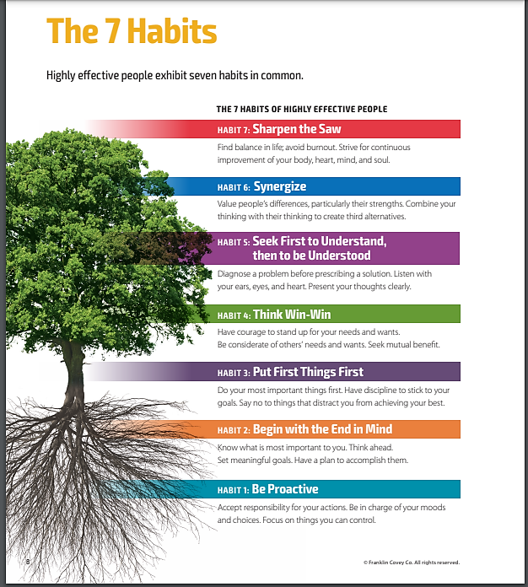
Online Journal

As you progress through the 7 Habits, you will keep an online journal charting your journey and your progress. Entries must be made in your journal once a week and turned in to your teacher every Friday for grading.
You may use whichever software you feel most comfortable with. Attached is a template you can use to cover the required information.
My 7 Habits Journal 2021-22

Name: _____________________________Class Period: _______
Habit #: __________________________________

Journal Entry: _____________________________________________
_________________________________________________________
_________________________________________________________

__________________________
Your Signature

RUBRIC – JOURNAL REFLECTION RUBRIC

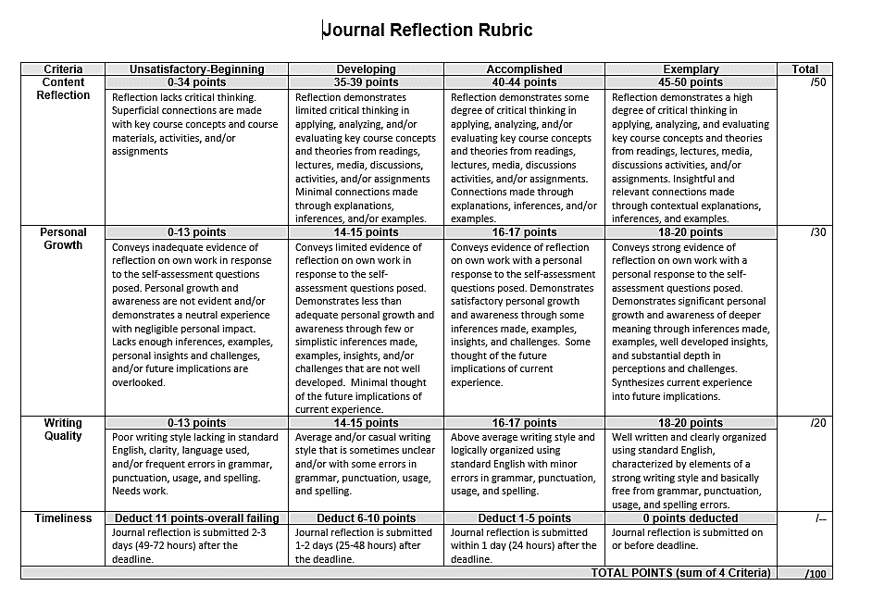

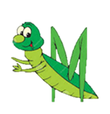

7 Habits of Highly Effective Teens – Learning Packets

