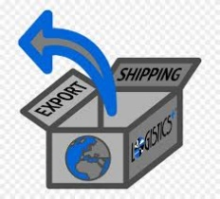
ACTIVITY: Defining INCOTERMS

Overview:
The Incoterms® rules (International Commerce Technology) have become an essential part of the daily language of trade. They are the selling terms that the buyer and seller of goods agree to. They clearly state which tasks, costs and risks are associated with each party. Incoterms are incorporated in contracts for the delivery of goods worldwide and provide guidance to importers, exporters, lawyers, transporters, insurers and students of international trade.

Directions: (Assignment is worth 100 points.)
- Watch the video on Incoterms at https://www.youtube.com/watch?v=NEY60B8Ocg4
- Provide a definition of “freight forwarder” and describe their role and responsibilities in shipping goods
- Using Microsoft Word, create a table outlining the 11 rules from the Incoterms® 2010 edition (https://iccwbo.org/resources-for-business/incoterms-rules/incoterms-rules-2010/). Make sure to differentiate between “freight collect” and “freight prepaid” by listing the obligations and charges of each party.

Rule | Definition | Freight Collect or  Freight Pre-Paid | Obligations and Charges  Buyer | Obligations and Charges  Seller

