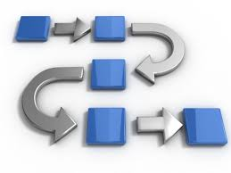
ACTIVITY: Flows and Tiers in Logistics

Name ___________________ Class ___

PART I: Label the following flows on the supply chain below – inbound, outbound, upstream, and downstream. Add a reverse flow. This section is worth 50 points.
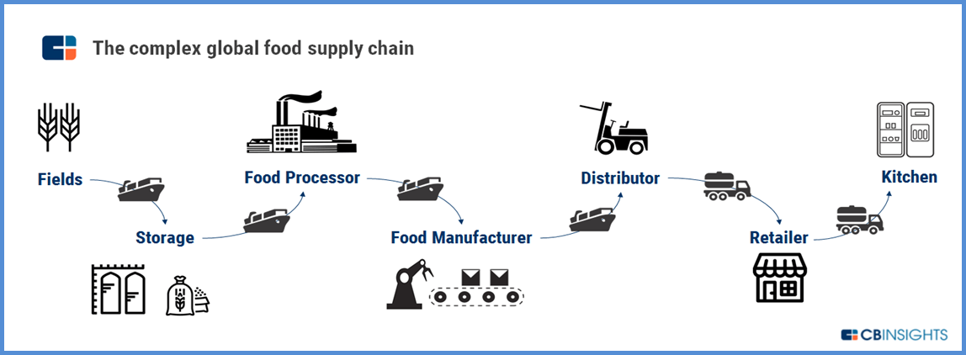

PART II: Label the supplier tier levels in this supply chain. This section is worth 30 points.

