ACTIVITY: How Does This Support the Triple Bottom Line?

Directions: Read the excerpt below. Working with a partner, provide an explanation of how Levi’s is supporting People, Planet, and Profit. Assignment is worth 40 points.
Blue Jeans and Sustainability
OM IN ACTION

The recent drought in California is hurting more than just farmers. It is also having a significant impact on the fashion industry and spurring changes in how jeans are made and how they should be laundered. Southern California is estimated to be the world’s largest supplier of so-called premium denim, the $100 to $200-plus-a-pair of designer jeans. Water is a key component in the various steps of the processing and repeated washing with stones or bleaching and dyeing that create that “distressed” vintage look. Southern California produces 75% of the high-end denim in the U.S. that is sold worldwide. The area employees about 200,000 people, making it the largest U.S. fashion manufacturing hub.
Now that water conversation is a global priority, major denim brands are working to cut water use. Levi, with sales of $5 billion, is using ozone machines to replace the bleach traditionally used to lighten denim. It is also reducing the number of times it washes jeans. The company has saved more than a billion liters of water since 2011 with its Levi’s Water Less campaign. By 2020, the company plans to have 80% of Levi’s brand products made using the Water Less process, up from about 25% currently.
Traditionally, about 34 liters of water are used in the cutting, sewing, and finishing process to make a pair of Levi’s Signature 501 jeans. Nearly 3,800 liters of water are used throughout the lifetime of a pair of Levi’s 501. A study found cotton cultivation represents 68% of that and consumer washing another 23%. So, Levi is promoting the idea that jeans only need washing after 10 years. (The average American washes after 2 wears.) Levi’s CEO recently urged people to stop washing their jeans, saying he hadn’t washed his one-year-old jeans at the time. “You can air dry and spot clean instead,” he said.
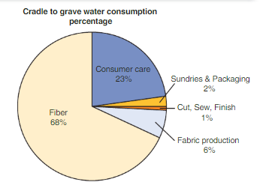
Sources: The Wall Street Journal (April 10, 2015) and New York Times (March 31, 2015).

