Activity: Amazon’s Presence in Tennessee

Website to use for research

MWPVL International
“Amazon Global Fulfillment Center Network”

http://www.mwpvl.com/html/amazon_com.html

Instructions
- Review the article on the website listed above
- Using Google My Maps, indicate all the different types of facilities that Amazon has in the state of Tennessee
- Make sure to indicate what type of facility they are by creating a key at the bottom of your map
- Email the map to kavasschs@gmail.com

grade
Activity is worth 100 points and is being graded on accuracy, following instructions, and completion.

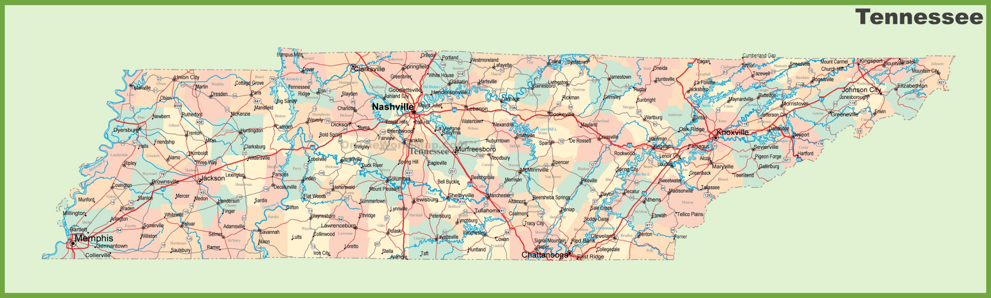

Profile
When Amazon.com launched in 1995, it was with the mission “to be Earth’s most customer-centric company.” What does this mean? It's simple. We're a company that obsesses over customers. Our actions, goals, projects, programs and inventions begin and end with the customer at the forefront of our minds. In other words, we start with the customer and work backwards. When we hit on something that is really working for customers, we commit to it in the hope that it will turn into an even bigger success.

Over the last 5-years, Amazon has created more than 125 jobs in the US every day – from fulfillment centers to corporate offices, we’ve invested over $100 billion in the US alone.

Subsidiaries
Audible
Good Reads
Ring
Whole Foods Market
Zappos
(and many more)

Headquarters
Seattle, Washington
CEO – Jeff Bezos

