Name _________________________________ Class _____
Activity: Channels of Distribution

Directions: Using the computer or classroom art supplies, make a visual diagram of the channels of distribution for the following scenarios. Make sure to number each one, label each part of the channel, and use arrows to show that a new part of the channel has started. Must have pictures for each step and make it creative. An example is shown below. Assignment is worth 40 points.
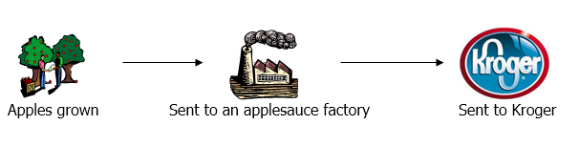
Scenarios:
- Peanuts grown, sent to a factory to be made into peanut butter, then sold to Wal-Mart

- A Talledega Nights movie produced, sent to a plant to be copied, shipped to a warehouse to distribute to Best Buy, customer buys it

- An Under Armour shirt produced, sent to a warehouse to be packaged, sent to Dicks Sporting Goods, you buy it

- Cotton grown, sent to a factory, woven by a factory worker into shirts, sent to a company where a logo is stitched onto the shirt, sent to a store, sold to you

