Name: __________________________ Class: ____
Classifying Factors of Production Worksheet
Directions: Decide if the pictures are one of the factors of production—land, labor, capital, or entrepreneur—or none of them. Then list them in correct columns below. Assignment is worth 24 points.
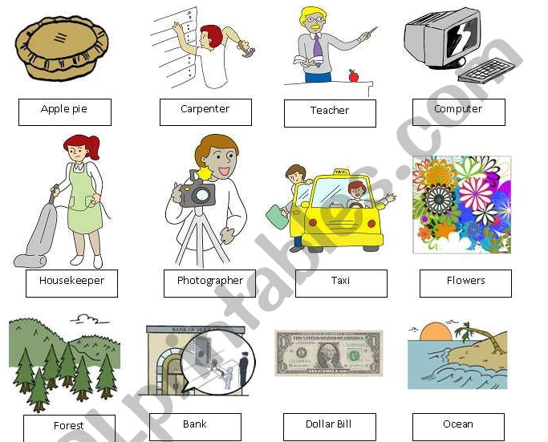

Land | Labor | Capital | Entrepreneur | None

