Name ___________________________ Class ___

PART I
Describe each core function of marketing and provide 2 examples of a task for each. This section is worth 28 points.

Core Function | Description | Task Example #1 | Task Example #2

PART II
Summarize how utilizing the core functions of marketing can lead to success in the marketplace. Provide at least 2 examples. This section is worth 20 points.

_____________________________________________________________________________

_____________________________________________________________________________

_____________________________________________________________________________

_____________________________________________________________________________

_____________________________________________________________________________

_____________________________________________________________________________

_____________________________________________________________________________

_____________________________________________________________________________

PART III
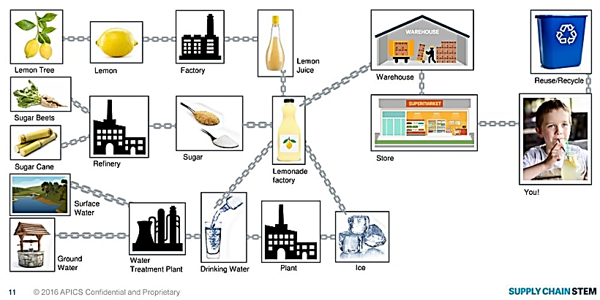
Label each core function of marketing on the attached Lemonade supply chain to indicate the relationship between marketing and supply chain. This section is worth 28 points.

