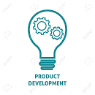
Activity: Define Phases of New Product Development
Name _________________________________ Class _____

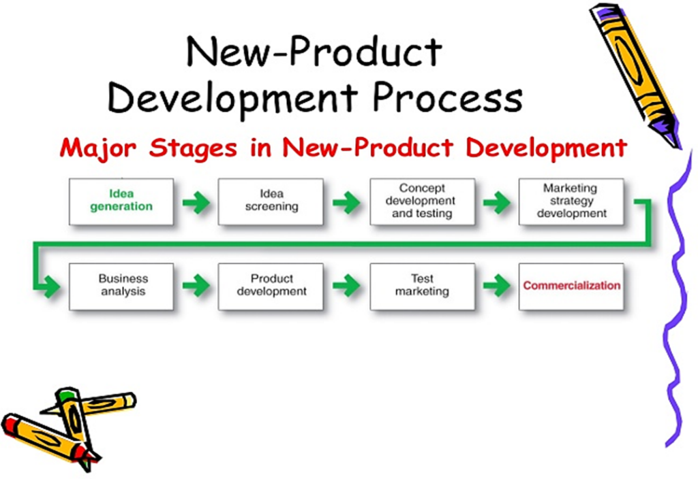
DIRECTIONS: Define each phase of new product development and provide an example. You may choose the format that you present this information – must be emailed to kavasschs@gmail.com.

Assignment is worth 24 points.

