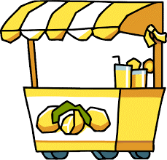
Assignment is worth 30 points.
Entrepreneurship Worksheet

Entrepreneur - The capacity and willingness to develop, organize and manage a business venture along with any of its risks in order to make a profit.
What do these people have in common—Bill Gates, Oprah Winfrey, Diddy, Martha Stewart, and Walt Disney? They are all entrepreneurs. They started small companies and grew very successful by providing a service or product that many of us use today. Some started their companies out of a garage or an extra room of their house.

Do You Recognize these Names?
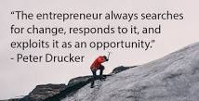
What are the following individuals known for?

Jeff Bezos ____________________________
Debbie Fields ____________________________
Richard Branson ____________________________
Ben Cohen ____________________________
Michael Dell ____________________________
Craig Newmark ____________________________
George Lucas ____________________________
Ray Kroc ____________________________
Sam Walton ____________________________
Ted Turner ____________________________
Steve Wozniak ____________________________
David Filo and Jerry Yang____________________________
Philip Knight ____________________________
Pierre Omidyar _________________________________

Do You Have Entrepreneurial Characteristics?

While all entrepreneurs don’t have the exact same personality, some personality traits are shared by most entrepreneurs. The list below shows several important entrepreneurial characteristics.
Place an “X” in the “Low,” “Medium,” or “High” box to rate yourself. If most of your responses are “Medium” or “High,” you may be a promising entrepreneur. If most of your responses are “Low” or “Medium,” you may be better suited to working for a company instead of owning it.

1. I don’t mind taking risks. _____Low_____Medium____High
2. I like a lot of responsibility. _____Low_____Medium____High
3. I’m willing to work in my free time. _____Low_____Medium____High
4. I like to work for myself. _____Low_____Medium____High
5. I am creative and industrious. _____Low_____Medium____High
6. I have tons of energy. _____Low_____Medium____High
7. I like to achieve. _____Low_____Medium____High
8. I don’t mind uncertainty. _____Low_____Medium____High
9. I am optimistic. _____Low_____Medium____High
10. I adapt easily to new circumstances. _____Low_____Medium____High

