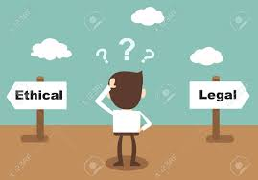
Activity: Ethics are Important

Name _________________________ Class ____
Directions:
Your ethics are your own personal moral judgements about right and wrong. Ethics are used to help us make decisions in business. But why is it important to make ethical choices? Assignment is worth 50 points.

1. If you and your company make ethical choices, what are the possible benefits to your company as a direct result of being trustworthy? _________________________________________________________________ ________________________________________________________________________________________ ________________________________________________________________________________________

2. If you and your company make unethical choices, what are the possible drawbacks to your company as a direct result of being untrustworthy? ____________________________________________________________ ________________________________________________________________________________________ ________________________________________________________________________________________

3. As a business owner, which employee would you rather hire, one who is ethical or one who is unethical? What makes you prefer one over the other? _____________________________________________________ ________________________________________________________________________________________

4. As a customer, do you care if a business is ethical? Why? What could go wrong if the company you use is unethical? _______________________________________________________________________________ ________________________________________________________________________________________

5. Different people have different codes of ethics. What one person believes is ok, may not be ok for another person. For example, one employee believes that loud music with swear words should not be played in the office and they complain about it. Another employee likes that music, and believes it is freedom of speech to be allowed to listen to this at work. If you are their manager, what would you do? Why do you believe that your decision is ethical? ________________________________________________________________________ ________________________________________________________________________________________ ________________________________________________________________________________________

