Activity: Ethics Poll Questionnaire

Name _________________________ Class ____
Directions:
Answer the following poll questions. Then compare your answers with 2 other individuals in class. Finally, write a conclusion statement on what the poll shows in general about fairness and honesty in the workplace. Assignment is worth 30 points.
___________________________________________
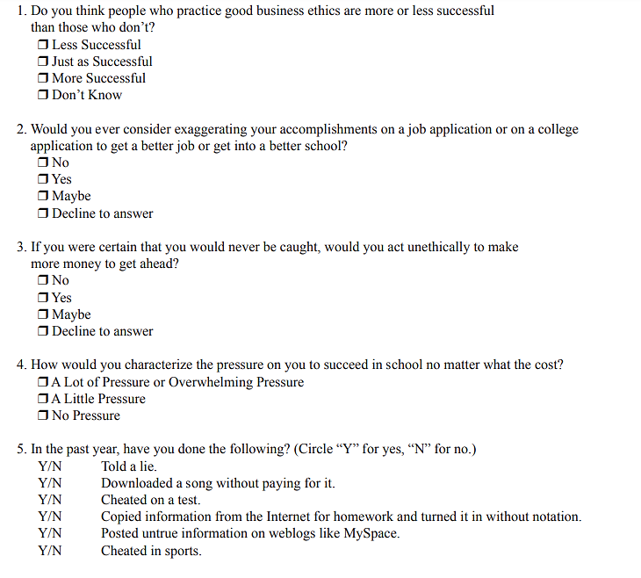

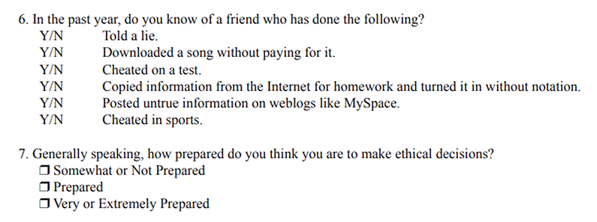
How did your answers compare to another individual in the class?
Individual #1:

Individual #2

Conclusion Statement

