ACTIVITY: Fresh Fruit for All
Providing unblemished ripe fruit to the store all year long

Case Study: Banana Logistics

If you have ever tried to start a garden, you know that each type of fruit or vegetable has a certain season. You may be able to get strawberries from your own yard all summer long, but once winter sets in those strawberries will not grow. Historically, the fruits and vegetables in the local stores were limited to what was in season nearby. In the global marketplace we can get fruits and vegetables year-round as many foods are imported from the southern hemisphere, where summer has just begun when our winter sets in.
One example of a fruit that comes from South or Central America all year long is Bananas. Bananas have their own typical transport chain. This can vary from company to company, but they generally go through the following steps.
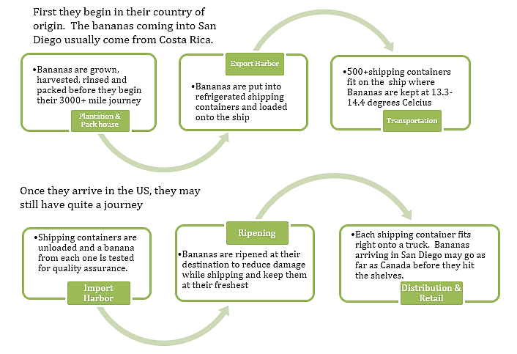

All of the bananas that Dole imports into the western United States and Canada come through the Port of San Diego. 500 or more containers of bananas per week are shipped from Costa Rica and Ecuador into the Port of San Diego on a large shipping freighter with refrigerated shipping containers. These containers are then carried by truck to the store so that you can buy fresh bananas all year long.
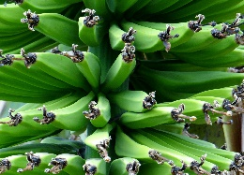
From Freight to Food- The Art of Ripening
Have you ever picked up a piece of fruit to see if it is ripe? You probably looked for fruit that was just barely squishy. As fruit ripens it becomes softer, however, this poses a big problem for shipping fruit. A piece of fruit that is ripe bruises more easily. Also – if one piece of fruit goes bad and begins to mold, it can affect the other fruit around it and cause them to mold as well. This adds an extra concern when transporting fruits and vegetables over long distances.
Some fruits, like bananas, can be picked when they are still green. This means they can ship them while they are firm and unripe so that there is less of a chance for the fruit to be damaged or spoil. But we don’t like to eat the hard green starchy bananas, so logistics managers had to work with food scientists to devise a way to trigger ripening when the bananas are ready to be sold.
To really understand ripening, the first question is, what is the point of a piece of fruit? We enjoy it and received nutrients from it, but why would a plant put all that energy and nutrients into something that will be eaten by another organism?
Fruit is full of seeds, which are the key to plant reproduction. In order for the plant to have a chance of reproducing, those seeds need to get into the ground. Ideally, it is best for the seeds to be spread out, farther away, so that multiple plants can grow without competing for resources.
Ultimately, this means that the goal of the plant is to have their seeds eaten. This is why it is beneficial to entice predators with sugary fruit. Once eaten, the undigested seeds of the fruit will be deposited in the animal’s defecation, surrounded by rich nutrients and ready to grow more plants wherever the seeds were deposited.
Fruits and vegetables will begin to ripen once they are exposed to specific chemicals. Specifically, the plant hormone called ethylene is responsible for ripening bananas. Carbon Dioxide helps to inhibit the production of ethylene, so bananas or other fruits in transit are often exposed to higher levels of CO₂ in order to slow their ripening.
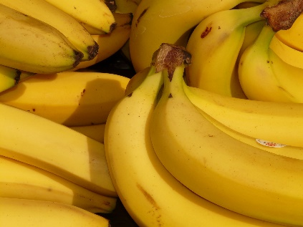
Ethylene is produced in many plant tissues, and production increases whenever the plant is exposed to excessive heat or is damaged. It prompts seeds to germinate, it is part of the process of leaves changing colors in the fall, and it can trigger the death of flower petals. Ethylene causes ripening because it begins production of amylase, which will break down the starches to make sugar – which is why ripe fruit tastes sweeter.
Hormones travel throughout the plant from cell to cell. There is a great advantage of having a signal to encourage quick ripening. If the parent plant dies it helps ensure that animals eat the fruit and spread the seeds so that more plants will grow. Ethylene is also emitted as a gas into the air around the plant and can help warn nearby plants that danger is near so they should activate their defenses. This causes nearby plants to begin ripening their own fruit.
Understanding the role of Ethylene has allowed scientists to develop processes for ripening bananas. They are able to produce ethylene synthetically, and when they want the bananas to become ripe, they only need to put them in a sealed room or container with an Ethylene source and they will ripen quickly.
This is also how we keep North American fruit for so many months after harvest. By picking apples before they naturally ripen, then storing them in an Ethylene free area, they can survive for months. Right before they are taken to market, they are exposed to Ethylene and they begin to turn sweet and ripe.
Activity Requirements:
Activity Requirements must be typed in an MS Word document and emailed to kavasschs@gmail.com.
Assignment is worth 100 points.

- Answer the following questions – must be typed in a MS Word Document – include the actual questions:
  - Where are many foods imported from during our winter? Why can they grow food when we can’t?
  - Where do many of our bananas come from? How many miles away is it?
  - Why are bananas shipped unripe?
  - At what temperature are bananas kept while being shipped?
  - What is the hormone that plants produce that begins the ripening process?
  - What can be done to slow ripening?
  - What can be done to speed up ripening?
  - Why does ripe fruit taste sweeter than unripe fruit?

- Draw the supply chain of bananas from Costa Rica to a Kroger store in Cordova, TN. Include all 6 components of the supply chain and the modes of transportation between each node. (NOTE: Use Drawing Canvas in MS Word)

- Map the shipping route from Puerto Puntareñas, Costa Rica, to the Port of San Diego, California (www.sea-distances.org ) including miles and days to travel via ship.
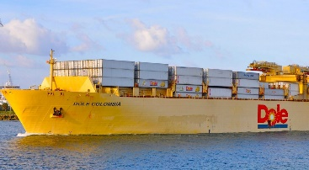
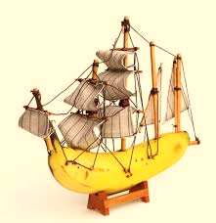
Global Banana
Mapping

Map the shipping route (using Draw in MS Word) from Puerto Puntareñas, Costa Rica, to the Port of San Diego, California (www.sea-distances.org ). Include locations, directional areas, miles and days to travel via ship.

