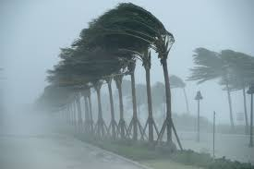

Impact of Natural Disasters on the Supply Chain

Objective – Problem Solving #18G

Analyzing the impact of natural disasters on supply chain – forecasting potential threats related to geography of a company’s supply base – designing of contingency plans in times of natural disasters

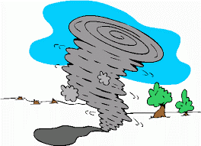
“Whether facing a hurricane, tsunami, or blizzard, any kind of natural disaster will inevitably disrupt global supply chains with postponed or paused deliveries, closed ports, canceled cargo flights, and unbalanced supply and demand.
Depending on the severity of the situation and the preparedness surrounding it, some supply chains even come to a complete halt. This often creates a ripple effect, as businesses in the affected area may not be able to procure the supplies they need on time or may receive fewer shipments than normal. And this, of course, ultimately impacts the consumer as well. Recovery can be time-consuming, expensive, and arduous.”
Source: Helen Carey, Thomas Industry Insights, 09/26/18

Preparing for Natural Disasters

Source: Helen Carey, Thomas Industry Insights, 09/26/18
Create a response and recovery plan.
Take time to develop well-thought-out, detailed guidelines and directions for team members, and be sure that everyone is on board and familiar with their duties. Look into backup suppliers and review the plan regularly to identify areas for improvements or adjustments.
Assess supply chain risks regularly and get to know the suppliers you partner with.
Find out if they have their own disaster response/preparedness plans in place, and what they entail. Creating a supplier scorecard can be helpful for analyzing risk levels and potential problems. This will guide you in determining which third parties are most useful for your business in the event of a disaster.
Understand the risks facing your organization’s reputation.
In the event of a natural disaster, how will your business fare in the public eye? Will people look upon your supply chain as reliable and responsible, putting consumers first, or will people be posting on social media about the potentially life-threatening issues they’re experiencing because of your poor planning?
If disaster does strike, make sure all investigations are thorough and well conducted.
This is an opportunity to learn from mistakes, identify what was done right, and reassess your preparedness plans in relation to the findings. If a disaster occurs in the future, you’ll be better able to take it on.

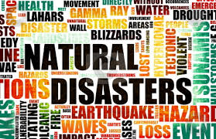
Assignment:

Choose one of the following natural disasters:

2018-19 California Wildfires
2017 Earthquake of Chiapas, Mexico
2017 Hurricane Maria, Puerto Rico
2018 Hurricane Florence, North Carolina
2018 Indonesia Earthquake and Tsunami

Provide the information requested below in a MS PowerPoint Presentation. You will present your findings to the class.

- Overview of Event
- Event Video
- Statistics on Damaged Caused
- Supply Chains Disrupted

Assignment:
Counts as a project grade worth 100 points

POWERPOINT PRESENTATION RUBRIC
CATEGORY | POSSIBLE  POINTS | POINTS  ASSIGNED
Research  - Includes all information requested  - Well-researched and accurate material  - Clearly and orderly prepared | 60
PowerPoint and Presentation  - Includes all information requested  - Format – readable and presentable  - Graphics included  - Class Presentation – well prepared and presented | 30
Instructions  - Followed all instructions  - Turned project in on time | 10
TOTAL POINTS ASSIGNED:

