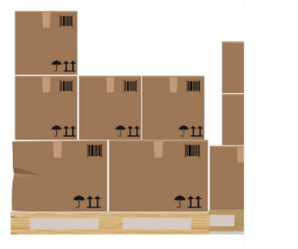
Activity: Inspecting Merchandise – Your Turn

Name________________ Class ___

An order has just arrived from Clean on Friday, a manufacturer of laundry supplies. Look at each carton’s bar code, then enter the product quantities into the inventory system.
Note that different cartons can have different product quantities and that the same type of product may be divided into multiple cartons. So, if you are expecting 50 of a specific item, and there are 10 of those items in each carton, there should be 5 cartons of that item because 5 x 10 = 50.
Pay close attention to item numbers, names, and details like color, scent, flavor, and size. A red shirt will be listed as a different item than a blue shirt, so make sure you count them separately.
Make sure you enter each carton and that you only count it once. Otherwise, your count will too high or too low.
Finally, if you note damage on any of the cartons, make a note of that in the system.

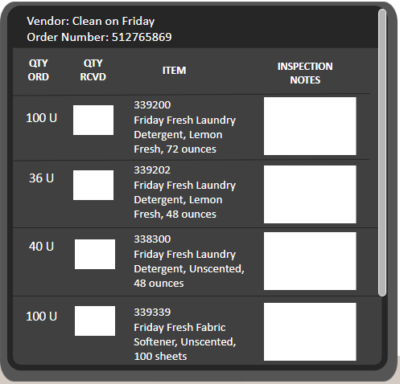
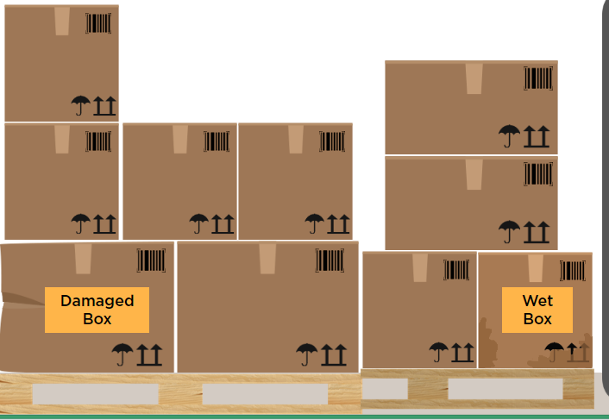
1

7

5
4
2
8

10
3
9
6

