 | Activity: Learn About Your State | 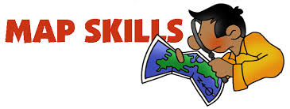

Name _______________________ Class ___
Directions
Learn about your state by researching answers to the questions below. Assignment is worth 50 points.

- Which state do you live in? Can you locate it on the map below?
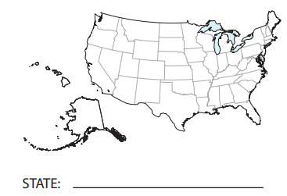

- What states border your state?

- What is the capital city of your state?

- Who is the current Governor of your state?

- How many representatives does your state have in the House of Representatives in Washington, D.C.?

- What is the population of your state? What is the population of Shelby County? of Memphis?

- What are the top agricultural items for your state?

- Who are some of the major manufacturing companies in your state?

- Who are the 3 largest companies that have world headquarters in Memphis?

- Which railroads travel through the Memphis area?

