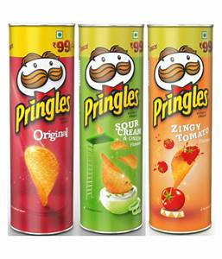
MANAGE THE PRODUCT MIX
Directions: Complete the table below providing examples for each of the methods available for changing a product mix. Assignment is worth 60 points.

Managing Product Mix | Example
Product Modifications
Line Extensions
Product Deletion
Imitations
Adaptations
Innovations

