A Step-By-Step Look at How McDonald's Makes Its Fries
Kim Bhasin

Oct. 25, 2012, 12:26 PM
Kim Bhasin
Oct. 25, 2012, 12:26 PM

Kim Bhasin, Business Insider, October 25, 2012
McDonald's Canada has put together a run-through of how it makes its fries as part of an initiative to answer questions from customers.
Instructions: Review the information below and then draw a supply chain (in the blank box provided on page 2) for McDonald’s Fries from the farm to the consumer. Make sure to label all links and nodes. This activity is worth 25 points and will count as part of your Exam grade for Intro to Supply Chain Exam.

STEP 4
Here, the potatoes are put on a long conveyor belt to get to what they call a "dirt eliminator."

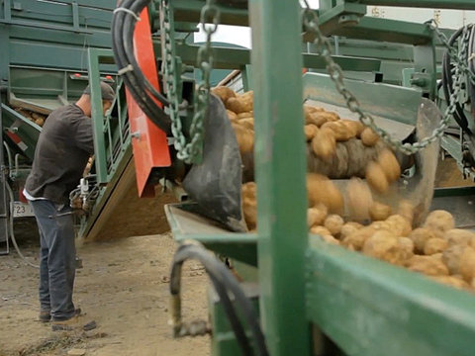
STEP 3
And the trucks head out to a sorting station.

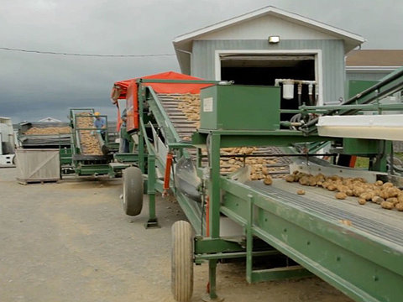
STEP 2
Then, it moves the potatoes over to a truck via conveyor belt.

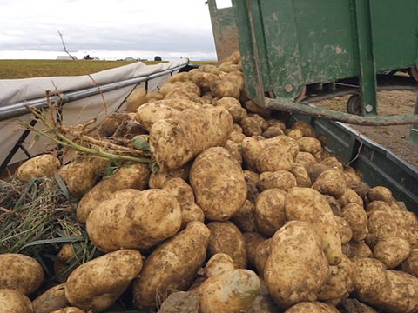
STEP 1
It all starts at the farm – in this case, Leveque Farms, one of McDonald's Canada's potato suppliers.

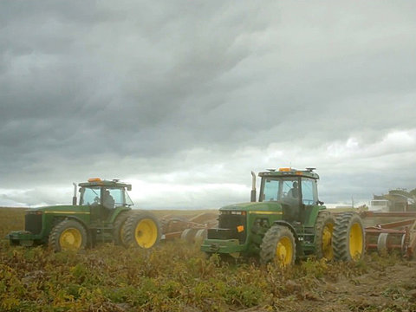

STEP 8
At the restaurant, they're put into the fryer.
Then they get dumped at the fry station, salted and put into the red packaging.
Then sold to customers.
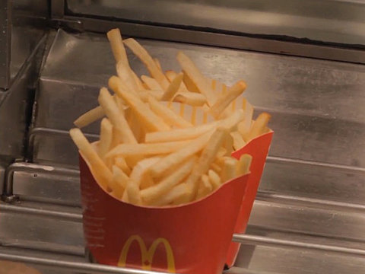

STEP 7
And then shipped off to McDonald's locations.

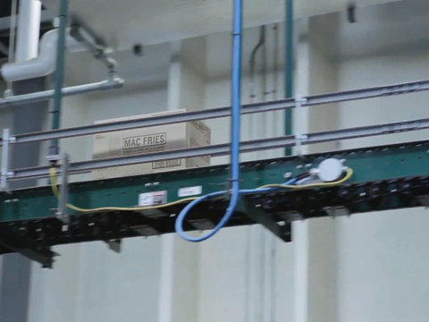
STEP 6
The plant receives potatoes from approximately 30 growers in the local region. The potatoes are washed, peeled, cut, blanched, dried, fried, frozen, and packaged.
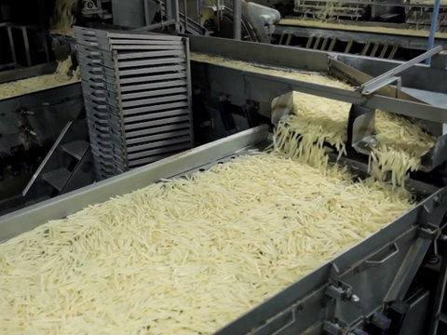
STEP 5
The potatoes are put onto a truck again, and then it's off to McCain's plant.

