Assignment is worth 24 points.
Measuring the Value of Education Worksheet
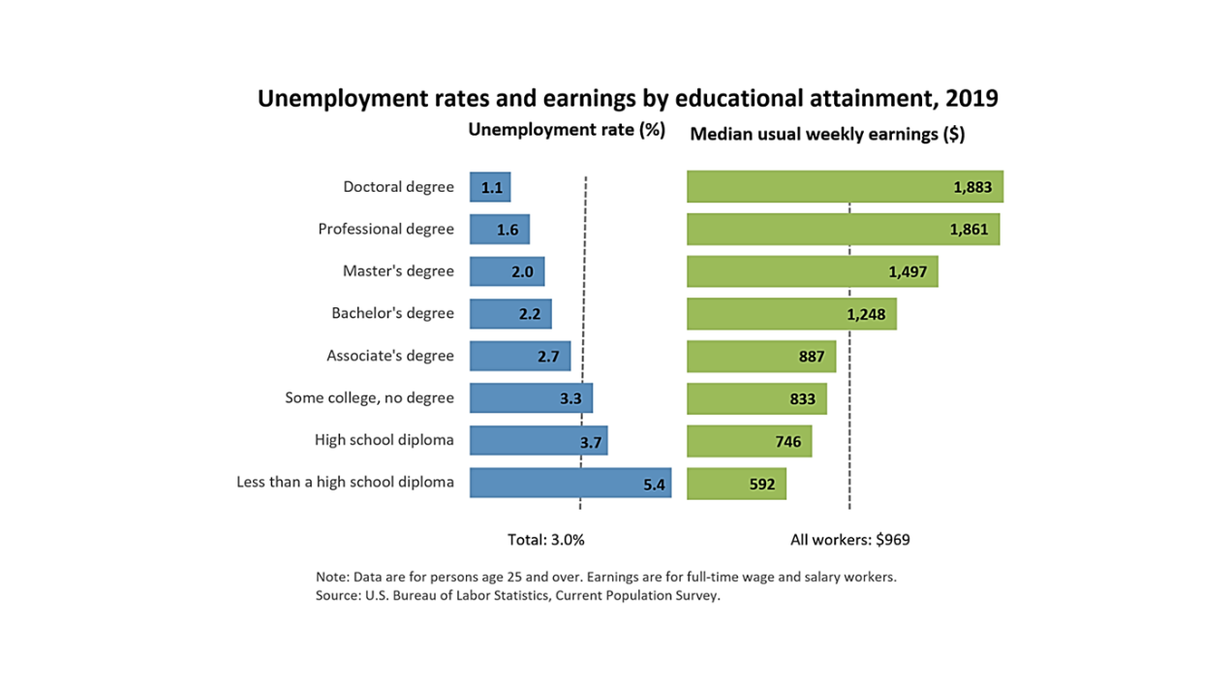

What is the median annual earnings for a Master’s Degree? ____________
for a Bachelor’s Degree? ___________
for an Associate’s Degree? ____________
for a High School diploma? ____________

If the average person works for 30 years, what is the lifetime earnings for someone with a
Master’s Degree? ______ Bachelor’s Degree? _________ Associate’s Degree ______

Why does the unemployment level decline as educational attainment increases? ______________
__________________________________________________________________________________
__________________________________________________________________________________

