Monster’s Inc SWOT Analysis
Directions: As you watch Monster’s Inc., create a SWOT Analysis matrix for the company Monsters Incorporated. You must list at least 4 items under each area of the matrix. At the end of this activity, write a situational analysis paragraph explaining what you found while conducting your SWOT analysis. (Video is available at https://www.youtube.com/watch?v=Po6OMK-4txo)
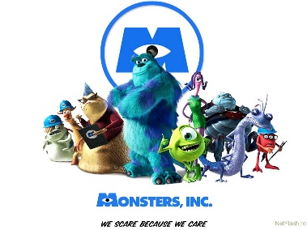
Consider the following when conducting your SWOT analysis:
- The employees of the company
- Company management
- Ethical practices of the company
- Products the company offers
- Competition

Strengths  1.  2.  3.  4. | Weaknesses  1.  2.  3.  4.
Opportunities  1.  2.  3.  4. | Threats  1.  2.  3.  4.

Write your situational analysis statement/paragraph over the Monsters Incorporated company in on the back of paper of this paper. (Example. of how to start: “While the Monster’s Inc company does an excellent job of ___________, they still have areas that could be improved upon...

