ACTIVITY: OUR FOOD’S JOURNEY
Food often travels thousands of miles from where it is produced to where it is sold and eaten. Students will learn why this is so and consider the advantages and disadvantages. Students will critically examine and debate different scales of food distribution (local, regional, national, and global).
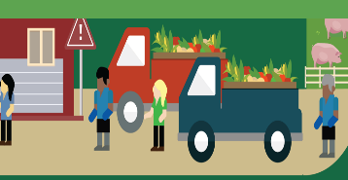
Essential Questions:
- Why is food transported long distances?
- What are the pros and cons of local, regional, national, and global food distribution systems?
- Which scale of distribution has the greatest net benefit for your community? For society?

Directions: Complete the following activities.
Activity A:
Read the article “Food Distribution” published by John Hopkins Center for a Livable Future (attached). Answer the essential questions listed above.

Activity B:
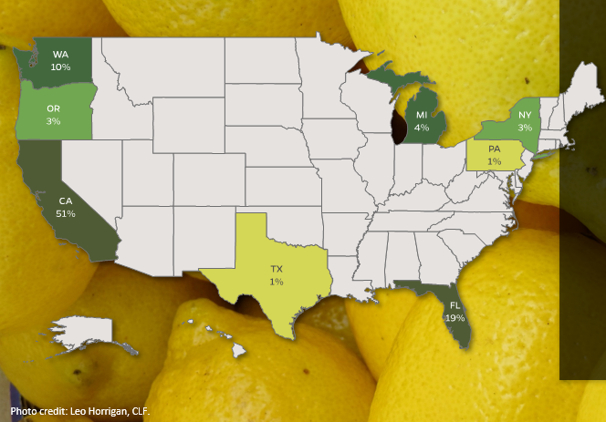
Which state harvests almost half the fruit in the US? _________________
Which state harvests the next largest amount of fruit in the US? ___________
Which other states harvest fruit in the US? ___________________________

Activity C: How Far Did Your Meal Travel?
Choose a favorite meal and make a list of up to four main ingredients. For example, a burrito might include cheese, tomatoes, beans, and rice.
On the Food Map of the U.S. (attached), plot where each ingredient was produced. If any ingredients come from outside the U.S., write the name of the country of origin along the edge of the map. (Note: To search for ingredients, google “US state that produces the most _________”)
Answer the following questions based on your research and map:
- Approximately how far did the ingredients travel before reaching your plate?
- What does the distance tell you about our food system?
- Can you find any of these ingredients locally?
- How feasible would it be for you to eat only locally produced food?
- What foods would you have to give up if you ate only locally produced food?
Activity D: Create a Supply Chain
Draw a supply chain for the meal you selected in Activity C. Be sure to include ALL 6 supply chain components, label everything and draw the appropriate arrows for direction.

Activity E: Why is Food Transported?
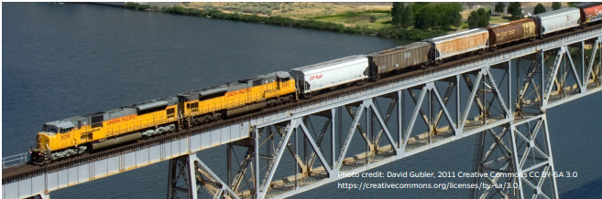
Pair up – prepare a brief presentation for the class answering the following questions:
- Can you think of places that might not have enough local farmland to support the local population?
- Can you think of reasons why transporting food long distances might provide consumers with a greater variety of food?
- Can you think of other regions that have a comparative advantage in producing certain foods?
- (Note: Comparative advantage means the ability of an individual or group to carry out a particular economic activity (such as making a specific product) more efficiently than another activity.)
- What are the pros and cons of transporting food long distances? Could we do without it? If so, how?

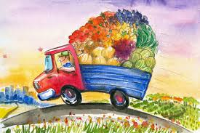
Food Distribution
Chilean grapes, Alaskan cod, Nebraskan beef, and nearly every vegetable grown under the California sun are at supermarket shoppers’ fingertips. The variety, abundance, and year-round availability of perishable foods are a modern marvel, made possible by the “cold chain”—an uninterrupted series of refrigerated vehicles and storage facilities that keep food within an ideal temperature range. Even before distributors began using mechanical refrigeration in the late 1800s, rail cars, steamships, and warehouses were cooled with ice to keep food from spoiling over long journeys from producers to consumers. Today, the cold chain allows perishable food to be transported to and from all corners of the globe.¹
When international food imports first entered U.S. markets, they were all the rage. In the 1930s, one upscale New York restaurant chain boasted on its menu about the mileage traveled by its exotic produce. The ingredients in their vegetable salad, they claimed, had traveled a cumulative 22,250 miles.¹
Today, restaurants are more likely to take pride in local ingredients. Consumers are paying more attention to where their food comes from, partly out of concern over environmental impacts of long-distance transport. How far food travels, however, may not be as important as what people eat, how food is produced, and why it is transported long distances in the first place.

WHY FOOD IS TRANSPORTED LONG DISTANCES
There are some valid reasons to transport food long distances, including:
Feeding densely populated areas: According to one estimate, if all the agricultural land in New York state were devoted to feeding New York City’s population of 8 million², there would be only enough food to feed half the city—with nothing left for the rest of the state.³ One adult eats roughly one ton of food per year. Where there are a lot of people in one place, there may not be enough local farmland to support them all.
Out-of-season variety: In northern latitudes, most food production is suspended through the cold season. If people in those regions ate only local food, their options would be very limited unless they preserve fruits and vegetables to last the winter. Some households are doing just that, but it requires effort and planning. Otherwise, shipping food from Florida, California, Central and South America, and other southern locales can provide people with year-round variety and nutritional diversity over the winter months.
Allowing regions to focus on their strengths: Some regions are better at producing certain foods than others. Vermont, for example, has a short growing season, rolling hills, and rocky soil—less than ideal conditions for growing many crops but suitable for raising dairy cows.⁴ From an economic standpoint, it makes sense for Vermont’s farmers to focus on the products they are best suited for. In fact, they produce far more milk and dairy products than are consumed within Vermont,⁵ and export the surplus to other states. Other states, in turn, export to Vermont the foods they are best at producing.

FOOD DISTRIBUTORS
Food distributors provide a bridge between the people who produce food and those who sell it. They gather products from farmers and food processors, store them in warehouses, and then transport them to retail and wholesale buyers.
Large businesses like supermarkets, chain restaurants, and food service providers for schools, hospitals, and other institutions rely on distributors to help acquire the many foods and ingredients they need to operate. A supermarket, for example, does not have time to purchase from hundreds of different farmers and processors to stock their shelves. One farmer, meanwhile, rarely produces enough food to make it worthwhile for a large business to purchase directly from them. A distributor brings together goods from many different producers and processors, so they can be sold in bulk.
Food distributors are also part of the reason foods are transported long distances. Larger, more competitive distributors may buy only from large farms that provide a steady supply of goods at the lowest prices—even if those farms are halfway across the globe.^{6,7} This competition for lower prices can drive smaller farmers out of business, while making regions more dependent on food from faraway places. For example, in 1870, all the apples eaten in Iowa were grown by Iowa farmers; by 1999, 85 percent were imported from outside the state.⁸
Some smaller-scale farmers are getting around these problems by “cutting out the middleman” and selling directly to consumers (e.g., at farmers’ markets). Farmers get a larger share of the profit this way, and they can build personal relationships with consumers who want to know and trust where their food comes from.

FOOD MILES
The term “food miles” refers to the distance foods travel from where they are produced to where they are purchased or eaten. One study suggests fresh fruits and vegetables grown in the U.S. travel roughly 1,500 miles, on average, before they are sold.⁸
Food miles have come under scrutiny by conscientious consumers, often out of concern for public health and the environment. Fossil fuel–powered vehicles deplete dwindling oil reserves, impact air quality, and emit greenhouse gases (GHGs) that contribute to climate change. In some cases, purchasing locally produced foods may lessen these impacts by reducing transport distances.
Food routes, however, are rarely as simple as a straight line from farm to market. Processed food companies often source ingredients from multiple farms, and their products may be sold and re-sold through many distributors before arriving in stores. Meat, milk, and egg production usually involves shipping feed to animals and transporting animals between breeding, feeding, and slaughtering facilities.
Some transport vehicles are also more efficient than others. Trains, for example, are many times more energy-efficient than trucks and planes (see image). Vehicles with more storage capacity also have advantages—shipping a large load of apples in an 18-wheeler, for example, is generally more efficient per apple than shipping a few crates in a pickup truck.
What people eat often matters more for climate change than how far food travels. Across the U.S. food supply chain, from farm to retail, transportation accounts for only an estimated 11 percent of GHG emissions. The vast majority of emissions are from food production, particularly livestock production. If Americans followed a plant-based diet one day per week, they could cut GHG emissions more than by following an entirely local diet.⁹

LOCAL AND REGIONAL FOOD SYSTEMS
“Local” food may mean different things to different people. It is sometimes defined as food that was produced within 100 or 250 miles of where the consumer lives, or food that is sold directly from a farmer to a consumer (e.g., at a farmers’ market).¹³
What is the appeal of local food? Surveys suggest consumers perceive local food as fresher, and like the reassurance of knowing where and how it was produced.¹⁴ They may also be drawn to opportunities to support their local economy—buying local can support new jobs and higher incomes in a community.¹³
For farmers, selling to the mass market often means growing hardy fruits and vegetables, bred to withstand the bumps and bruises of long-distance transport and long periods on supermarket shelves. Selling locally, on the other hand, allows farmers to experiment with crop varieties that may be more flavorful, nutritious, or rooted in local heritage.¹⁵
In many cases, however, it is neither realistic nor desirable to source food entirely within 100 or 250 miles. Highly populated, very cold, and very dry places, for example, may need to source food from farther away.
If local is too limiting, how far should food travel? The idea of a regional food system takes into account the distance needed to produce enough food, with enough variety, and to produce it in ways that are sustainable. Because those distances vary from place to place, the boundaries of a regional food system are not universally defined, though they usually encompass a much larger area than what is considered local (e.g., a multistate area in the U.S. such as the Northeast).
Source: http://www.foodsystemprimer.org/food-distribution/

FOOD MAP OF THE U.S. HANDOUT

Directions:
- Choose a favorite meal and make a list of up to four main ingredients. For example, a burrito might include cheese, tomatoes, beans, and rice.
- For each ingredient, plot on the map where each ingredient was produced. If any ingredients come from outside the U.S., write the name of the country of origin along the edge of the map.

List of Ingredients
1. ___________________________________ 6. ____________________________________
2. ___________________________________ 7. ____________________________________
3. ____________________________________ 8. ____________________________________
4. ____________________________________ 9. ____________________________________
5. ____________________________________ 10. ____________________________________
