WHO AM I?
Soft Skills in the Workplace
Employers are seeking individuals that know who they are – their personality, skills, strengths, and weaknesses. Sharing your skills with a potential employer must be done with clarity and preciseness.
- How long do you believe the average person’s attention span to be?
- Close your eyes and estimate how long you think 30 seconds lasts. Once you believe 30 seconds has passed open your eyes and look at the timer on the board. How many seconds actually passed?
- Now, prepare a 30-second introduction of yourself to your potential employer – describe who you are and what skills you have to offer this company.

Soft Skills - the personal attributes you need to succeed in the workplace - often related to how you work with others

Define each of the following soft skills:
TIP: Employers want employees who are able to effectively interact with others. These skills are also very hard to teach, so employers want to know that job candidates already have the soft skills that enable them to be successful in the workplace.
Soft Skill | Definition
Communication
Flexibility/Adaptability
Interpersonal
Leadership
Problem-Solving
Team Work
Work Ethic

Hard Skills – teachable abilities or skill sets that are easy to quantify
Make a list of the hard skills that you currently have:
1. ___________________________ 6. ____________________________
2. ___________________________ 7. ____________________________
3. ___________________________ 8. ____________________________
4. ___________________________ 9. ____________________________
5. ___________________________ 10. ___________________________

Directions: Below is a short, multiple choice exercise to generate discussion about soft skills and how to apply them in the workplace. Answer each question on your own and then compare your answers with a partner. Activity is worth 20 points.
Soft Skills in the Workplace Worksheet

You are due at work at 2:00 pm. You're across town and running late. You know you won't make it to
work before 2:15. What should you do?
- Call your supervisor and tell him/her you're going to be about 15 minutes late.
- Don't waste time calling — just hurry up and get to work as soon as possible so you won't be even later.
- Do nothing — the rule of thumb is to call if you're going to be more than 15 minutes late.

You're overwhelmed at work. Yesterday, your boss gave you a big job to finish within two days. A
few minutes ago, the company owner asked you to help on a project later that day. Meanwhile, a
co-worker has asked you for your help on planning a birthday party for another employee. You know
you can't get everything done in time. What should you do?
- Start looking for another job — companies that pile on too much work on their employees have unrealistic expectations about worker performance.
- Talk to your boss. Communicate the demands on your time and ask if he/she can help you prioritize what needs to be done.
- Do the company owner's job first, your boss' second and politely decline to help you co-worker: Birthday parties are inappropriate in the workplace.
- Do the task in the order they were given to you.

You discover that some money is missing from your desk. Two of your coworkers told you that they
noticed another co-worker poking around in your office while you weren't there. What's the best
thing to do in this situation?
- Go directly to that person and ask whether or not he/she took your money.
- Say nothing to that person, but confidentially tell your boss who took your money so that he can reprimand the culprit.
- Report the theft (without mentioning names) to a security guard or supervisor and lock your desk or keep your money elsewhere from now on.

Your supervisor has given you a small but very important task and you're not sure how to complete
it. You know that another one of your co-workers has done this task before. What should you do?
- Do the task to the best of your ability without asking for help — employers appreciate employees who don't need a lot of guidance.
- Trade job duties — ask your co-worker to complete your task in exchange for you completing one of his.
- Ask your supervisor how she/he would like you to complete the task.
- Ask your coworker how he has completed the task in the past.

You and a coworker have completed a project together. You each did about half the work. Your
boss came and thanked you for your work, without ever mentioning your coworker's name or saying
she knew your coworker was involved. Which of the following is the best thing to do?
- Give your coworker most or all of the credit — it's unprofessional to take individual credit for a group project.
- Don't mention your coworker — it's unprofessional to correct your boss.
- Thank your boss for her praise and acknowledge that the project was a combined effort between you and your coworker.

Activity is worth 25 points.
Networking Worksheet
INDIVIDUALLY
- Respond to each prompt (as it pertains to your own life and experience) by writing your answer on the “Me” line in each box.
- You have ______ minutes to complete this portion of the exercise.
- After someone has yelled “BINGO”, go back and complete the questions at the bottom of the page.

IN A GROUP
- Stand up, walk around, and talk to people. This is called “networking.” Identify individuals that have the same response for each box. When you find someone that matches your response, write their name in the box. You may not have the same person’s name more than ONE time in the grid.
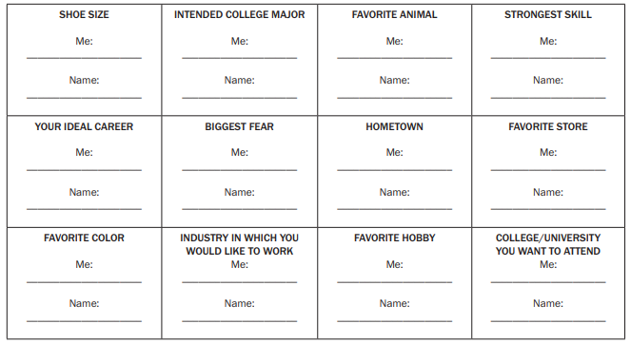
- You have ______ minutes to network and complete your grid. Yell “BINGO!” when all blanks are filled in.
- How could people who share your interests help you make good educational and career choices?
- Who would be the most beneficial connection on your grid? Why?
- How might a “fun” connection like “favorite hobby” or “animal” help in your career development?
- Can social media, like Instagram or Snapchat, help us network? If so, how? Can it hurt our networking opportunities?
Activity is worth 30 points.
Work Place Ethics Worksheet
Ethics - moral principles that govern a person's behavior or the conducting of an activity

DIRECTIONS:
In groups of 3, discuss what workplace ethics are and how they govern the conduct of both employers and employees.
_______________________________________________________________
_______________________________________________________________ _______________________________________________________________
As a group brainstorm and create one list of ethics that apply to employers (ex. Hours, safe work environment) and another that apply employees (ex. Honesty, treat company resources with care).

List of Ethics – Employer | List of Ethics - Employee
1. | 1.
2. | 2.
3. | 3.
4. | 4.
5. | 5.

As a group, problem solve the ethical scenario you were assigned. Share your group’s solution with the class.
Solution: ___________________________________________________________________
___________________________________________________________________________
___________________________________________________________________________
___________________________________________________________________________
___________________________________________________________________________
___________________________________________________________________________

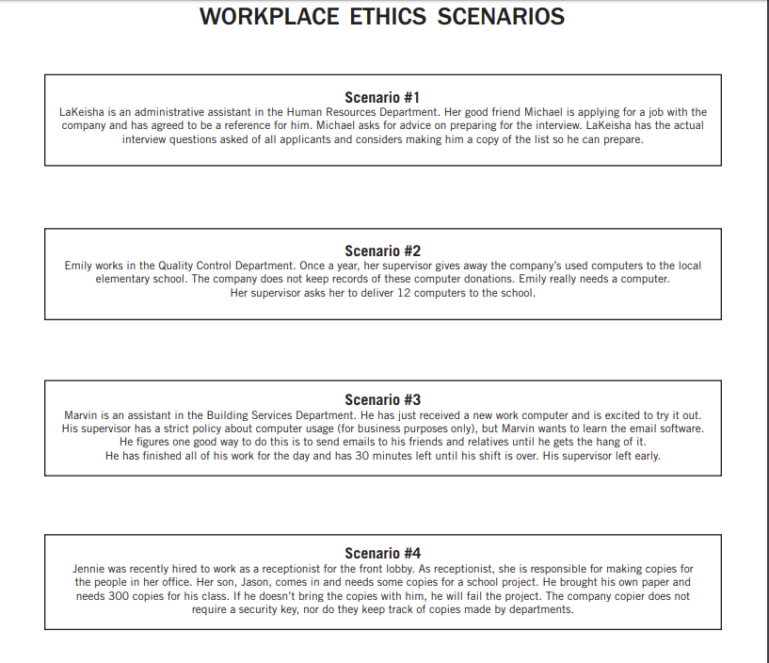

Communications Worksheet
Communications
Communication skills are important to everyone - they are how we give and receive information and convey our ideas and opinions with those around us. Communication comes in many forms: • verbal (sounds, language, and tone of voice) • aural (listening and hearing) • non-verbal (facial expressions, body language, and posture) • written (journals, emails, blogs, and text messages) • visual (signs, symbols, and pictures)

Activity: Quit Talkin’! I Know What to Do!
Gain a better understanding of how non-verbal communication (both intended and unintended) can be interpreted by others…and the impact and effect of this form of communication.

Three-Minute Quiz –
- Read everything before you do anything.
- Write your name in the upper top left-hand corner of this page.
- Circle the word “name” in sentence two.
- Draw five small squares in the upper right-hand corner.
- Put an X in each square you have just drawn.
- Put a circle around each square.
- Sign your name under the title of this page.
- After the title, write, “yes, yes, yes.”
- Underline sentences number seven and eight.
- Put an X in the lower left-hand corner of this page.
- Draw a triangle around the X you have just made.
- Stand up and (loudly) call out your first name.
- On the back of this page multiply 5 times 4.
- Draw a circle around the word “top” in sentence four.
- On the reverse side of this paper add the numbers 25 and 100.
- Count out in your normal speaking voice from one to 10.
- If you are the first person to get this far, say, “ME, ME, ME!”
- Using your pencil, punch three small holes at the bottom of this paper.
- If you think you have carefully followed these directions, stand up, turn around and whisper, “I have carefully followed the directions.”
- Now that you have finished reading the directions carefully, do only sentences one and two. Sit quietly until everyone else if finished.

