ACTIVITY: SUPPLY CHAIN FUNCTIONS FOR WAL-MART

DIRECTIONS: Read the following article. Then find an example of each of the 7 Supply Chain Functions in the article (circle or underline it – also label it with the specific function.)

In 1962 Sam Walton opened a discount store in Rogers, Arkansas. He started with the idea that, ‘The secret of successful retailing is to give your customers “what they want” and this includes “a wide assortment of good quality merchandise; the lowest possible prices; guaranteed satisfaction with what you buy; friendly knowledgeable service; convenient hours; free parking; and a pleasant shopping experience.” Sam called his store Wal-Mart, and was so successful that his chain grew quickly. In 1983 he opened a Sam’s Club Warehouse for members and in 1988 he opened the first ‘Supercenter’ selling groceries.
During the 1980s Wal-Mart became the leading retailer in the USA, and started its international expansion. Early moves into Mexico, Puerto Rico and Canada were followed by South America, Asia and Europe – with most of the later expansion from buying local companies (such as ASDA in the UK and Interspar in Germany). Wal-Mart is a classic example of how to manage rapid growth without changing the company’s underlying values – in this case “the basic value was, and is, customer service.” This is emphasized from the front door of each store, where someone greets each customer and tells them about special offers and promotions.
What started small, with a single discount store and the simple idea of selling more for less, has grown over the last 50 years into the largest retailer in the world. Each week, nearly 270 million customers and members visit our more than 11,700 stores under 65 banners in 28 countries and e-commerce websites. With fiscal year 2018 revenue of $500.3 billion, Walmart employs approximately 2.3 million associates worldwide. Walmart continues to be a leader in sustainability, corporate philanthropy and employment opportunity. It’s all part of their unwavering commitment to creating opportunities and bringing value to customers and communities around the world.
Distribution Centers
A large Wal-Mart store stocks approximately 120,000 different items, each of which has its own supply chain. Not surprisingly, the company needs a huge logistics effort.
Walmart's 150+ distribution centers are hubs of activity for our business. Our distribution operation is one of the largest in the world servicing stores, clubs and direct delivery to customers. Walmart transportation has a fleet of 6,100 tractors, 61,000 trailers and more than 7,800 drivers delivering $4 billion dollars’ worth of goods each week.
- The distribution center network ships general merchandise, dry groceries, perishable groceries, along with other specialty categories to our consumers daily.
- There are 6 disaster distribution centers, strategically located across the country and stocked to provide rapid response to struggling communities in the event of a natural disaster.
- Each distribution center is more than 1 million square feet in size and employs 600+ personnel unloading and shipping over 200 trailers daily.
- Every distribution center supports 90 to 100 stores in a 150+ mile radius.
- Walmart is able to move goods to and from distribution centers because they maintain a private fleet of trucks and a skilled staff of truck drivers. They're part of one of the largest and safest fleets, and every year they drive 700 million miles to make millions of deliveries to stores and clubs. Each driver averages around 100,000 miles annually-that's like driving around the world 4 times!
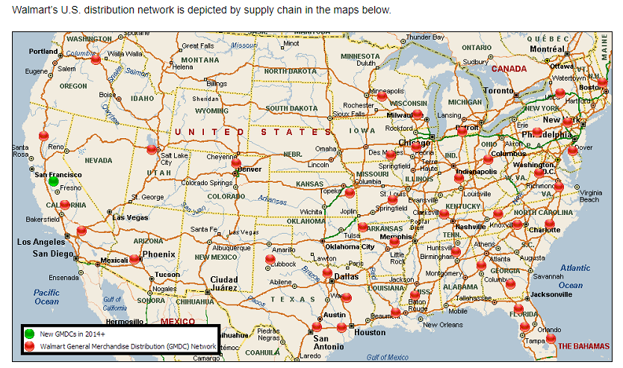
Efficient logistics plays a large part in Wal-Mart’s success, and it uses the “industry’s most efficient and sophisticated distribution system.” This includes high levels of automation, sophisticated communications, utilization of resources, and guaranteed availability of products. The logistics costs are so high that small improvements can have a considerable effect on profit. For instance, improving fuel consumption in their fleet of 7000 trucks by one mile a gallon would save more than US $50 million a year. In 2006 installing auxiliary power units in trucks that made overnight stops (meaning that the main engine could be turned off for longer) saved 10 million gallons of diesel fuel a year, US $25 million and 100,000 tons of carbon dioxide emissions.

Sources: Wal-Mart reports and websites at www.walmart.com, www.walmartstores.com and www.walmartfacts.com)

