**Task 1: Draw and fully label the economic cycle including labels for each stage of the business cycle**

**The Business Cycle**

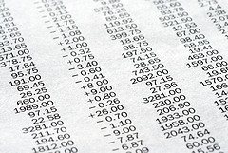

K: The share prices of leading industrial companies are rebounding



I: Home delivered pizza becomes more popular

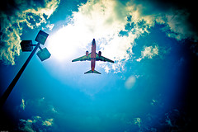

J: Rising business class air revenues boost profits of leading airlines

G: The number of shifts at leading car plants is cut

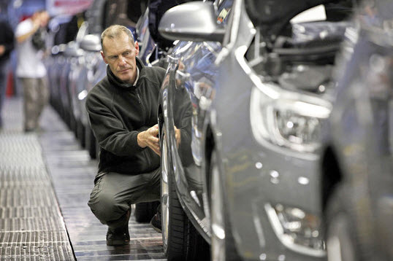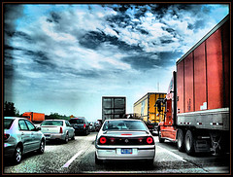

H: Consumers hit by delays in product delivery

F: Long-term unemployment reaches new high

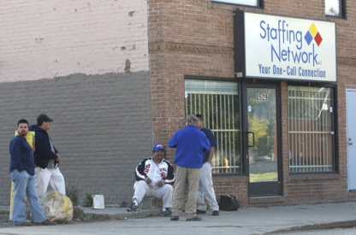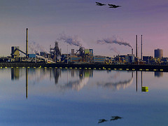

E: Rising demand for steel products

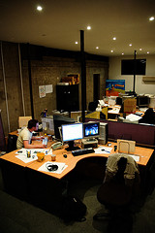

C: Increasing hours of overtime are worked

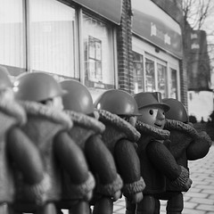

B: Reports that the number of new job vacancies is rising

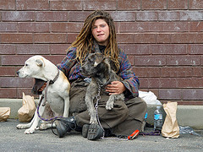

D: A growing number of people are counted as homeless

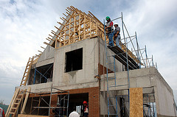

A: Builders decide to delay construction of new homes

**Task 2: Decide whether the following events are characteristics of an expansion, peak, recession, or depression/trough**

N. Government announces a fall in the trade deficit due to decline in imports

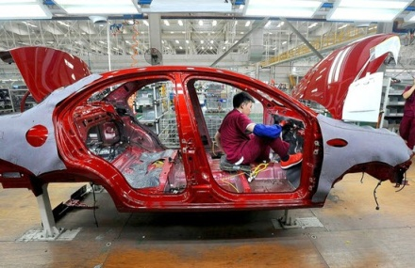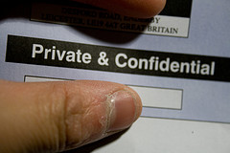

M: Real take-home incomes start to fall

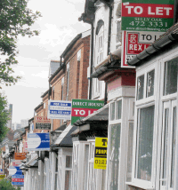

O: Supply of rented property exceeds demand



L: Rising lipstick sales

X: Recruitment agencies forecast a rise in new jobs from small businesses

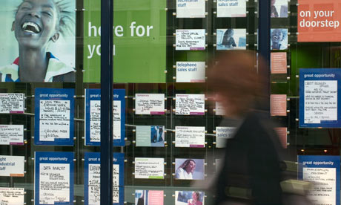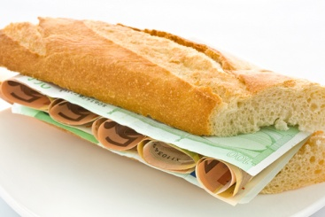

W: Shops delivering lunchtime sandwiches to offices raise their prices because of strong demand

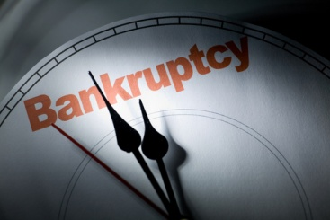

Y: More companies introduce wage freezes or wage cuts

V: Retails stores report an increase in demand for male suits

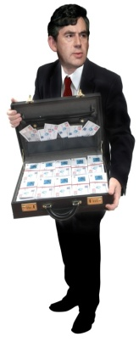

Z: Rising government spending on welfare benefits

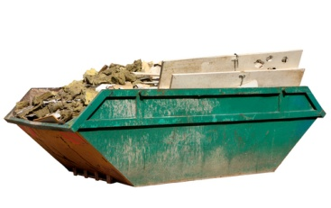

U: More building skips start appearing on the streets

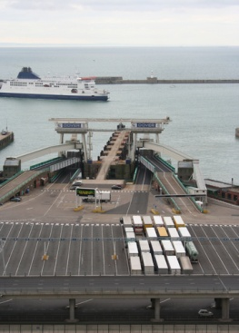

T: The cost of shipping goods around the world starts to rise

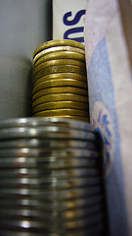

S: Banks relax their credit/ lending rules

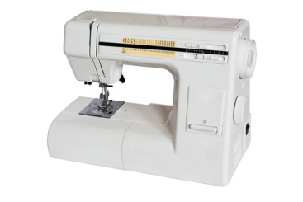

R: Imports of sewing machines rise

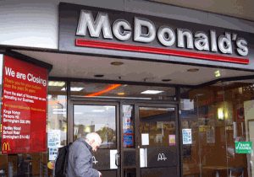

Q: McDonald’s holds prices despite a rise in ingredient costs

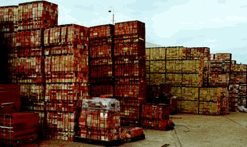

P: Brick manufacturers report a rise in unsold stocks

|  |  |
| --- | --- |
| Stage of the Business Cycle | Letter |
| Expansion |  |
| Peak |  |
| Recession |  |
| Depression/Trough |  |
|  |  |