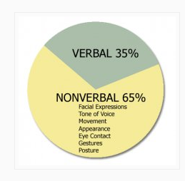
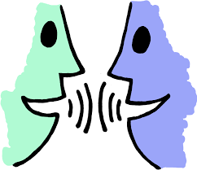
Verbal Communication
Activity: Verbal vs. Non-Verbal Communication
- Sharing of information between people using spoken words
- Main function is to relay a message to one or more people

Non-Verbal Communication
- Transfer of information through the use of body language—gestures,
facial expressions, posture, etc.
- Sets the tone of the conversation - can tell your mood and help others interpret emotions
