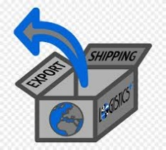
ACTIVITY: What is a Free Trade Zone?

Directions:
Research and answer the following questions on free trade zones. (Hint: Check the CBP website). Assignment is worth 80 points.

- What is the definition of a free trade zone/foreign trade zone?

- What are the advantages of using a free trade zone?

- What is the role of U.S. Customs and Border Protection in free trade zones?

- What can be placed in free trade zones?

- What may be done in free trade zones?

- What will be taxed in a free trade zone?

- Does Memphis have a free trade zone? If yes, where is it located?

- What are the economic benefits to Memphis to have a free trade zone?

