 | Activity: What State Am I? | 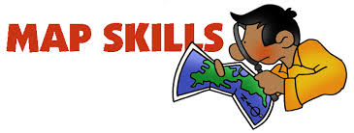

Name _______________________ Class ___
Directions
Using Google, research the questions below to determine which state they are referring to. Then label all the states on the U.S. map (label Memphis, TN, so you can get a good overview of locations). Assignment is worth 30 points.

 | Question | State
1. | Which state produces the most agriculture for the US?
2. | Which state is known for potatoes?
3. | Which state is known for oranges?
4. | Which state is known for peaches?
5. | Which state produces the most soybeans?
6. | Which state is known for the most oil reserves?
7. | Which state produces the most wheat?
8. | Which state produces the most cotton?
9. | Which state produces the most sugar?
10. | Which state produces the most corn?

