 | PROJECT: Where Do Those Pants Come From? | 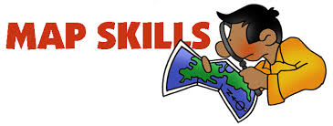

Name _______________________ Class ___
Directions
Today, clothing production is a complex global system of manufacturing and retailing. Using the world map below, follow the international journey of an order of pants. Mark the journey in different colors indicating trains, ships, trucks, and planes—provide a color key. Assignment is worth 50 points.

Step 1: Texas cotton is transported by train to Charleston, South Carolina. In Charleston, the cotton fibers are spun into yarn and then packed into a container. The container Is trucked to the Port of Charleston.

Step 2: At the Port of Charleston, the container is lifted from the truck and loaded onto a container ship, joining thousands of other containers. Traveling through the Panama Canal, it will journey for 24 days to Shanghai, China.

Step 3: In Shanghai, the container is trucked to a mill. The yarn is woven into fabric, dyed, and repacked in containers to be shipped by sea to the Maldives Islands, west of Southern India.

Step 4: After a 12-day sea journey, the fabric travels by truck to a factory in the Maldives to be cut into pieces. The completed pieces are brought to the airport and placed on a special cargo plane to Colombo, Sri Lanka. The flight to Sri Lanka (east of southern India) takes about 90 minutes.

Step 5: In Sri Lanka, the pieces are sewn into pants by factory workers. The finished pants are put into containers and loaded onto a container ship. They journey to Newark, New Jersey, taking 30 days (remember this is a sea journey).

Step 6: In Newark, New Jersey, trucks are loaded to deliver the product to destinations throughout the U.S.—including stores in Chicago, Il, Houston, TX, Memphis, TN, and Portland, OR.

