 | Activity: Which Continent Am I? | 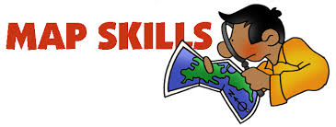

Name _______________________ Class ___
Directions
Please label all 7 continents and 5 oceans. Assignment is worth 24 points.
