Business Concepts Review Worksheet

Part I – Types of Businesses
Define and provide an example for each form of business.

Which Business Type is Best?
Read and discuss the client case with a partner. Then make a recommendation about what form of business organization you think is best. Be sure to state reasons to support your position.

Client 1
I am 16 years old and I love little kids. I like to organize special events—like birthday parties for children. I have decided that a great way to earn extra money is to provide families with children’s birthday parties for a modest fee. I do it all—arrange the food, supply the music, decorate the party room, play games, give away small prizes, even play the part of Bongo, the Birthday Clown. Families I know love the idea. I have an advertising plan figured out, with posters to put up at the local grocery stores.

What type of business organization do you recommend? Why?

Part II: Goods and Services
Read each scenario and write whether it is a good or service.

A good is something you buy and consume. Goods are things that you can keep, eat, or use to make other goods. They are tangible (can touch a good).
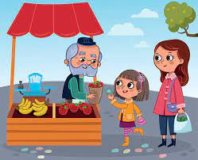
A service is something that someone does for you. Your hire people for services, but you are not buying something you can touch or hold. Services are intangible.
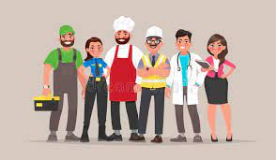

- You get your hair cut. ________________
- You buy a book from a garage sale. ________________
- You buy your mother a flower from a flower shop. ________________
- You hire someone to cut your lawn. ________________
- You visit the doctor for a check-up. ________________
- You purchase a game to give as a birthday gift. ________________
- You pay your sister $5.00 to clean your messy bedroom. ________________
- You buy an ice cream cone from a food truck. ________________
- You take an airplane when you go on a trip. ________________
- Your brother sells you his old baseball mitt for $10.00 ________________

- Give an example of someone purchasing a service. (Do not use an example from above).
________________________________________________________________________

- Give an example of someone purchasing a good. (Do not use an example from above).
_________________________________________________________________________

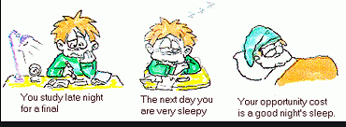
Part III: Scarcity and Opportunity Cost
Scarcity: When there is a limited amount of a given resource. Examples:
- A government works with a limited budget. The amount of the money that it has is scarce.
- A state has a limited number of acres of free land to build upon. The amount of land is scarce.

Opportunity Cost: What you give up when you have to make a choice between 2 things.
Examples:
- I have $15.00 to spend. I decide to buy a baseball cap instead of a book. The book represents the opportunity cost.
- A city government has $20,000 to spend. They decide to spend it on new job programs instead of on trash collection days. A clean environment is the opportunity cost.

Directions: For each of the following examples, underline what is scarce and circle the opportunity cost.

- Joey and Tanisha arrive to school thirty minutes early. Joey wants to go to the corner store. Tanisha wants to see if any of her teachers are at school early for extra help. They decide to go up to get extra help instead of going to the corner store.
- Jenny has $150.00 to spend at the mall. She decides to buy a pair of Nike shoes instead of saving the money in her bank account.
- The Memphis City Council has $1 million to spend in designing the upcoming budget. Council members decide to spend most of that money on new curriculum to be used in schools rather than repairing roads and bridges.

Directions: For each of the following scenarios, identify the opportunity cost by circling the correct choice.

- A city government decides to spend money on new stoplights instead of new textbooks for schools. What is the opportunity cost of this decision?
  - Protecting the safety of citizens b. Promoting the education of citizens

- A teacher decides to spend time grading homework assignments instead of making calls to parents. What is the opportunity cost of this decision?
  - Giving students feedback b. Communicating with parents

- The U.S. Congress spends money on supporting our military instead of on public assistance programs. What is the opportunity cost of this decision?
  - Our country’s national security b. Ensuring the welfare of all citizens

Part IV: Supply and Demand
Supply is the amount of goods available at a given time. If there is a lot of something available for sale, the supply is high. If there isn’t enough of something available for sale, the supply is low (there is scarcity).

Demand is how many people want the goods that are available. If many people want the goods available, demand is high. If there aren’t that many people who want the goods available, demand is low.

Directions: Jim and Kate own a farm. They have twenty hens that produce eggs. Jim and Kate sell the eggs to the local supermarket. Based on the information above, answer the following questions.

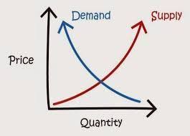
- In April, many people wanted to buy eggs for Easter. Was the demand for eggs higher or lower than normal? ____________________

- In June six of Jim and Kate’s hens were sick and could not lay eggs. Was the supply of eggs higher or lower than normal? ___________________

- In August, Jim and Kate bought ten more hens. Did this cause the supply of eggs to go up or down? _______________________

- October was National Pancake Month. Because of this, many people stopped buying eggs. Did this cause the demand to go up or down? _____________________

- Do you think Jim and Kate prefer for demand to be low or high? Explain. _____________________
_________________________________________________________________________________
_________________________________________________________________________________

- If most of the hens stop laying eggs and eggs become scarce, what will probably happen to the price of eggs? Explain. ___________________________________________________________________
_______________________________________________________________________________

