A Supply Chain Makeover for Sephora:
How the Beauty Retailer Reduced Inventory Levels,
While Improving Customer Service

What is important to retailers? The obvious answer is the customer. The not so obvious answer is getting the right merchandise (planning and assortment), to the right store (allocation), with the right quantity (allocation), at the right time (supply chain effectiveness) and at the best-managed cost (supply chain efficiency). This was Sephora’s goal when the $2+ billion-a-year omni-channel, specialty beauty retailer engaged enVista. The retailer wanted to know how to improve in-store service and sales, while maintaining or reducing total inventory working capital. Sephora engaged enVista’s retail supply chain consultants to evaluate their supply chain from source to consumption, improve customer service and manage total supply chain costs.

The Opportunity
A retail leader, Sephora operates 260+ U.S. stores and a thriving e-commerce business from two regional distribution centers (DCs) in the U.S. At any given time, each store carries around 9,000-plus unique SKU items across three major departments (color, fragrance and skin care). At the distribution centers, there are over 14,000 individual SKUs stocked to replenish the stores and additional SKUs to fulfill online orders. The stores operate 364 days a year, and like most specialty retailers, sales
predominantly occur on Fridays, Saturdays and Sundays (>55%). Only two dozen stores, located in major metropolitan cities, have rather stable sales demand during the week. Overall demand is generally predictable, with expected peaks before the holidays, such as Christmas, Valentine’s Day and Mother’s Day.

Like any retailer, Sephora’s goal is to provide superior customer service. The company takes great pride in exceeding customer expectations and delivering a personalized, memorable experience. To enhance its store experience, the company trains its “cast members” to the extent that they are not only knowledgeable about Sephora’s merchandise, but are also skilled at providing guidance to shoppers with respect to skin
care, color and fragrance.

Within its supply chain operations, the company took steps to ensure customer satisfaction by having the right product, at the right location, at the right time, in order to maintain high inventory stock percentages and service levels. However, for
Sephora, like most retailers, this translated into carrying excessive inventory levels and positioning product at every available location, thereby tying up both excess space and working capital. The opportunity, therefore, was to plan and forecast over 2.5M SKU and location combinations (top down and bottom up).

enVista’s Solution
Sephora and enVista began by assessing Sephora’s operations. The team identified opportunities to improve reaction times (the item replenishment cycle time from DC to store shelf) and determined the optimal inventory levels for Sephora’s stores, back storage rooms and two regional DCs. As mentioned, the retailer had inevitably been stocking excessive inventory due to a series of ineffectively managed variables within their supply chain. enVista mapped out a plan to analyze the impact of each supply chain variable and correlate the variables to either
improved service or reduced working capital (inventory).
Inventory Management Unit|Student Handout #4
Page 1

The team utilized Llamasoft’s Supply Chain Guru and Product Flow solution to analyze Sephora’s inbound and outbound flow between all nodes of Sephora’s supply chain network, as well as the inventory levels at all storage locations (stores
and DC) throughout a one-year planning horizon. The analysis demonstrated that Sephora not only carried excess inventory, but also carried excess inventory at the wrong time and locations (DC and stores) due to purchasing practices that were disconnected with forecasted demand (reference Illustration 1). This disconnect was causing Sephora to carry excess inventory for longer periods at the DC and the stores, thereby increasing the total average inventory on hand. Complicating matters, Sephora had recently increased the number of shipments to their higher selling stores without adjusting their store order quantity levels based upon new and improved replenishment frequencies and transit times. The improved store replenishment frequency had a number of unintended consequences: (1) the back stock rooms in the stores filled up very quickly, (2) offsite storage was required to manage the excess inventory, and (3) the over allocated inventory was shipped back to the DC.
Note: increased inventory does not always equate to better
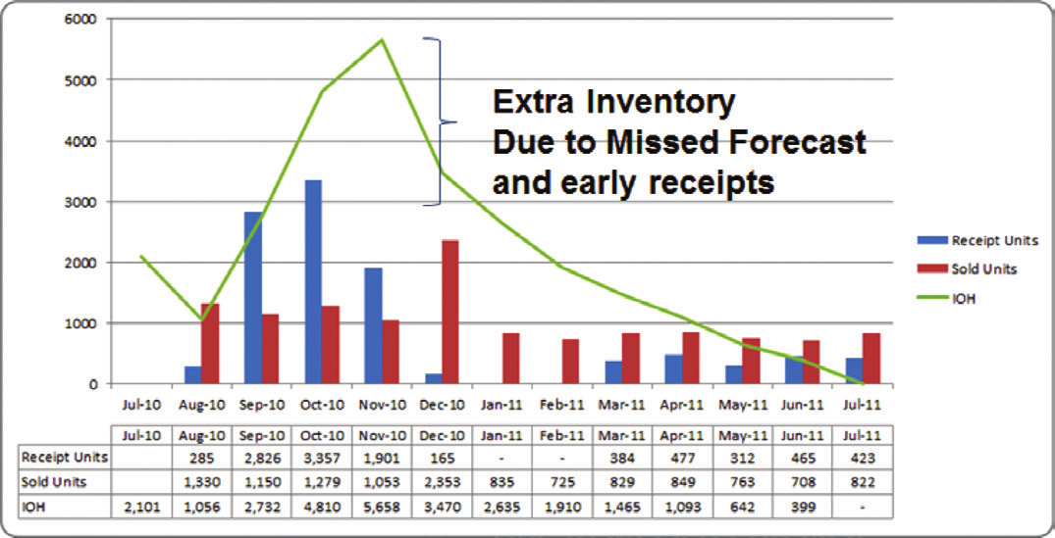
service and improved sales.
and simulation to better understand how supply chain variability (supply and demand), order policies, forecasting techniques, lead times, and order frequencies impacted both service and cost. The solution design required both a static network model
(least cost modeling) and simulation in order to understand how inventory was impacted by the network design. A key goal for any retailer is to improve comparative store sales while maintaining gross margin. The enVista team had to model the
supply chain network (DC placement, pool point placement and transportation costs), while simulating inventory to understand how each variable impacted in-stock percentages and total costs.
From Source
Sephora retail planners were accustomed to creating monthly purchase orders regardless of supply and demand variability. Many of Sephora’s vendors are located in the US with less than 14-day lead times. The purchase order review periods were set within Sephora’s JDA E3 replenishment system.
The review period for a vendor was configured to 14 to 21 days; however, the planners (buyers) ordered in bulk, which amplified safety stock in both DC and stores. Additionally, it was determined that vendor fill-rates were less than 85 percent, causing high variability and increased safety stock levels. enVista recommended establishing a vendor performance management (VPM) program focused on increasing fill percentages and ensuring that Sephora’s vendors complied
with the established ship windows set by the planners.

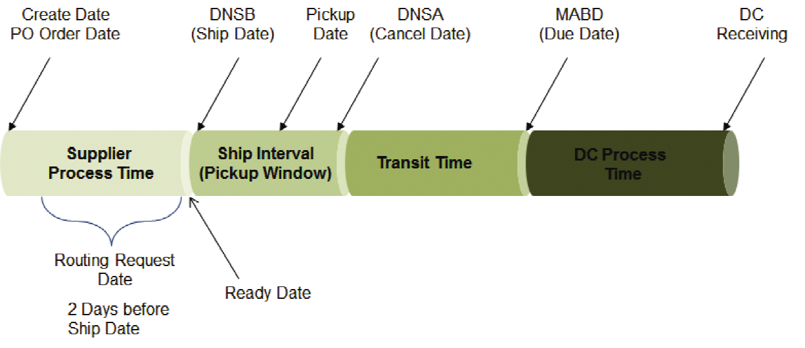
Illustration 1

enVista needed to examine the variables that caused the excess Illustration 2 inventory flow through the network throughout the year and
Inventory Management Unit|Student Handout #4
Page 2

determine which variables impacted inventory reduction while improving service. The enVista team used advanced analytics

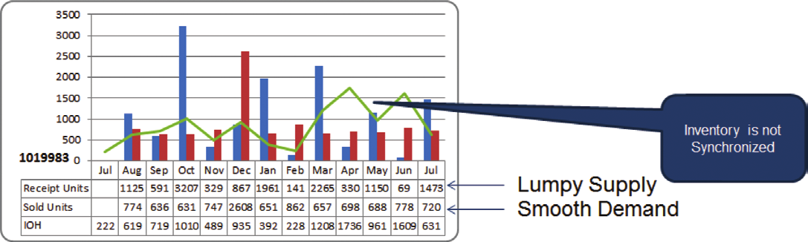
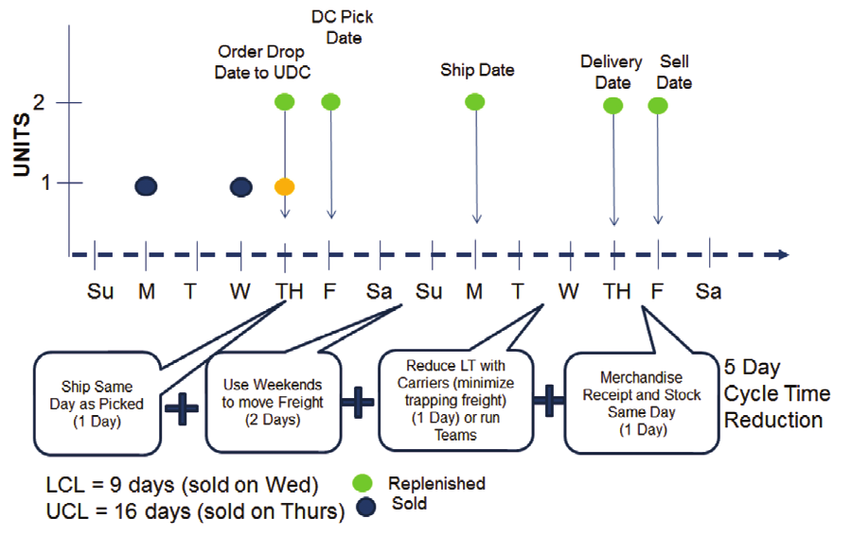

The analysis determined that Sephora’s forecasts for new items were not based upon a discrete SKU |Location forecast. The planning team used an average storage demand and applied an average forecast curve across the retail store chain. By using a rolled-up average, the planning team’s forecast accuracy
was less than 55 percent from Vendor to DC, whereas the forecasting accuracy for DC to Store (allocation) was greater than 80 percent. Traditionally, the forecast accuracy would be reversed. Sephora has a replenishment (I/O) solution but does not have an integrated planning and forecasting solution for new SKUs. Therefore, when the SKU|Location was sold out, many times there was no buffer inventory at the DC to replenish the store. enVista recommended that Sephora evaluate, select and implement an integrated Merchandise Planning, Assortment and Forecasting solution for new SKU introductions and use one forecasting solution for both new and replenishment items, thereby eliminating the need to “reconcile” forecast.

Illustration 3

To Distribution Center
Within any retailer’s supply chain there are always unintended consequences; in Sephora’s case, their purchasing practice (monthly buys and open to buy) caused operational bottlenecks at their distribution centers. The lack of visibility (ASNs and Inbound Transportation) made it difficult to plan receiving labor. In addition, the monthly open to buy (OTB) created a hockey stick, with 80 percent of all inbound shipments being received in the first week of the month and the remaining 20 percent of the inbound inventory being received in weeks two through four. enVista recommended that Sephora require an advance ship notice (ASN) from all vendors as a part of its vendor compliance
program to reduce quality assurance inspection and improve
dock to stock performance. Secondly, enVista recommended that Sephora eliminate monthly OTB and move to a bi-weekly OTB schedule, adding additional metrics, including: inventory turns, inventory turnover, forecast accuracy, DC fill percentage and in-store stock percentage.

To Consumption
With the exception of large volume A+ stores, Sephora’s stores were replenished once a week, creating a number of service challenges for a large percentage of stores. First, higher volume stores were especially impacted by one large weekly shipment. Once per week shipments created store operational challenges, back stock room overflow and longer than desired reaction time. In some cases, it could take as many as 16 days to put a SKU back on the shelf (reference Illustration 4). Second, medium to higher volume stores, especially the ones that had a longer lead time from the DC, had to keep more safety stock to cover themselves until the next delivery arrived. As a result, enVista recommended that the medium and higher volume stores replenish inventory more than once a week. The increased delivery frequency improved the total reaction time and allowed Sephora to reduce safety stock, while improving service to their stores. This change in strategy allowed Sephora to replenish over 60 percent of their stores in the same week and replenish items before the next selling weekend.

Inventory Management Unit|Student Handout #4
Page 3

Illustration 4 – Total Reaction Time

The stores preferred the smaller shipments for the following reasons: 1) smaller shipments required less operational labor to receive and stock the store, and 2) the smaller shipments
reduced back stock room overflow. However, the largest impact was improved in-stock percentage for SKUs with high demand variability (forecast accuracy is improved with reduced cycle time). The high volume, high sales items comprised 50 percent of revenues and 5.5 percent of the SKU count. As a result, the cycle stock requirement for high velocity/low variability (CV) SKUs was increased, while low velocity/high variability (CV) items were set closer to their presentation quantity (PQ). The improved reaction time allowed Sephora to set “order up to levels” closer to their PQ, which allowed the retailer to reduce inventory, without impacting service. In summary, the lead time reduction, both from the vendor to the DC and from the DC to the store, increased inventory turns and decreased the level of average inventory on hand.

Connecting the Dots
Although the variables that impacted Sephora’s inventory levels listed above were easily identifiable, the delicate equilibrium between those variables was not easy to accomplish (theory
vs. practice). Numerous scenarios were evaluated with the use of simulation in order to find the balance between improved service levels and total “managed” supply chain costs (reference Illustration 5). The simulation results produced a theoretical
21 percent reduction in total inventory working capital by balancing each supply variable from source to consumption.

During the simulation, enVista’s retail consultants made different changes to the variables for distinct SKU classes to understand the sensitivity of the network models. Eventually, the outcome of the scenarios for each SKU category were applied to the
rest of the SKUs’ average inventory on hand values to estimate
inventory carrying costs savings.

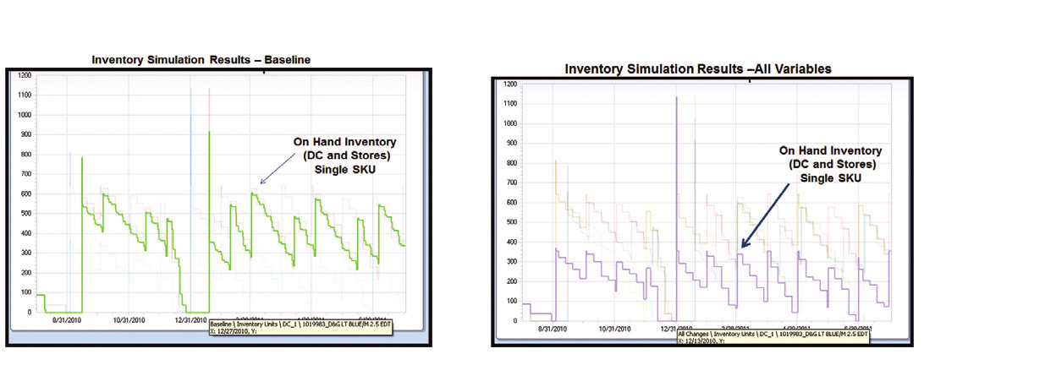Illustration 5

In order to synchronize a supply chain from source to consumption ALL variables must be considered simultaneously. Making a change to a downstream process (increased store shipment frequency) in isolation can have unintended consequences. Retailers must first understand which
variables impact cost and service and then change each variable in unison, not in isolation. Making small incremental improvements that are calculated and focused will drive long-term improvements.

The Results
As a result of the project Sephora has reduced inventory levels (safety stock) and improved inventory allocation and velocity (speed to market). Sephora has selected a new Merchandise Planning and Forecasting solution (JustEnough). The incremental improvements have ultimately enabled Sephora to better
serve its customers, capitalize on more sales opportunities,
and improve both brand loyalty and competitive advantage.

For more information on enVista’s services, please call 877-684-7700 or contact
info@envistacorp.com

Inventory Management Unit|Student Handout #4
Page 4

enVista | 11711 N. Meridian St, Suite 415 | Carmel, IN 46032 | 877.684.7700 | www.envistacorp.com
C37 Copyright © enVista, LLC
Sephora Case Study Instructions
- Provide a 2-paragraph overview of the company, its’ products, and its’ customer base (https://www.sephora.com/about-us)

- Answer the following:
  - The Challenge
  - The Solution
  - The Results

Inventory Management Unit|Student Handout #4
Page 5

