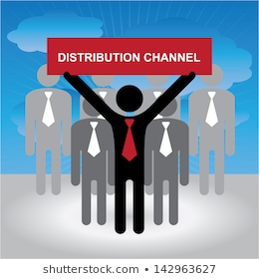

CHANNELS OF DISTRIBUTION UNIT INSTRUCTIONS

Course
Foundations of Supply Chain Management

Objectives
- Students will examine channels of distribution for manufacturers, retailers, and service
- Students will identify channel members and describe how materials flow from each type of facility
- Students will differentiate between various types of facilities—office buildings, factories, package handling centers, warehouse or fulfillment centers, cross-dock facilities, and bulk break centers
- Students will examine the use of cold chain and blockchain in the supply chain
- Students will analyze issues in global distribution

TN State CTE Standards
Components of Supply Chain Management #14: Examine the various types of facilities involved in the supply chain of each type of business: manufacturer, retailer, and service. Describe how materials and information feed into and flow from each type of facility in an illustrated paper. Include the following categories, as well as hybrid facilities where these categories overlap: a. office buildings/management headquarters, b. factories, c. package handling center, d. warehouse or fulfillment center, e. cross-dock facility, and f. bulk break center.

Essential Questions
- What are the different types of channels of distribution?
- What is the difference between the major channel members?
- How does material flow from each type of facility in the supply chain?
- What is cold chain and how is it incorporated into the supply chain?
- What advantages does block chain add to the supply chain?
- What are key issues in global distribution? How has it changed during the Covid-19 pandemic?

Duration
2 weeks

ACTIVITIES
Assignment | Due  Date | Date Completed | Grade
Channels of Distribution PPT
Glossary: Channels of Distribution Unit
Quiz – Channels of Distribution (Quizziz)
Activity: Facilities Used in Flow of Materials
Reading: The Changing Logistics of Grocery Delivery
DECA Connection Role Play – Channels of Distribution
Activity: Marketing Channels for Consumer Products
Activity: The Green Marketer
Project: Wayback is About to Disrupt Delivery as We Know It
Case Study: Journey’s Group
Reading: The Big Chill: 10 Trends in Cold Chain Logistics
Case Study: The Beauty of Global Logistics
Project: Global Distribution in Diverse Cultures
Unit Exam: Channels of Distribution

