Supply Chain Logistics

Supply Chain Logistics

Foundational Knowledge:
For Frontline Workers

Chapter 1: Global Supply Chain
Logistic

Chapter 2: The Logistics Environment

Chapter 3: Material Handling Equipment

Chapter 4: Safety Principles

Chapter 5:
Safe Material Handling & Equipment Operation

Chapter 6: Quality Control Principles
OvERvIEW OF CHAPtER

The purpose of this chapter is to explain logistics safety. In addition to the basic concepts of safety learned in Chapter Four, frontline material handling workers need to know safety principles specifically related to material handling and equipment operation. This chapter will introduce the most common safety measures used in logistics facilities when handling materials.

ObjECtIvES
When you have completed this chapter, you will be able to do these things.

1. List basic safe material handling practices

2. Identify types, functionality and use of personal protective equipment

3. List equipment safety features

4. Describe the two basic types of maintenance

Chapter 7: Work Communication

Chapter 8: Teamwork & Good Workplace
Conduct to Solve Problems

Chapter 9: Using Computers

Supply Chain
Logistics Chapter 5

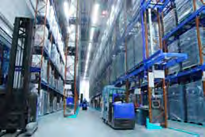
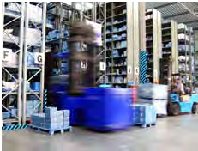
basic Safe Material Handling Practices

Logistics workers must be knowledgeable and cautious about handling materials in all facilities within the logistics supply chain. Most of the materials are heavy, and some may be hazardous.

Various types of equipment are used in material handling. The simplest systems being manually operated equipment. Large operations generally require power equipment, the most common being the forklift truck. The modern forklift is a
versatile piece of equipment with a number of fork replacement attachments enabling it to perform
a wide variety of functions.

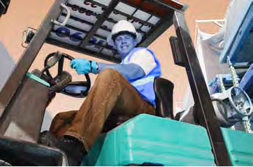
Vendors that make material handling equipment are responsible for providing detailed safety information. Workers must be well trained on the use of any piece of equipment that they may operate, including the safety processes involved in using the equipment.

Despite the increased use of automation and mechanical handling equipment in distribution centers and warehouses, there are still many potential hazards involved. The increased speed of operation required in modern logistics facilities has also created a new set of hazards.

Some of the hazards that are still very common include manual handling injuries, vehicle reversing incidents, unstable racking and personnel slipping, tripping and falling. This chapter focuses on safety processes related to manual material handling.

Page 64 | CLA: Foundational Knowledge: Chapter 5 - Safe Material Handling & Equipment Operation

Chapter 5

Definition
According to the U.S. Department of Labor, manual material handling is defined as: “Seizing, holding, grasping, turning or otherwise working with the hand or hands. Fingers are involved only to the extent that they are an extension of the hand, such as to turn a switch or to shift automobile gears.”1 In this text, man-ual material handling means that the worker’s hands move individual containers or products manually by lifting, lowering, filling, emptying or carrying them.

Safety Issues Related to Manual Material Handling
Manual handling of containers may expose workers to physical conditions (e.g., force, awkward postures and repetitive motions) that can lead to injuries, wasted energy and wasted time. To avoid these problems, companies can directly benefit from improving the fit between the demands of work tasks and the capabilities of its workers. The variation in workers’ abilities to perform work due to differences in age, physical condition, strength, gender and stature affect that fit.

Ensuring a good fit between tasks and capabilities can greatly benefit the workplace by:

• Reducing or preventing injuries

• Reducing workers’ efforts by decreasing forces in lifting, handling, pushing and pulling materials
•Reducing risk factors for muscle and bone disorders (e.g., awkward postures from reaching into containers)
•Increasing productivity, product and service quality
and worker morale
Supply Chain Logistics

•Lowering costs by reducing or eliminating material handling bottlenecks, error rates or rejects, medical treatment, workers’ compensation claims, excessive worker turnover, absenteeism and retraining

What to Look for
Manual material tasks may expose workers to physical risk factors. If these tasks are performed repeatedly or over long periods of time, they can lead to fatigue and injury. The main risk factors, or conditions, associated with the development of injuries in manual material handling tasks include:
FPO

•Awkward positions (e.g., bending, twisting)

•Repetitive motions (e.g., frequent reaching, lifting, carrying)
•Forceful exertions (e.g., carrying or lifting heavy loads)
•Pressure points (e.g., grasping or contact from loads, leaning against parts of surfaces that are hard or have sharp edges)
•Static postures (e.g., maintaining fixed positions for a long period of time)

Repeated or continual exposure to one or more of these factors initially may lead to fatigue and
discomfort. Over time, injury to the back, shoulders, hands, wrists or other parts of the body may occur. Injuries of this type are known as musculoskeletal disorders, or MSDs.

In addition, poor environmental conditions, such as extreme heat, cold, noise and poor lighting may
increase workers’ chances of developing other types
of problems.

CLA: Foundational Knowledge: Chapter 5 - Safe Material Handling & Equipment Operation | Page 65

Supply Chain
Logistics Chapter 5

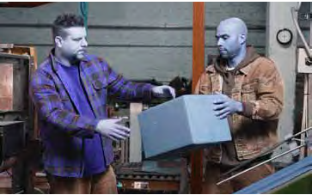
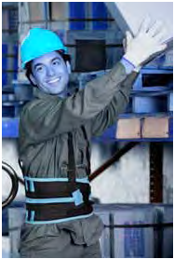
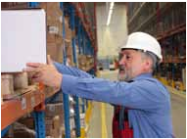
training
Workers need training and hands-on practice with new tools, equipment or work practices to make sure they have the skills necessary to work safely. Training is most effective when it is interactive and fully involves workers. Below are some suggestions for training for safer manual material handling training:2

•Provide hands-on practice when new tools, equipment or procedures are introduced
•Use several types of visual aids (e.g., pictures, charts, videos) of actual tasks in the workplace
•Hold small-group discussions and problem-solving sessions
•Give workers ample opportunity for questions

Employee Guidelines for Safer Lifting and Carrying

•Stretching is an appropriate part of a comprehensive ergonomic program. However, stretching must not be used in place of engineering and/or administrative improvements.
•Check for tags on loads.

•Always test the load for stability and weight.

•For loads that are unstable and/or heavy, follow management guidelines for:
- Equipment use
- Reducing the weight of the load
- Repacking containers to increase stability
.

•Plan the lift:
- Wear appropriate shoes to avoid slips, trips and falls.
- If wearing gloves, choose a size that fits properly. Depending on the material and the

Page 66 | CLA: Foundational Knowledge: Chapter 5 - Safe Material Handling & Equipment Operation

Supply Chain Chapter 5 Logistics

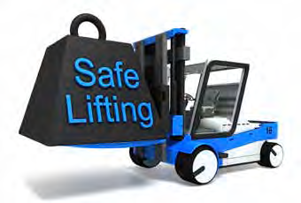
number of pairs worn at once, more force may be needed to grasp and hold objects. For example, wearing a single pair of heat-resistant gloves can reduce your grip strength up to 40 percent. Wearing two or more pairs of gloves at once can reduce your grip strength up to 60 percent.
- Lift only as much as can be safely handled alone. - Keep the lifts in the power zone (i.e., above the
knees, below the shoulders, and close to the body), if possible.
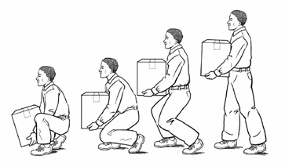
- Use extra caution when lifting loads that may be unstable.
•When lifting:
- Get a secure grip.
- Use both hands whenever possible.
- Avoid jerking by using smooth, even motions.
- Keep the load as close to the body as possible.
- To the extent feasible use legs to push up and lift the load, not the upper body or back.
- Do not twist the body. Step to one side or the other to turn.
- Alternate heavy lifting or forceful exertion tasks with less physically demanding tasks.
- Take rest breaks.

• Avoid lifting from the floor whenever possible.
If a load must be lifted from the floor, do not bend at the waist.
• Use team lifting; mechanical assistance; a turntable; or other lifting and carrying assistance if available.
• Work within the power zone. Raise or lower the work surface.
• Store heavier or bulkier containers so that they can be handled within the power zone.
• Use angled shelving to improve access to containers.

CLA: Foundational Knowledge: Chapter 5 - Safe Material Handling & Equipment Operation | Page 67

Supply Chain
Logistics Chapter 5

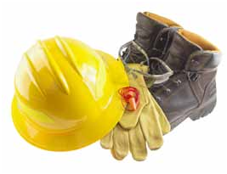
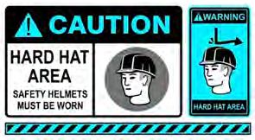
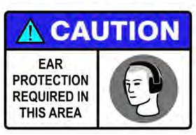
• Hold the container close to the body.

• Add extra handles for better grip and control.3

Personal Protective Equipment

Occupational Safety and Health Administration (OSHA) Requirements OSHA’s Personal Protective Equipment (PPE) standard ensures the use of gloves, safety goggles
and hard hats—items that directly affect warehouses and distribution centers. Employers are required by the standard to perform a hazard assessment at the workplace to determine if employees should wear PPE. If so, the employer must put that requirement in writing, select the proper PPE and see that employees use it.

Any employee working in an area that the employer has determined to need PPE must receive training on what PPE is required, when it should be used, how
to wear and adjust the PPE and how to maintain and dispose of the PPE. The employer must then certify that the employee has received and understands the training.4

types of PPE Head Protection
Falling objects, water, dirt and sparks can be a danger in supply chain logistics facilities. Protective helmets, usually called hard hats, protect against these hazards. Insulated hard hats offer additional protection. They are designed for workers exposed to electrical shock hazards.

Page 68 | CLA: Foundational Knowledge: Chapter 5 - Safe Material Handling & Equipment Operation

Chapter 5

Hand & Arm Protection
Burns, cuts, pinches and chemical or biohazard exposure are hazards that prompt hand and arm protection. Different types of gloves protect hands from specific hazards. Some protect against chemicals or electrical shock. Cut-resistant gloves protect against sharp tools or materials such as metal, glass or abrasive materials.

Lung Protection
Some airborne dust, fiber and particles put workers at risk for lung injury and illness. A dust mask, which is worn over the lower part of the face, filters out large particles. A respirator includes a face piece, hood or helmet with a replaceable cartridge. It filters smaller
particles and dangerous fumes from the air.5
Supply Chain Logistics

Foot Protection
The most common PPE is steel-toed boots. These are rugged shoes usually made of leather or a strong synthetic fiber. They have a steel plate in the front part of the boot that covers the front part of the foot. Even when every precaution has been taken, acci-dents do happen, and quality work boots can protect feet from falling or dropped items.

Eye/Face Protection
Safety goggles are used to shield the eyes from heat and impact hazards, chemicals and dust. Goggles should form a protective seal around the eyes, preventing objects or liquids from entering under or around the goggles. When fitted and worn correctly,
goggles protect your eyes from hazardous

Supply Chain
Logistics Chapter 5

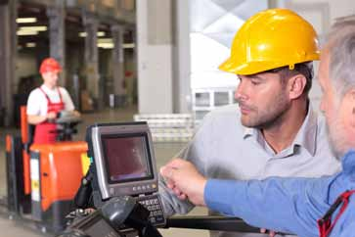
substances. A face shield may be required in areas where workers are exposed to severe chemical hazards. Safety goggles may incorporate prescription lenses mounted behind protective lenses for individuals requiring vision correction. Take time to consider specific lens, frame, and ventilation options when selecting safety goggles.

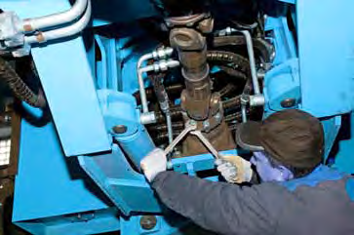
These workers are performing an equipment safety check.
Ear Protection
OSHA regulations require ear protection and annual training to be provided to employees who are exposed to noise at or above 85 decibels for an average 8-hour day. Ear protection can be in the form of earplugs that fit in the outer ear canal and form an airtight seal or earmuffs that fit over the entire outer ear to form an airtight seal (they will not seal around eyeglasses or long hair). Properly fitted earplugs
and earmuffs reduce noise levels 15 to 30 decibels. In extremely noisy conditions, it may be necessary
to wear earplugs and earmuffs together.

Safety Checks

Safe use of material handling equipment and loading equipment is important in any logistics system. Misuse of this equipment can be costly or even
This worker is performing maintenance on a heavy loader. deadly. For example, one expert noted “in the United States, over 1,000 warehouse employees died from forklift-related incidents between 1980 and 2004.”6 One way of ensuring that equipment is safe is to monitor equipment regularly for any malfunction
or hazard.

Material handling equipment must be regularly maintained and checked to ensure that workers are not injured when operating or working near the
equipment. Depending on the frequency of use and potential dangers, safety checks may need to be

Page 70 | CLA: Foundational Knowledge: Chapter 5 - Safe Material Handling & Equipment Operation

Chapter 5

performed daily or before each operation. Many of the vehicles and machinery used by
logistics workers require training before operation
of the equipment. The company or the manufacturer of the equipment usually provides this training.
The manufacturer is responsible for providing safe operation information, and employers are responsible for ensuring that workers have sufficient understand-ing of how to operate the equipment safely. It is important that front-line workers do not operate equipment unless they have been trained to do so.

Equipment Safety Features
Logistics equipment may have safety features
or you may need to employ safety devices before operating the equipment.

Restraints
Once trucks are positioned at the dock they must be restrained from further movement by means of wheel chocks or trailer restraints.

Communication lights
Similar to traffic signals seen on the street, communication lights can be either a two or three light device. They operate in pairs with one set
of lights stationed on the interior warehouse wall at the dock doors and another set of lights on the exterior wall near each loading dock door.7

Interior communication lights
These lights serve to notify warehouse personnel of the location of trucks and railcars relative to the doors of the warehouse. Operated by personnel or by photo eyes, they register a vehicle’s presence at the loading dock door or if the vehicle has been pulled away. A red light typically signals to the
operator of a lifting device that there is no vehicle
Supply Chain Logistics

at the floor. A green light signals that there is
a vehicle waiting and that it is safe to open the door.8

Exterior communication lights
A green light on the exterior door signals that it is safe to dock the vehicle. A red light signals the person positioning the vehicle that there is a reason not to pull up to or station a vehicle at that door.9

Capacity rating
Each type of equipment has a capacity limit based on weight and/or volume. Racks, for example, are given a capacity rating based on the strength of the components of the rack system. Placing too heavy or too large a load on a section of pallet rack is a safety risk to personnel because the rack may fail and fall. Damage may also occur to the product housed on the pallet rack.

Audible alarms
In addition to communication lights, some doors are equipped with alarms that sound when the door is about to open or close to warn workers to stand
clear. Many powered material handling and transport vehicles are also equipped with back-up beepers.

Maintenance

In order to ensure safety and cost effective operations, routine maintenance must be performed on all types of logistics equipment. There are two basic types of maintenance, corrective and
preventive.

Supply Chain Logistics

Terms To Know

Corrective maintenance
The maintenance required to restore an item to a satisfactory condition.

Material handling
The movement of items from one point to another inside a facility or between facilities.

Personal Protective Equipment (PPE) Equipment worn by workers to protect them from harm, including steel toed boots, gloves, goggles, ear plugs, etc.

Preventive maintenance
The activities, including adjustments, replacements, and basic cleanliness, that forestall machine breakdowns.
The purpose is to ensure that production quality is maintained and that delivery schedules are met. In addition, a machine that is well cared for will last longer and cause fewer problems.

Chapter 5

Corrective Maintenance
This is also known as equipment repair. It is dealing with a malfunction or failure after it has occurred.

Preventive Maintenance
Preventive maintenance is the care and servicing of equipment to ensure satisfactory operation and to provide for early detection of possible failures, defects or hazards. It usually involves scheduled maintenance checks to prevent a breakdown or malfunction before it occurs.

Operating Equipment Checklists
One form of preventive maintenance is an operating checklist. Logistics equipment must be maintained on a daily basis. An effective method of ensuring that all equipment is operating properly is to have an operator examine the machinery prior to use each day according to a predetermined checklist
of critical items. The manufacturer of the equipment or the employer will usually provide a checklist
that needs to be used for a particular piece of equipment at the beginning of each day or shift.

Safety and maintenance checks will vary based on the type of equipment: whether it is manually-or machine-powered and the size and traffic volume of the equipment are factors that influence
what checks must be performed.

Below is a sample checklist for a forklift operator. In larger companies, a maintenance crew rather than the equipment operator may perform some of these checks.

Page 72 | CLA: Foundational Knowledge: Chapter 5 - Safe Material Handling & Equipment Operation

Supply Chain Chapter 5 Logistics

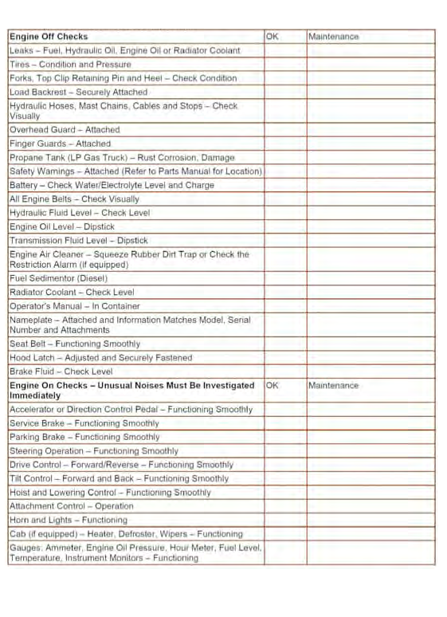
Safety and Operational Checks (Prior to each shift) Have a qualified mechanic correct all problems

All operators must be trained and evaluated on the types of industrial trucks and attachments they will be operating.

