Supply Chain Logistics

Foundational Knowledge:
For Frontline Workers

Chapter 1: Global Supply Chain
Logistic

Chapter 2: The Logistics Environment

Chapter 3: Material Handling Equipment

Chapter 4: Safety Principles

Chapter 5:
Safe Material Handling & Equipment Operation

Chapter 6: Quality Control Principles

Chapter 7: Work Communication

Overview of Chapter

The purpose of this chapter is to provide an overview of the most common safety features
and practices used in material handling operations. Employers and employees have responsibilities when it comes to safety. This chapter will explain safety practices and procedures used in modern logistics facilities.

OBJECTIVES
When you have completed this chapter, you will be able to do these things.

1. Identify the principle federal safety organizations and their fundamental requirements

2. Identify characteristics of a safe, clean and orderly work environment

3. List emergency safety procedures

4. List common safety markings and signs

5. List types of fire extinguishers

Chapter 8: Teamwork & Good Workplace
Conduct to Solve Problems

Chapter 9: Using Computers

Supply Chain
Logistics Chapter 4

Federal Safety organizations & Requirements

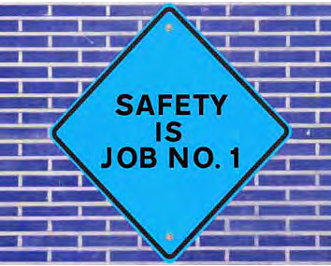
Government agencies play an important role in workplace safety. They develop standards, conduct research and help educate the public. Most of the safety practices described in this chapter are based on government standards.

oSHA
The Occupational Safety & Health Administration (OSHA) is the primary federal government agency devoted to workplace safety. OSHA was established in 1970 by the U.S. Department of Labor to “assure safe and healthful working conditions for working men and women.” OSHA develops guidelines and issues regulations for safety and health standards and conducts inspections of workplaces for compliance with these standards.

OSHA sets and enforces thousands of safety standards. These cover everything from using ladders safely, to noise control, to storing hazardous materials. To ensure that these standards are met, OSHA officials inspect workplaces periodically. Employers can be fined or imprisoned for violating OSHA standards.

OSHA rules make a difference. Since OSHA was created, workplace deaths have been reduced by over half. Supply chain logistics material handling operations must comply with all health, safety and
environmental policies and procedures defined by OSHA. Safety is everyone’s responsibility.
OSHA standards set only the minimum requirements. Supply chain logistics facilities may use additional guidelines from other government agencies or professional organizations.

Page 46 | CLA: Foundational Knowledge: Chapter 4 - Safety Principles

Chapter 4

USDot
The U.S. Department of Transportation (USDOT) is the primary federal regulatory body for transportation safety. Although USDOT’s safety responsibilities encompass all modes of transportation, the U.S. Coast Guard regulates safety of inland water carriers.

A current example of USDOT safety rules that directly affect logistics operations are the hours-of-service (HOS) safety rules. Effective January 2004, USDOT changed rules that had been in effect since 1939. The changes permit commercial motor vehicle drivers more time and opportunities for quality rest and restorative sleep to reduce the number of crashes caused by fatigued drivers.

FAA
The Federal Aviation Administration (FAA) has the primary responsibility for developing and enforcing air transportation rules and strives to improve the safety and efficiency of aviation. FAA issues various regulations related to air cargo handling around and within aircraft.

other Federal Agencies
There are other federal agencies that have responsibilities related to the safe handling and movement of materials including:

• The Federal Motor Carrier Safety Administration (FMCSA) of USDOT is primarily focused on safety regulations for large trucks and buses. A recent FMCSA report on accidents involving large trucks indicated that driver behavior was much more likely than weather, road conditions or equipment factors
to cause these accidents.
Supply Chain Logistics

•The Federal Railroad Administration (FRA) has primary responsibility for safety in the U.S. railroad industry. FRA employs over 400 safety inspectors who investigate operating practices, tracks and structures, signal and train control issues, among others.
•The Environmental Protection Agency (EPA) is the federal agency that develops and enforces regulations protecting the land, air and water.
EPA sets standards that directly affect the industrial workplace, including the disposal and handling
of hazardous materials.

•The National Institute for Occupational Safety & Health (NIOSH) studies the causes of workplace injuries and illnesses and develops ways to help control hazards.
•The Food and Drug Administration (FDA) regulates labeling, packaging and safety of food products during production, transport and sale of the products.

State Agencies
Many states also set and enforce their own standards for workplace safety, commercial transportation and environmental preservation. According to OSHA, state workplace safety standards must be at least
as effective as OSHA standards.

Supply Chain
Logistics Chapter 4

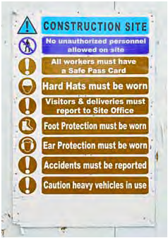
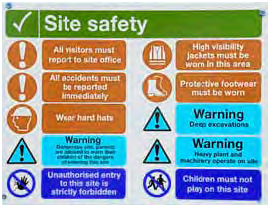
Safe, Clean & orderly Work environment
Companies are required to inform workers and visitors
about possible workplace dangers.

While federal agencies establish and enforce guidelines and regulations, safety is also a major responsibility of both employers and workers. Safety is a top priority in most workplaces today. Knowing the language, tools and practices of safety systems help make workers safer.

Responsible employers
Employers are required and strongly motivated to create a safe and healthy workplace. Their
responsibility to provide a safe working environment includes proper training, ample protection, safety equipment and hazard communication. Posting written warnings about unsafe conditions is one way to communicate hazards and encourage workplace safety.

Employees are required to follow safety rules set by their employers.
General Requirements
To fulfill their safety responsibility, many employers have a safety committee that meets regularly
and keeps a file of the notes of these meetings. The safety committee is an excellent source for corrective actions and accident reviews, as well as accident prevention plans. The safety committee only makes recommendations. It is the employer’s responsibility to correct any unsafe or hazardous
conditions.

Page 48 | CLA: Foundational Knowledge: Chapter 4 - Safety Principles

Supply Chain Chapter 4 Logistics

Employers must follow all local, state and federal laws regarding safety and the environment. They are required to keep a record and report to OSHA any workplace injury or illness that results in days away from work. They must also report any accident that results in medical treatment beyond basic first aid.
Did You Know?
General Workplace Injury Statistics
• According to OSHA, four out of five compensable injuries from manual materials handling workers were lower back injuries. Three out of four of those injuries occurred while lifting.
• According to a 2002 Liberty Mutual Insurance report, accidents and incidents resulting from manual materials handling cost more than $10 billion.
• Direct compensation for overexertion injuries in the U.S. in 2006 was $12.4 billion, exceeding the compensation costs of injuries combined for the second and third categories, which include various types of falls.
• A 20-pound sack of flour held 20 inches in front of the body places about 400 pounds of compressive force on the lower spine.
• The back has 300 muscles, 33 vertebrae, and discs between the vertebrae. Discs are fibrous cartilage surrounding a soft, gelatinous material. Discs maintain alignment of the vertebrae and cushion the forces imposed by daily activities. Over a period of time, stresses can tear the fibrous outer casing of the discs. The discs have no blood supply for healing. The inner contents can leak out of a disc, causing it to narrow. The results can be pinching, deterioration of the joints, inflammation, and pain.
Source: Fast Facts, Office of Compliance, http://www.compliance.gov/wp-content/up-loads/2010/08/Manual-Material-Handling-Fast-Fact-May-2010.pdf, August 2013

Employers are required by law to provide financial aid to workers who are injured on the job. This aid is called workers’ compensation. It pays medical expenses and lost wages if the person cannot work. Job-related illnesses and death are also covered
by workers’ compensation.

Environmental accidents must be documented
and reported to the appropriate government agency. These records must be made available to workers and worker representatives, including unions.

training Requirements
Safety training is a major employer responsibility. Frequent refresher courses are essential to reinforce workplace safety practices. As new machines or processes are added, more training may be required. At a minimum, employers must teach workers about:

• Company first-aid and first-response procedures

• Emergency alarms and procedures

• How to inspect a work area and report possible safety risks

• Possible hazards in the workplace to help ensure personal safety as well as the safety of others

• Health and safety standards to ensure that quality problems are addressed correctly without impairing health and safety

CLA: Foundational Knowledge: Chapter 4 - Safety Principles | Page 49

Supply Chain
Logistics Chapter 4

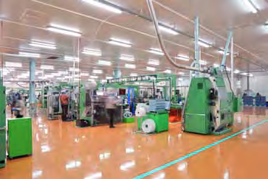
Safety programs not only save lives but also save money. Accidents and illnesses cost employers and employees millions of dollars every year. This includes the cost of compensation payments, damaged prod-ucts, clerical costs, lost work days and medical costs.

In addition to reducing accidents and injury, many safety practices also speed up processes and improve quality. For example, keeping floors clean and clear helps to prevent falls and to move material more quickly.6

Workers are responsible for keeping their workstation clean.

Responsible employees
“Safety is Number One” is an essential guideline for employees. Obviously, employees have a strong vested interest in preserving a safe work environment. By keeping their own work areas well-organized, clean and free of clutter, workers
help protect themselves and their co-workers against
serious accidents or injury.

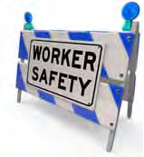
Throughout safety training, workers should stay focused and ask questions as needed. Following training, workers must make their own effort to remain informed and stay up-to-date on safety-related information.

Regular Inspections Safety Inspections
Routine safety inspections are one way to determine if safety measures are working. They also help determine what improvements may be needed. Inspections can focus on a single workstation or
an entire department. They can take place at any time and as often as necessary. If day-to-day safety practices are good, preparations for inspections are minimal.

Page 50 | CLA: Foundational Knowledge: Chapter 4 - Safety Principles

Supply Chain Chapter 4 Logistics

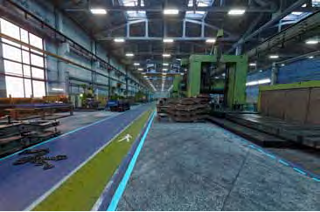
Safety inspectors must know and understand OSHA regulations and company safety measures. They verify that all safety processes are being performed correctly. This can be accomplished by reading a company’s safety policies and procedures. Problem areas should receive extra attention. These might include any equipment or process that has resulted in a high number of accidents or near misses.

Checklists can be helpful tools for safety inspectors. However, if something is not included on a checklist, it does not mean it is not hazardous. Checklists are used only as guides. If other hazards are found, they must be noted and addressed. They should also be
added to the checklist for future inspections.

This factory has clearly marked pedestrian walkways for added safety.

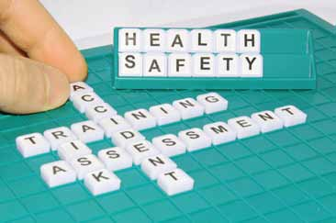
Upon completing an inspection, findings are documented. Flaws are recorded so they can be corrected. Improvements from the last inspection are also noted.

Hazard analysis
Hazard analysis is sometimes referred to as job safety analysis. It is a process used to reduce the risk of hazards to an acceptable level. In a hazard analysis, each step of a job is studied in detail. By identifying possible hazards, corrections can be made to help reduce injuries and time lost due to
injuries.

Employers conduct a hazard analysis to assess and eliminate possible dangers.

Once a task is broken down, each step is analyzed for hazards. A hazard analysis may indicate that workers should wear protective clothing when handling a new chemical product. This would avoid the worker being splashed with a potentially toxic substance.

Supply Chain
Logistics Chapter 4

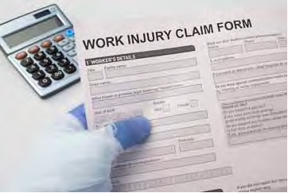
A hazard analysis requires many of the same skills used by a good detective. Asking questions, watch-ing work closely and keeping an open mind are important. Logistics workers often have the greatest insights into the hazards of different materials and containers.

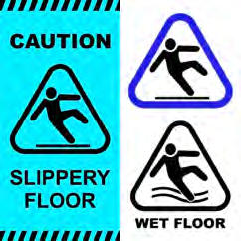
If an accident does occur, employees and employers must report any injuries.
Correcting Hazards
Uncovering hazards and finding solutions are two big steps toward improved workplace safety. However,
if unsafe conditions and practices are not corrected quickly and effectively, safety efforts will have been wasted. The best solution is to eliminate the hazard. This may involve changing the way a material is moved or using more automated equipment for
handling certain kinds of material.

If elimination is not possible, the risk of injury or accidents must be reduced in other ways, such as requiring protective equipment or adding machine guards, warning lights and better signs. Changing standard operating procedures (SOPs) may also be necessary. SOPs are the step-by-step instructions that explain how to carry out work processes. Once hazard corrections are made, it is critical to share them with all the workers affected by the change.

Employers post warning signs to help prevent accidents.
environmental Inspections
Either as part of a safety inspection or as a separate activit , an environmental inspection may be required. This involves checking for anything that may cause air, ground or water pollution. For example, a worker may check hazardous material containers for leaks or dents, or the worker may
y
check for proper waste disposal.

Page 52 | CLA: Foundational Knowledge: Chapter 4 - Safety Principles

Supply Chain Chapter 4 Logistics

Looking for environmental hazards involves many of the same techniques used in identifying safety hazards. This includes checklists and good observation skills. In fact, there is often overlap between safety and environmental issues. For example, a leak in a hazardous chemical container could cause air pollution. It could also threaten the
Accident Investigating and Reporting

Accidents do happen. When they do, workers who are involved or who witnessed the accident have to participate in the reporting and investigation process. When an accident happens in the warehouse, an investigation will occur. This investigation may be conducted by a company safety officer, an OSHA inspector or a third-party investigator, depending upon the severity of the accident or injury:

A typical investigation process:

1. Establish the facts of the accident (time, individuals involved, witnesses, contributing
factors, etc.)

2. Draw a sketch or diagram of the scene: this does not have to be an artist’s sketch,
but a simple drawing that shows the location of any people, equipment and hazards that were involved in the accident

3. Take photos of the scene

4. Interview witnesses and evaluate their statements compared to the scene and each other’s statements

5. Determine the direct and indirect causes of the accident
6. Examine the standard operating procedures: SOPs are examined to determine if they were properly followed and to determine if it might be necessary to change procedures to prevent a similar accident in the future

7. Consult with experts or supervisors as necessary

8. Write up a report that clearly identifies the facts of the accident, causes and recommendations
to prevent similar accidents in the future

health of workers who inhale or come in contact with it.

Complete and accurate record keeping is critical when conducting environmental and safety inspections. In fact, detailed documentation is often required by law. Inspection forms must be completed and filed according to company policies. If a hazard is identified, inspectors must follow correct policies for alerting supervisors and correcting the hazards.

effective Reporting
Workers are the eyes and ears for safety and environmental protection in supply chain logistics. It is important to promptly report all safety issues to safety representative or employer.

Reporting Incidents
A safety or environmental incident includes anything that poses a potential hazard. Incidents can range from damaged automatic storage and retrieval equipment to a burned-out light bulb in a safety sign. Incidents also include near misses. These are incidents in which an accident almost occurred but did not. Near misses often serve as an important warning sign that something is wrong and needs to be changed. The sooner an incident is reported, the faster it can be addressed. Some companies require a written report to be filled. Others require that a safety representative or supervisor be notified.

CLA: Foundational Knowledge: Chapter 4 - Safety Principles | Page 53

Supply Chain
Logistics Chapter 4

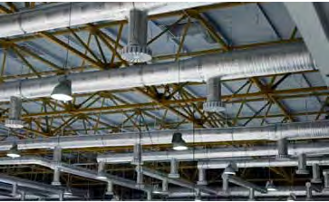
Reporting Accidents
Companies are required by law to keep records of serious accidents. They rely on workers to provide them with complete and accurate reports. These reports help investigators understand what caused a problem and how to prevent it from happening again.

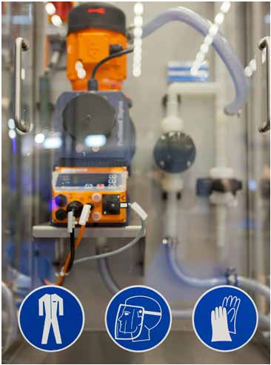
With all of the equipment, dust and materials that are in a warehouse, it is important that the facility be properly ventilated.
If you are injured on the job, witness an accident or develop a job-related illness, notify a supervisor
immediately. Once you have completed any required reports, request or make copies for your own files. Then, if your supervisor has not already done so, alert your safety representative or safety committee. They, too, can take action to correct the problem
and prevent further injuries or incidents.

Well-designed Workplace environment Sound Construction
The integrity and strength of a facility’s floors, walls, ceilings and roofs are essential elements of safety in the workplace.

ventilation
Ventilation provides a way of circulating and refreshing the air. It is critical when working around hazardous materials and dust, and in confined spaces, crowded rooms or areas without windows. Exhaust fans, open windows and air conditioning systems are examples of ventilation systems. Employers are responsible for providing proper ventilation. If you suspect poor ventilation, notify your supervisor.

Some parts of the facility may require extra protection.

Page 54 | CLA: Foundational Knowledge: Chapter 4 - Safety Principles

Chapter 4

ergonomics
The science of designing and arranging tools people use is called ergonomics. In the workplace, ergonom-ics is used to determine the safest and most efficient way to work in a particular space. It includes studying the lighting, tools, workstations and movements used when working. It also studies their effects on injury and illness.

Ergonomics has helped identify the types of activities that can cause injury or fatigue. These include repetitive motions, forceful exertions, vibrations and awkward working positions. These types of activities cause about one-third of all workplace injuries and illnesses. If any activity or repetitive motion causes continual discomfort, they may be able to correct the problem simply and prevent from becoming seriously injured or disabled.

Lighting
Poor lighting can hinder production quality and worker health. Dim work areas reduce the clear vision needed to produce products and conduct quality control. In turn, reduced vision contributes to accidents, eyestrain and vision problems. Employers are responsible for offering well-lit work areas, aisles, stairways, ramps and storage areas. Burned-out light bulbs should be reported and replaced promptly.

exit Doors & Aisles
Exit areas must be clearly marked and not blocked. Time is critical during emergencies, and the time
it takes to unblock an exit could cost a life. Aisles should be wide enough to allow workers to safely walk through the area. They also must remain as clear as possible. Forklift drivers should safely and promptly pull over their vehicles to permit passage
through the aisles.
Supply Chain Logistics

Large facilities often have specific walk ways for pedestrians throughout the building. These are identified with markings painted on the floor, and forklift drivers know to be cautious when operating in and around these areas.

Safety Markings
Companies use many types of safety signs and markings to communicate safety information in the workplace. These signs are usually color-coded to identify specific dangers.

Special Handling Storage Measures
It may be necessary to isolate certain types
of stored products in separate areas. These may include hazardous chemicals, flammable materials or high-value items. This will allow management
to better apply any special regulations regarding the safe handling of these materials.

Clean floors
Slips and falls are one of the top three causes of injuries in the workplace. Any spills or leaks should be cleaned immediately. In areas where water or chemicals are used for cleaning purposes (i.e. battery
cleaning areas) drains must be provided to handle the runoff and contain any unwanted residue from the bat-tery. Slip-resistant floors are often used in such areas.

Housekeeping
Housekeeping at work is about more than making the warehouse or dock look nice. Keeping work areas clean and uncluttered helps prevent serious accidents, including falls and fires. Housekeeping is an ongoing activity throughout the workday. Pallets should be neatly stacked no more than 8-ft
high, waste packaging and rubbish should be placed

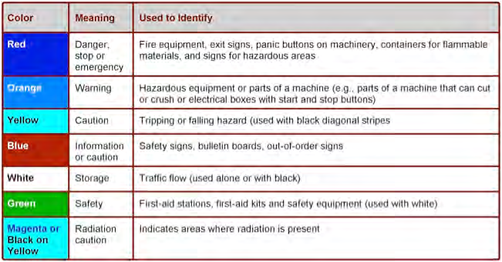
Supply Chain
Logistics Chapter 4

in an appropriate area, spillages of any kind should be cleaned promptly and fire exits should be free of any impediments.

Clear aisles
Aisles, walkways, stairways, storage areas and work surfaces that are clear of extraneous materials, debris and clutter are safer for everyone. Covered, fire-resistant containers reduce the dangers of fire. Quick cleanup of dust, loose wrappings, fibers and other small particles that can catch fire or explode also lowers accident risk. Clear walkways are also critical in the event of a fire or other emergency—workers must be able to exit the building quickly and easily.

Ladders and Scaffolds
Using a ladder or a scaffold to reach an item can be dangerous. Even a short fall can result in a serious injury. Some guidelines to prevent accidents include:

• Wear shoes with a minimum one-half-inch heel to ensure that feet catch on ladder rungs and prevent slipping.

• Before each use, inspect ladders and scaffolds for tight fasteners as well as broken rungs and side rails.

• Use short ladders and a fall-protection system on scaffolds.

• Use the right ladder or scaffold for the job. Fiberglass is often the safest material for ladders.

Page 56 | CLA: Foundational Knowledge: Chapter 4 - Safety Principles

Supply Chain Chapter 4 Logistics

• Use a full-body harness and an attached cord when riding in a mechanical lift basket.

Loading Docks
Loading docks are areas where materials and prod-ucts are loaded and unloaded. They are often centers of much activit . There may be large vehicles, heavy loads being shifted and people working in a fairly small space. Loading docks can also be noisy, mak-ing it difficult to hear which can compromise safety.
y

The following devices and practices are designed to prevent loading dock accidents:

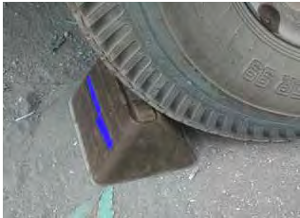
• Flashing lights and other warnings, such as audio signals, may indicate a vehicle is approaching or backing up.

• A wheel chock is a block placed in front of the back wheels of a truck or trailer to prevent the vehicle from moving away from the dock during loading and unloading.
• Most facilities are equipped with “dok-lok” devices that secure the trailer to the building and use a system of lights to indicate that the trailer is safe to enter or not.

• A secure ramp connecting a trailer or truck to the dock and preventing forklifts or workers from falling between the vehicle and the dock. These ramps
are sometimes called bridge plates.

Wheel chocks are used to help ensure that a trailer doesn’t move during unloading.

• Spacious and clean dock areas allow access to and movement by vehicles and people.

• Visibility and safe practices in dock areas are essential in avoiding falls over step edges.

• Some companies use marine and railroad loading docks. Ships and trains pull up to these docks to load and unload goods. These docks require special safety measures.

Supply Chain
Logistics Chapter 4

Preventive and emergency Safety Procedures

A fire can quickly become a tragedy. The best way to stop a fire is to prevent one from starting. However, in the event of an emergency, workers must be prepared. Work with all team members to conduct effective fire, safety and emergency drills.

Fire Prevention
Most material handling workers are exposed to flammable and combustible materials. These include boxes, pallets, protective coverings, dust and hazardous materials.

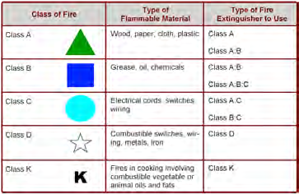
The following techniques help prevent fires.

• Cigarette, lighter and match use is banned near flammable or combustible materials.
• Flammable liquids are stored in approved, labeled and closed containers so liquid or vapor cannot escape.

• Flammable materials are not stored near any material that can make a fire worse. These materials include oxidizers such as peroxides.

• Spills involving flammable or combustible liquids or unidentified liquids must be reported immediately.

• Proper ventilation is essential to prevent the buildup of vapors that can catch fire.

• Tested and approved grounding techniques are used when transferring and transporting flammable or combustible liquids.

Page 58 | CLA: Foundational Knowledge: Chapter 4 - Safety Principles

Supply Chain Chapter 4 Logistics

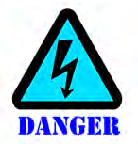
• Heat-producing equipment, such as burners, heat exchangers, boilers and stoves, are kept free of flammable residues. Flammables are not stored close to these pieces of equipment.
• Scraps and rubbish are disposed of regularly.

Fire extinguishers
A fire extinguisher is a container filled with a fire-retardant material. There are different extinguishers for different types of fires. Using the wrong type of extinguisher can make some fires worse. Figure 4.4 shows the different types of extinguishers and the types of fires they are used to fight.

Safety within supply chain logistics facilities depends upon workers knowing fire-extinguisher locations, types, and uses. When using a fire extinguisher, operators should ensure that there is an escape route behind them. This will ensure a safe exit if the fire grows out of control. Use an extinguisher only
if you have received proper training for its use.

When fighting small fires, workers are encouraged to follow the PASS sequence:

P ull the pin to unlock the fire extinguisher lever. A im low, toward the base of the fire.
S queeze the lever to discharge the extinguishing agent. S weep the hose back and forth across the fire.

Once used, fire extinguishers must be recharged. Regular inspection and maintenance of extinguishers is also critical. An extinguisher that is broken or empty is useless in an emergency. In some work-places, workers are told not to try to put out a fire. Instead, they are to evacuate the premises, call 911 and leave the firefighting to trained personnel.

CLA: Foundational Knowledge: Chapter 4 - Safety Principles | Page 59

Supply Chain Logistics

Terms To Know

Accident
An event causing injury, ill-health or property damage.

ergonomics
Approach to job design that focuses on the interactions between human operator and such traditional environmental elements as atmospheric contaminants, heat light, sound, and all tools and equipment.

Grounding (electrical)
Connecting electrical equipment and wiring systems to the earth with a wire or other conductor to reduce the risk of serious electrical shock

job hazard analysis
A technique that focuses on job tasks as a way to identify hazards before they occur. It focuses on the relationship between the worker, the task, the tools, and the work environment.

Near miss
A safety incident in which an accident does not occur, but came close to occurring.

Safety incident
An unplanned, undesired event that hinders completion of a task and may cause injury or other damage.

SoP
Standard operating procedure.

Chapter 4

Fire exits
During an emergency, efficient evacuation depends upon workers moving promptly and calmly towards the closest exits. They must know where all emergency exits are located. Many large companies conduct regular fire and safety drills to ensure that all workers know how to react in the event of an emergency.

electrical Safety
Electrical equipment and power lines are dangerous if not handled properly. They can cause severe shocks, burns or even death. The body experiences electrical shock when it is part of the path through which electrical current flows. For example, touching a live wire and another wire of a different voltage can cause an electrical shock. Electrical shocks can cause severe injuries and death.

Many people believe that it is the amount of voltage that determines the danger of an electrical shock. However, the real danger is the rate and amount of current moving through the human body and the path the current takes through the body. This means that
it is possible for a shock of 100 volts can be more deadly than one of 10,000 volts. The amount of current moving through the body depends on resistance fac-tors. These include the wetness of the skin, the length of contact and whether the person is well grounded.

Electricity demands respect and caution. To prevent shock, workers should:

• Alert supervisors or maintenance personnel of possible problems.
• Never open electrical enclosures unless authorized.

• Ground all electrical equipment.

• Do not use equipment if the electrical cord is frayed,
cracked or damaged in any other way.7

Page 60 | CLA: Foundational Knowledge: Chapter 4 - Safety Principles

Supply Chain Chapter 4 Logistics

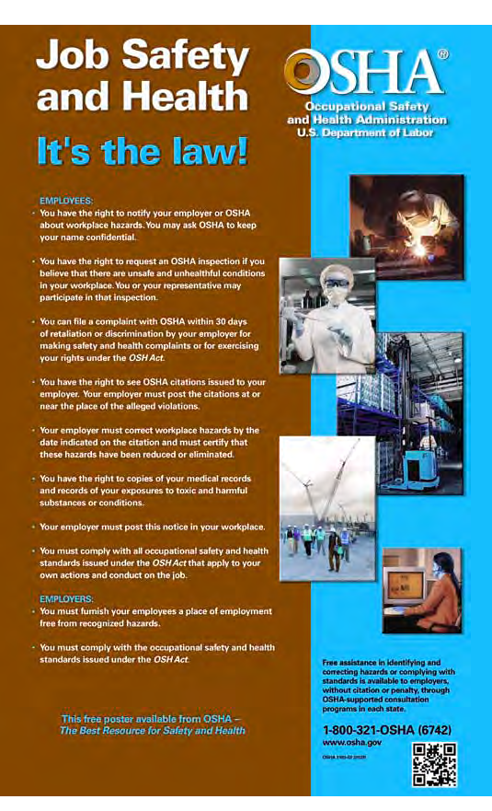
OSHA makes sure that workers know their health and safety rights.

Supply Chain
Logistics Notes

