DECA Connection Role Play | - channels  - of  - Distribution
Role – Owner, Wholesale Kitchen Appliance Company  Situation  Your company sells the finest kitchen appliances available. You have agreements with all of the appliance manufacturers whose appliances your company offers for sale as selective distribution.  Earlier this week, you finalized an agreement to become the exclusive distributor for the most sought-after brand of European kitchen appliances. The European brand represents a significant financial investment for your company. You feel that the investment is worthwhile because of the quality of the appliances and the prestige of distributing these appliances. Your exclusive distribution rights mean that your company will be the only one in this country to sell the European brand.  You are very happy about selling the European appliance line and the potential it offers your company. You have called a special staff meeting to announce that your company is the country’s exclusive distributor of the European appliance line.  Activity  You are to explain to your employees (judge) the significance of your company being the exclusive distributor of the European appliances line. You must also explain exclusive distribution and how it differs from the selective distribution of your other appliance lines.  Evaluation  You will be evaluated on how well you meet the following performance indicators:  - Explain the nature of channels of distribution  - Explain the nature of channel-member relationships  - Explain the nature and scope of channel management | 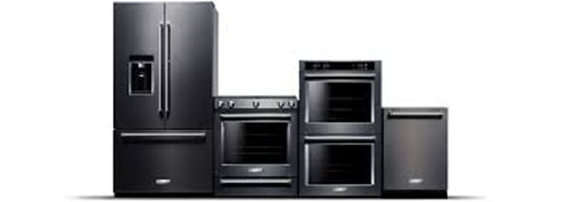  Objective  Explain the nature of channels of distribution and the scope of channel management.  TN State CTE Standard  Supply Chain as a Component of Marketing - #14  Examine the various types of facilities involved in the supply chain of each type of business: manufacturer, retailer, and service.  Aspects of Industry  - Business Planning  - Management

