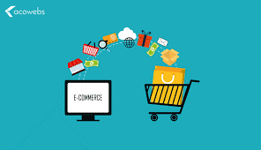
E-COMMERCE UNIT INSTRUCTIONS

Course
Supply Chain Management I

Objectives
- Define eCommerce
- Analyze the growth of eCommerce
- Describe how eCommerce has changed traditional supply chains
- Analyze how continual changes in technology have affected delivery of goods and services in both BTB/BTC segments of the supply chain
TN State CTE Standards
Trends #22: Describe how eCommerce has changed traditional supply chains. Analyze how continual changes in technology have affected the delivery of goods and services in both the business-to-business and business-to-consumer segments of the supply chain.

Essential Questions
- How is eCommerce similar to traditional commerce? Different?
- How is eCommerce affecting lives today and how will it affect them in the future?
- How do you think this influence on consumers might influence local stores or small businesses?
- How can future technology affect eCommerce?
- How will the continued growth of eCommerce affect transportation? Affect warehousing needs?
Duration
2 weeks

ACTIVITIES
Assignment | Due  Date | Date Completed | Grade
E-Commerce PPT
E-Commerce Vocabulary PPT
Activity: E-Commerce WebQuest
Case Study: Girl Scout Cookie Sales Go Digital and Milk E-Commerce Innovation
Case Study: How Amazon is Changing Supply Chain Management
Activity: Amazon Presence in TN
Reading: E-Commerce Spurring Changes for Logistics Managers
Activity: What am I? (Vocabulary Review)
Quiz: E-Commerce Vocabulary
Reading: How Covid-19 is Changing the E-Commerce Supply Chain
Project: Impact of E-Commerce on Shipping and Transportation Infographic
* All activities and PowerPoint are located on my website (bkavass.weebly.com) *

