HABIT 1
The 7 Habits of Highly Effective Teenagers
Key Concept
Your choices are yours.

Key Words
Choices
Control
Proactive
Reactive
Setbacks
Triumphs
Will Power

HABIT 1—BE PROACTIVE
“I used to look in the mirror and only see my flaws. I constantly worried about what other people were thinking about me. This year I’ve decided to try to focus more on what I like about myself. Now I’m not as worried what other people think, I feel stronger and in control.”
Directions: Read the chapter on Habit 1. Complete the packet. Your grade will be based on completion up to 100 points.

What does proactive mean? ____________________________________________________________________
What does reactive mean? _____________________________________________________________________
Proactive people make choices based on ____________. Reactive people make choices based on ____________.
Give an example of a proactive choice you have made in the last week. _________________________________
___________________________________________________________________________________________
Give an example of a reactive choice you have made in the last week. __________________________________
___________________________________________________________________________________________
How could you have handled your reactive choice differently? ________________________________________
___________________________________________________________________________________________

Below are various examples of reactive and proactive language. With two different colored markers, determine which phrases are which by highlighting proactive in one color and reactive in another.
It’s not my fault! I will do that right now! I just can’t decide!
That’s unfair! If only. . . I’m sorry. I didn’t mean that!
Who does he think he is anyway? Can we talk about this first?
Leave me alone. It’s none of your business.

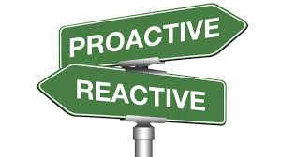

Proactive Language Reactive Language
I will I have to
I can I can’t
I choose to You make me

Role Play: (Need one water bottle and one soda bottle)
Students will role play a hectic morning scenario—woke up late, favorite jeans are dirty, missed the bus, forgot homework. Instructor will shake both bottles and ask students which bottle they would like to open. Explain that the soda bottle represents reactive people—they blow up when things go wrong; the water bottle represents proactive people—they choose to stay calm and work the problem.
Students will now go back and replay the role play but this time two of the students will be proactive (using only proactive language) and show how they handle the problem and two students will be reactive (using only reactive language) and show how they react to the problem.

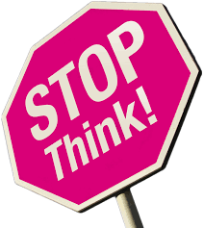
Stop And Think Activity:
When something happens (event), you can choose to stop and think before responding. You’re in control! The next time you have a choice to make, stop and think:
- Is this choice mine, or am I letting someone else influence me?
- Is this a choice I will be proud of?
- Is this choice going to help me or hurt me?
- Is this a choice I may regret?
- Will this choice move me closer to my dreams?
Response:
Someone started a rumor about me
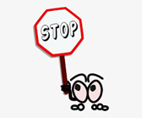
Response:
I’m overwhelmed with school work.

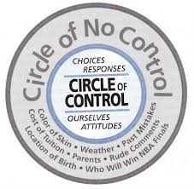
There is one thing we can control—how we respond to what happens to us!
“Getting older means you definitely have more control of your life, but there will always be things you can’t control, like the weather or what other people think, say or do.”
From the list below, move the items to either your inner circle—Circle of Control or your outer circle—Circle of No Control.
What other people think Asking for help A past mistake
A parent’s bad day Effort on homework What other people say or do
Walking away from trouble Where I was born The way I talk to other people
My attitude A grandparent passing away A friend gossiping

My Circle of Control
Things I Cannot Control

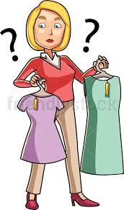
As you get older, you have more choices to make and the choices become more difficult. What are some of the choices you make for yourself now that did not make when you were younger?

WHAT IF. . .everyone stopped to think before responding? Only worried about the things in their circle of control?
Fill in the blanks:
Lives would ____________________________________________________________________________
Communities would ______________________________________________________________________
Countries would _________________________________________________________________________
The World would ________________________________________________________________________

If I were proactive more often, my life would be different because _________________________________
_______________________________________________________________________________________
_______________________________________________________________________________________

HUMAN TOOLS
Self-Awareness: I can stand apart from myself and observe my thoughts and actions
Conscience: I can listen to my inner voice to know right from wrong
Imagination: I can envision new possibilities
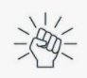
Willpower: I have the power to choose

Think of a choice you have made recently regarding your personal life—using your knowledge of the 4 human tools, complete the activity indicating how you could have used those tools to make a different choice resulting in a different outcome:

Description of Your Choice: _____________________________________________________________
____________________________________________________________________________________
What was the result of your choice? ______________________________________________________
How could you have used each of these tools together to have made a different choice:
Self-Awareness: _____________________________________________________________________
Conscience: _________________________________________________________________________
Imagination: ________________________________________________________________________
Willpower: _________________________________________________________________________

