**HABIT 5**

***The 7 Habits of Highly Effective Teenagers***

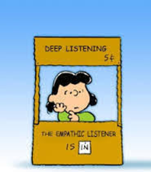

**Key Concept**

Listen first, talk second.

**Key Words**

Communication

Genuine Listening

Mimic

Mirror

Pretend Listening

Selective Listening

Self-Centered Listening

Spacing Out

Word Listening

**HABIT 5 —Seek First to Understand, Then to Be Understood**

*Seek first to understand, then to be understood is the key to communication and having power and influence with people. Listen first, talk second. If you can learn this simple habit—to see things from another’s point of view before sharing your own—a whole new world of understanding will be opened to you.*

***Directions:*** Read the chapter on Habit 5. Complete the packet. Your grade will be based on completion up to 100 points.

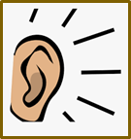**I’m All Ears Activity:**

**Everybody wants to be listened to. When people feel like you listen, they are more**

**likely to like you. So, be a good listener, and you’ll have lots of friends.**

What are some ways that you Who is a good listener? Create

can show people that you **ARE** a list of people that you know that

listening? listen well.



**The Deepest Need of the Human Heart Activity:**

*This habit makes communication work, since the deepest need of the human heart is to be understood. Everyone wants to be respected and valued for who and what he or she is – an individual. Think of the saying, “People don’t care how much you know until they know much you care.” How do you feel when someone doesn’t take the time to really listen to you? It feels as if they don’t really care.*

Three things I wish my parents understood about me are:

1. __________________________________________________________
2. __________________________________________________________
3. __________________________________________________________

Three things I wish my teachers understood about me are:

1. __________________________________________________________
2. __________________________________________________________
3. __________________________________________________________

Three things I wish my friends understood about me are:

1. __________________________________________________________
2. 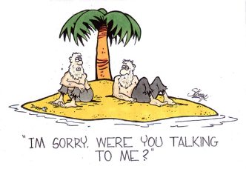__________________________________________________________
3. __________________________________________________________

**Poor Listening Styles Activity:**

Provide a definition for each type of style. Then, provide an example of a response you

might make for that listening style (ex. Spacing Out – might say Uh! Uh!)

|  |  |  |
| --- | --- | --- |
| **Style** | **Definition** | **Example of What You Might Say** |
| Spacing Out |  |  |
| Pretend Listening |  |  |
| Selective Listening |  |  |
| Word Listening |  |  |
| Self-Centered Listening |  |  |

The poor listening style I struggle the most with is: ________________________________________

Think of a trigger you can use to switch to genuine listening the next time you find yourself engaging in that type of poor listening ___________________________________________________________________________

**Good vs. Poor Listening Activity:**

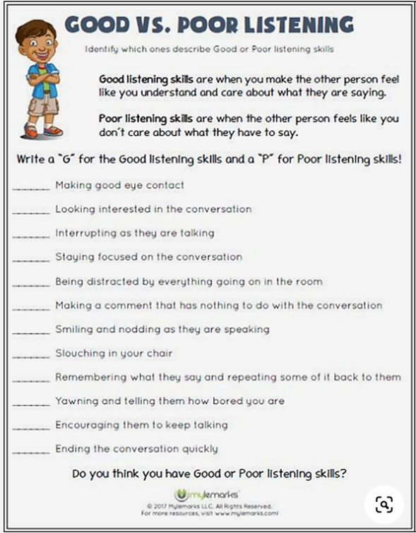



**Genuine Listening Activity:**

1. What 3 things must you do differently to actively listen?

______________________________

______________________________

______________________________

1. What is the difference between mimicking and mirroring? Provide

How People Communicate

examples of both.

_________________________________________________________

_________________________________________________________

_________________________________________________________

**Self-Evaluation for Active Listening Activity:**

What are your listening habits? Take a few minutes to rate yourself. Read each statement below. Circle YES if it is true for you most of the time. Circle NO if it is not true for you most of the time.

1. I allow the other person to finish what s/he is saying before I speak. YES NO
2. I pay attention even when I don’t like the speaker. YES NO
3. I easily ignore distractions when I am listening. YES NO
4. I can easily remember what other people say to me. YES NO
5. I ask the speaker questions when I don’t understand something. YES NO
6. I look at people when they are talking to me. YES NO
7. I don’t do other things when I am listening. YES NO
8. I keep listening even when the message is too complicated. YES NO
9. I ignore behavior or appearances that bother me and listen to what

the speaker is saying. YES NO

Your YES answers show that you already have some active listening skills. In other words, you are involved in the communication process. You take responsibility for understanding the speaker’s message.

Your NO answers show that you could use some improvement in some areas of active listening. With practice, you can improve your listening skills.

**Active Listening Video Activity:**

* Video #1 – Everybody Loves Raymond - <https://www.youtube.com/watch?v=aP55nA8fQ9I&list=PLZJvitcRdyysBGI1vcB4Q3-m3HbycGb4C&index=1>

What insight does this video provide on active listening? _______________________________________

_____________________________________________________________________________________

* Video #2 – Big Bang Theory - <https://www.youtube.com/watch?v=3_dAkDsBQyk>

What insight does this video provide on active listening? ______________________________________

____________________________________________________________________________________

* Video #3 – Malcolm in the Middle - <https://www.youtube.com/watch?v=TBIfjBP-3e4>

What insight does this video provide on active listening? _____________________________________

___________________________________________________________________________________

**Let’s Practice Listening Activity:**

Now that you have had a chance to learn about understanding and communication, practice some of the skills that you learned with a friend of yours and then come back and fill-out the survey below.

