HABIT 6
The 7 Habits of Highly Effective Teenagers

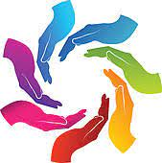
Key Concept
It’s not your way or my way, but together it is a better way.

Key Words
Cliques
Diversity
High Way
Ignorance
Prejudice
Synergize
Teamwork

HABIT 6 —Synergize
Achieved when two or more people work together to create a better solution than either could alone. It’s not your way or my way but a better way, a higher way. Synergy consists of celebrating differences, teamwork, open-mindedness, and finding new and better ways.

Directions: Read the chapter on Habit 6. Complete the packet. Your grade will be based on completion up to 100 points.

Synergy is Everywhere Activity:
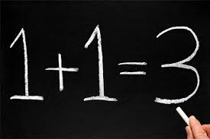
What do you think about the image to the left? What could 1 + 1 = 3 mean? ____________________________________________________________

Story of the Great Sequoia Tree
The Great Sequoia Tree grows to heights of 3oo feet or more. The trees grow together in clumps and share a network of intermingled roots. When a storm blows through, this web of roots holds all of the trees upright and keeps them from falling down. How does this represent 1 + 1= 3? _______________________________________________________________________ ___________________________________________________________________________________________
___________________________________________________________________________________________

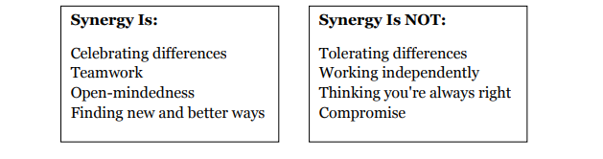

Story of Their Lives In 2010
Five male solo artists auditioned for the Boys category of the UK's X-Factor. All five artists individually made it through to the show's bootcamp round but were cut at the end of the round. The show's producer saw that the show's Group category was weak, so gave these five reject boys an opportunity to synergize and form a band. Working together, the group won third place of the 2011 UK X-Factor and took the world by storm. This, of course, is the story of One Direction. How does this story represent the four examples of synergy given above? ______________________________________________________________________________________________ ______________________________________________________________________________________________ _____________________________________________________________________________________________

Preparing to Synergize Activity:
Find a partner and list at least 5 adjectives that describe them and yourself in the Venn Diagram below. (Example: organized, artistic, strong, funny, hard-working). Write any similar strengths in the overlapping section.

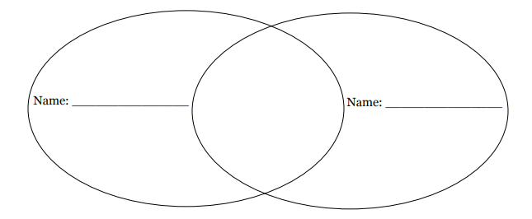

Think about how you and your partner could utilize your strengths in the following scenarios to be more effective. Remember: you are not working independently or compromising. Be creative!

Both of you are in charge of putting together the Cordova High School Spring Jam Fest

How can you synergize? ____________________________________________________________

You are in charge of presenting Cordova High School's recycling program to the 5th graders at the middle school.

How can you synergize? ____________________________________________________________

Celebrating Differences Activity:
The world is a great melting pot of cultures, races, religions, and ideas. Since this diversity around you is always expanding, you’ve got an important decision to make regarding how you are going to handle it. Synergizing does not just value differences, it truly celebrates differences.

Circle the answer that is the most accurate.
How much does our class value and celebrate people’s differences?
Sometimes Often Always
We like hearing each other’s ideas—even wild ideas!
Sometimes Often Always
We know each other’s strengths and use those strengths.
Sometimes Often Always
We ask good questions when trying to understand other’s ideas.
Sometimes Often Always
When new people join our class, we quickly learn their strengths.
Sometimes Often Always
We look for ways to synergize with people outside our class.
Sometimes Often Always

Based on the answers that you selected above, do you believe that you class celebrates differences?
_____________________________________________________________________________________
_____________________________________________________________________________________
_____________________________________________________________________________________
If just sometimes, what can your class do to change this? ______________________________________
_____________________________________________________________________________________
_____________________________________________________________________________________

Similarities and Differences Activity:
Choose someone you don’t know well and write his or her name in the middle of the flower. Fill out the following sentences about yourself. Then fill-In each petal with the information for your person (answering the same questions). Compare the similarities and the differences between the two of you.
My family is from ________________ My favorite sport is _________________________
My favorite food is _________________ I am good at ______________________________
My favorite movie is ________________ My favorite thing about myself is ______________

Brainstorm New Solutions Activity:
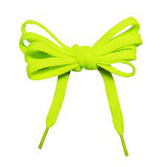
I value other people’s strength and learn from them. I get along well with others, even people who are different than me. I seek out other people’s ideas because I know that by teaming with others, we can create better solutions that what any one of us could alone.

You are stranded on a deserted island with only two shoelaces. What will you do with the shoelaces? Write your ideas in the box. Now, turn to a neighbor and write his/her ideas. Finally, how many ideas can you think of together?

What are your neighbor’s ideas?
What are your ideas?
Ideas you thought of together:
Brainstorm New Solutions

Types of Learning Activity:
 | Learns Through | Example
Linguistic
Logical-Mathematical
Bodily-Kinesthetic
Spatial
Musical
Interpersonal
Intrapersonal

Which of these learning styles do you think represents you the best? ___________________________
Complete the Multiple Intelligence Survey below. Put a check next to each sentence that describes you. You might be surprised by the outcome.
Area 1 |  | I like to listen to songs on the radio.
 |  | I like to watch music videos on TV.
 |  | I like to go to music concerts and hear live music.
 |  | I can easily remember tunes, raps, or melodies.
 |  | I take music lessons, singing lessons, or play a musical instrument.
 |  | I can learn new songs easily.
 |  | I like to sing.
Area 2 |  | I like art classes.
 |  | I like to draw, paint, and make things with clay.
 |  | I enjoy putting puzzles together.
 |  | I like to build things using blocks, Legos, and models.
 |  | It is fun to play video games.
 |  | I can create a picture in my mind to help me think things through.
 |  | I notice the different styles of things, such as clothes, cars, and hairstyles.
Area 3 |  | I like to read books, magazines, and comic books.
 |  | I have a good vocabulary and like to learn new words.
 |  | I enjoy writing e-mails to my friends.
 |  | I like to write.
 |  | It is fun to play word games or do crossword puzzles.
 |  | I think it would be fun to keep a journal of my thoughts and ideas.
 |  | I like to talk to my friends on the telephone.

Area 4 |  | I like to play with animals and take care of them.
 |  | I like going to zoos, parks, and aquariums.
 |  | I like being outside.
 |  | I like to hike, walk, or run outdoors.
 |  | I like observe nature’s changes, such as thunderstorms, rain, and sunshine.
 |  | I help to recycle and take care of our environment.
 |  | I pay close attention to things in my environment such as trees, flowers, etc.
Area 5 |  | I like to do science experiments and go to science museums.
 |  | I find arithmetic and math problems interesting.
 |  | It is fun to solve mysteries.
 |  | Numbers are really interesting to me.
 |  | I like games like chess or computer games where you have to think a lot.
 |  | I like TV shows like the News and National Geographic that talk about science and math.
 |  | I can do math problems in my head and make good estimates.
Area 6 |  | I like to dance.
 |  | I like to play sports.
 |  | I like to build models or do sewing, beading, or carpentry.
 |  | I enjoy acting in plays or skits or playing charades.
 |  | I like to move when I am thinking about things.
 |  | I like activities such as the martial arts, tennis, running, etc.
 |  | I can sometimes “feel” the right answer.
Area 7 |  | I like to be with my friends often.
 |  | I like to help those who need help.
 |  | I like to read books or see movies about people and their lives.
 |  | I can usually tell how other people are feeling.
 |  | It is fun for me to organize activities at home and at school.
 |  | I would rather spend time with others than spend time alone.
 |  | I like to talk in class discussions.
Area 8 |  | I like doing things by myself.
 |  | I would rather work by myself than with other students.
 |  | I like to spend time thinking or writing about things that matter to me.
 |  | I like to play computer games.
 |  | I usually know what my feelings are.
 |  | I like to write my thoughts and feelings in a diary or journal.
 |  | I know what things I am good at, and what things I am not so good at.

Scoring—Count up the number of responses you had for each area. The areas that you check show how you are smart in the different areas.
_____ = Area 1 (Music Smart) _____ = Area 5 (Math Smart)
_____ = Area 2 (Picture Smart) _____ = Area 6 (Body Smart)
_____ = Area 3 (Word Smart) _____ = Area 7 (People Smart)
_____ = Area 4 (Nature Smart) _____ = Area 8 (Self Smart)
A score of 5 or more indicate a very strong area; a score of 3-4 indicates a moderate area; and a score of less than 3 indicates a developing area.
Source: Brain-Based Strategies to Reach Every Learner © J. Dianne Connell, Scholastic Teaching Resources

Characteristics and Personality Traits Activity:

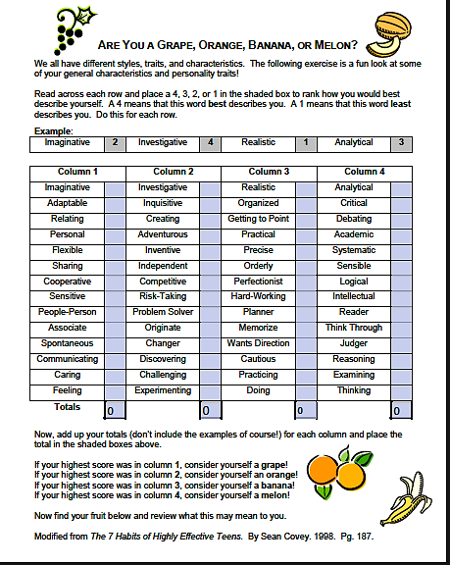
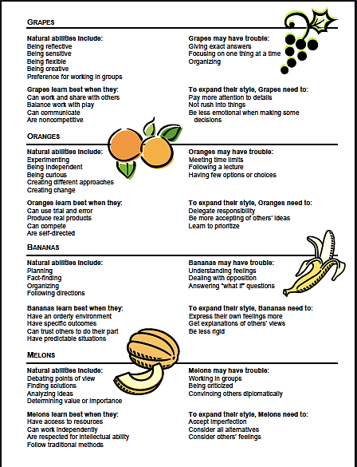

Libby shared her ideas but often spoke when others were talking. credit for it.
YES NO
Alex decided to share his idea. He knew sharing his idea might lead to other great ideas!
YES NO
Successful teams are the result of sharing ideas and learning from one another. Working together can produce team synergy. Read the following statements. Circle “Yes” if it will lead to an effective team. Circle “No” if it will NOT lead to an effective team.

Chen shared her idea after listening to everyone share their ideas.
YES NO
Sara did not share her idea because she did not want anyone else taking credit for it.
YES NO
Team Work

Final Review Activity:
Read the stories. In the boxes on the right,
Indicate whether each story illustrates
Synergy or Not Synergy.

 | SYNERGY | NOT SYNERGY
1. You and your brother have chores. You like doing some chores, but not others. Your brother feels the same way. You take turns picking the chores.
2. The class is going to visit a senior home. Some want to put on a play and some want to sing. The class creates a musical play.
3. Kylie and Carmen are playing. Kylie wants to swing, and Carmen wants to play ball. They can’t agree, so they play with other people instead.
4. Jerome and Lara are giving a surprise party for a friend. Jerome wants brightly colored decorations. Lara wants pastel-colored decorations. They decide not to get any decorations.
5. Your team needs to raise money. Some want to sell things. Some want to work to earn money. The team decides to make things to sell.
Choose one of the stories that you marked “Not Synergy.” How could you synergize it to make the situation better?

