HABIT 7
The 7 Habits of Highly Effective Teenagers
Key Concept
Keep your personal self sharp so that you can better deal with life.

Key Words
Balance
Emotional
Mental
Nature
Niche
Physical
Soul
Spiritual

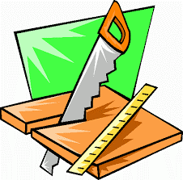
HABIT 7 – SHARPEN THE SAW
“The story is that a man was sawing down a tree and not making much progress. When asked why he didn’t stop sawing to sharpen his saw, he answered that he was too busy sawing.
Habit 7 reminds us that we are more productive when we are in balance—with our body, brain, heart, and soul. If one area is being ignored or overused, the rest will feel the results.
Sharpen the saw means preserving and enhancing the greatest asset you have—you.”
Directions: Read the chapter on Habit 7. Complete the packet. Your grade will be based on completion up to 100 points.

Key Dimensions of Your Life Activity:
What are the four key dimensions of your life?
- ___________________________________ 3. ____________________________________
- ___________________________________ 4. ____________________________________

Why is maintaining a balance between the 4 dimensions so important? _______________________
__________________________________________________________________________________
__________________________________________________________________________________

Balance Feels Best Activity:
Move each term below into the correct dimension
of life.

HEART
BODY

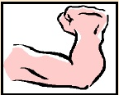

SOUL
MIND

Exercise Build Relationships Give Service Laugh|Love
Pray Meditate Eat Healthy Learn New Skills
Sleep|Rest Read Keep a Journal Educate
Relaxation Watch quality media Write

Personal Assessment Activity:
Read the section “Sharpen your Saw” on page 206 then complete the following assessment:
 | Never | Sometimes | Always
I eat a nutritious diet and try and stay away from junk
I exercise regularly
I get enough sleep
I take care of my personal hygiene
I take time to relax
I regularly read good books, magazines, or newspapers
I regularly listen to the news
I play or listen to good music
I write or draw
I attend cultural events, watch uplifting movies or educational TV shows
I learn new skills and develop my talents
I laugh out loud at least once a day
I use my talents
I develop new relationships
I pray or meditate regularly
I keep a journal or private blog
I read poetry or other inspiring literature
I ponder my decisions and situations in life
I enjoy going for nature walks, looking at landscapes or taking time to enjoy a sunset

Read pages “Balance is Better” on page 207 and decide 3 ways you are going to renew yourself.
Body | Brain | Heart | Soul
1. | 1. | 1. | 1.
2. | 2. | 2. | 2.
3. | 3. | 3. | 3.

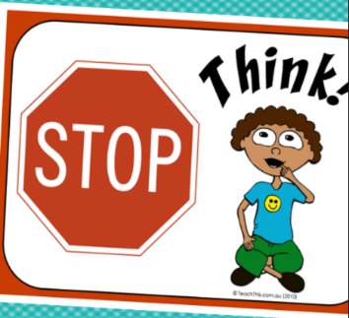
Each day you have a choice to keep yourself balanced and sharp. Leaders know how great they feel when they take care of all four parts of themselves. They are ready for anything!

In each box of the Stop and Think Chart, write something you will do to stay sharp.

I choose to keep my body sharp by. . .
I choose to keep my brain sharp by . . .
I choose to keep my heart sharp by. . .
I choose to keep my soul sharp by . . .

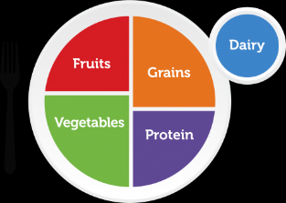
What’s on Your Plate Activity:
Go to www.myplate.gov and take the quiz under “What’s on Your Plate?”
Check out your results from the quiz and explore the areas that you can improve on.
Write a summary of how you can eat healthier. ______________________________
_____________________________________________________________________
_____________________________________________________________________
_____________________________________________________________________
_____________________________________________________________________

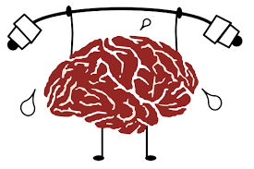
Sharpen the Brain Activity:
- Read pages 216 - 227
    - Watch the video “Brain Jump with Ned the Neuron” at
https://www.youtube.com/watch?v=g7FdMi03CzI&t=35s
      - Complete the following brain teaser activities:

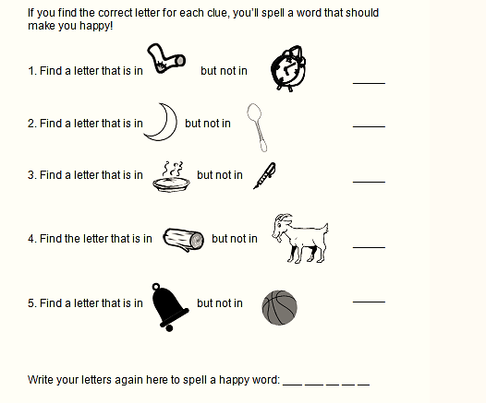

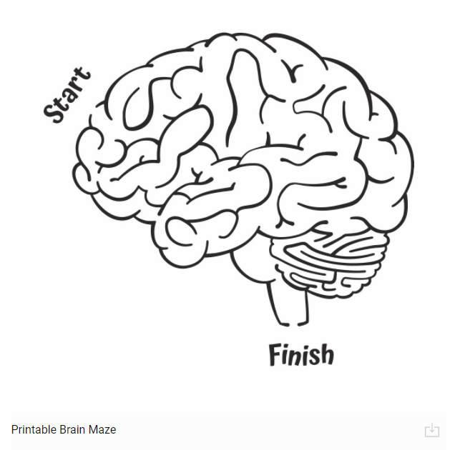

BRAIN MAZE
See how fast you can complete the maze. Time yourself. Now, do it a second time and see if you can beat your time from the first try.

Caring for Your Heart Activity:
Read pages 228 – 233.

We are in charge of our own happiness. If we are not happy, we need to change something! The more frantic our lives get, the more important it is to take quick breaks throughout the day to calm down and clear our heads. Focusing on the five senses can help shift our focus away from our worries and back to what our heart wants. It can also help us develop awareness of and gratitude for the world around us and the small everyday things we might take for granted.

Complete the chart below as to what you can do when thing get stressful and your heart is on-edge.
Each day write down one thing you noticed that made your heart happy through your senses.

 | Sight | Sound | Taste | Smell | Touch
Monday

Tuesday

Wednesday

Thursday

Friday

