Intro to Supply Chain Learning Packet
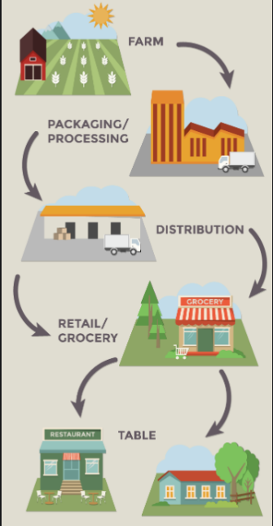
Define supply chain management in your own words and provide an example.
__________________________________________
__________________________________________
__________________________________________
__________________________________________
__________________________________________

Components of Supply Chain Management
List each component of supply chain management and provide an example (NOT a definition).

Example
1.
2.
3.
4.
5.

Define Components of a Supply Chain.
Make sure to write the definition in your own words.
 | Component | Define in Your Own Words
 | Raw Materials
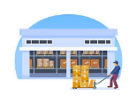 | Supplier
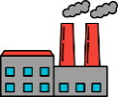 | Manufacturer
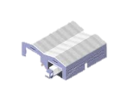 | Distributor/Warehouse
 | Retailer
 | Consumer

Is it a Link or a Node?
Label each part of the supply chain in the diagram as either a link or a node.

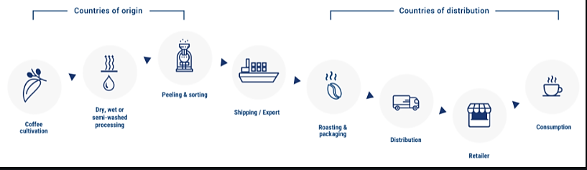

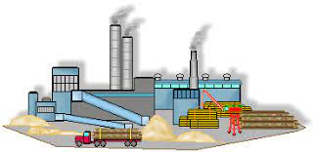
Processing Raw Materials
Determine the type of processing facility used by the supplier to ready raw materials for the manufacturer.

Raw Material Type of Processing Facility
- Barley __________________________
- Beef __________________________
- Coal __________________________
- Corn __________________________
- Diesel __________________________
- Maple Syrup __________________________
- Oranges __________________________
- Paper __________________________
- Soybeans __________________________
- Steel __________________________

What is the difference?
Draw a line from the correct type of management to the correct scenario.

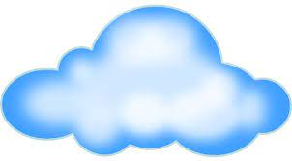
A supply of tomatoes are sent to the Ragu Spaghetti Sauce factory
Transporting lobster from Maine to Texas on an airplane
Hiring and training employees at your Memphis facility
Operations Management
Supply Chain Management
Logistics Management
Draw a Supply Chain
Select a specific product – list the raw materials (only list the main ingredients) used to produce the product – draw the supply chain for the product labeling all 6 components.

PRODUCT: ________________________________

RAW MATERIALS/INGREDIENTS: ____________________________________________

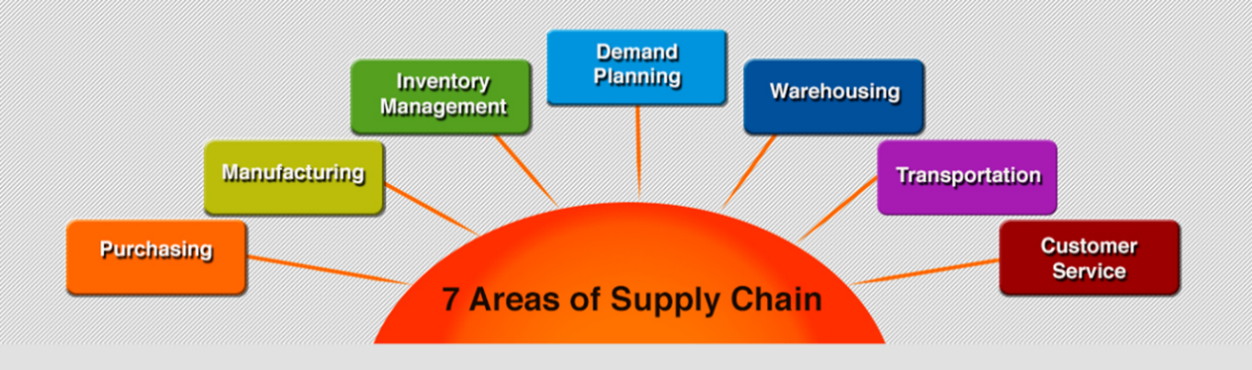
Functional Areas of Supply Chain Management
Complete the table below for each of the 7 Supply Chain Functions.
Use website: https://www.supplychain4me.com/7-areas-of-supply-chain

Function | Definition | Example
Customer Service
Demand Planning
Inventory Management
Manufacturing
Purchasing
Transportation
Warehousing

Flows in Supply Chain
Draw the 3 flows for your supply chain. Make sure that you areas are directional and begin at the correct node.

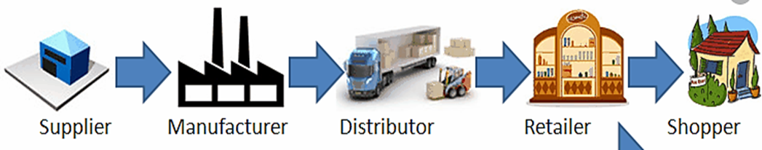

Common Documents Used in Supply Chain
Match the document to the correct definition.

Request for Proposal (RFP) |  | Document that itemizes and records a transaction between a buyer and a seller.
Purchase Order |  | Agreed timings of payments from one party to another
Invoice |  | Practice of counting your retail products in person
Inventory Counts |  | Document that itemizes and records a transaction between a buyer and a seller.
Delivery Schedule |  | Specifies the time for delivery of goods or services from a supplier to a customer
Payment Schedule |  | Company solicits select suppliers and contractors to submit price quotes and bids for the chance to fulfill certain tasks or projects

