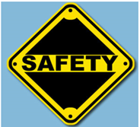
SAFETY UNIT – Job Safety Quiz

Name ___________________________ Class ____

Directions: Work together in your group to answer these questions. Guessing is okay! You won’t be graded on your answers. Pick one person in your group to report your answers later to the class.

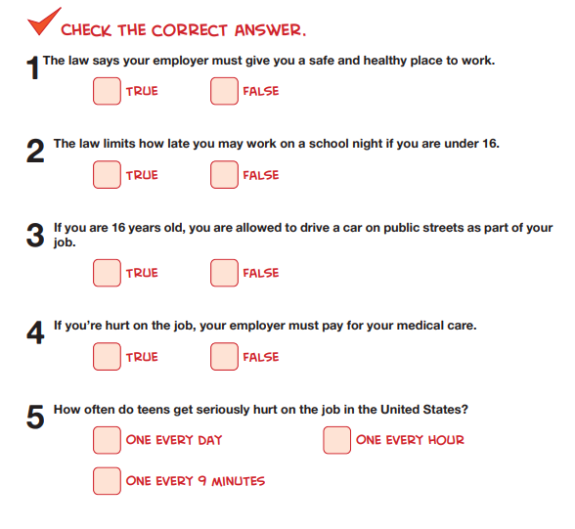
Source: https://www.cdc.gov/niosh/talkingsafety/states/tn/2015-157/pdfs/Talking_Safety_TN.pdf

