SAFETY UNIT – OSHA Safety Data Sheets Activity

Name ___________________________ Class ____

Directions: Describe each section of the Hazard Communication Standard – Safety Data Sheets in the table below. Assignment is worth 40 points (each scenario is worth 20 points).
https://www.osha.gov/Publications/OSHA3514.html

Section # | Area Covered | Description | One Example of Required Information

IDENTIFY THE GHS LABEL
Match each pictogram from the OSHA Globally Harmonized System (GHS) of Classification and Labeling of Chemicals with the label that it represents. (Worth 18 points)

a. Aquatic Toxicity
b. Flammable
c. Explosives
d. Gases under pressure
e. Carcinogen
f. Skin Corrosion/Burns
g. Irritant (eye & skin)
h. Oxidizing Gases
i. Acute Toxicity
GHS – Hazard Pictograms and Related Hazard Classes

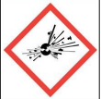 | 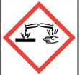 | 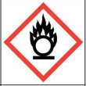
1. Match: _____ | 2. Match: _____ | 3. Match: _____
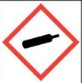 | 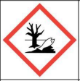 | 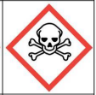
4. Match: _____ | 5. Match: _____ | 6. Match: _____
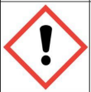 | 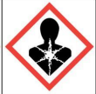 | 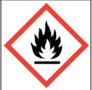
7. Match: _____ | 8. Match: _____ | 9. Match: _____

READING A MSDS DATA SHEET
Directions: View the attached sample Material Data Sheet and answer the following questions. Each question is worth 2 points for a total of 20 points.

- What is the chemical product name?
- Under Hazards Identification, what potential health effects exist for eye contact?
- What are the first aid measures for ingestion?
- What extinguishing media should be used?
- What respiratory protection is required for exposure to this chemical?
- What is the chemical’s appearance and odor?
- What is the stability of this product?
- What the recommended disposal considerations?
- What is the NMFC ID Number and Shipping Classification?
- What is the OSHA status for this product?

