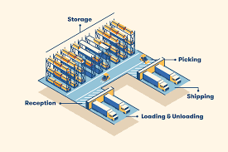
Practice: Warehouse Facility Design

Name________________ Class ___

Directions: Sketch your facility design using all the sections into the blank areas in the warehouse. The goal is to provide maximum optimization of space for efficient throughput. Assignment is worth 18 points.

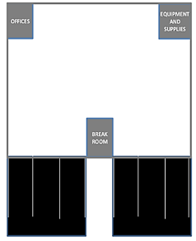
SECTIONS:
Inbound Trucks
Outbound Trucks
High security storage
Long-term Pallet Storage
Long-term seasonal storage
Packing
Picking
Receiving
Short-term shelf storage
Short-term bin storage

