Course
Supply Chain Management I

Objectives
Create a presentation on how Wal-Mart and IBM are using blockchain in the food industry
TN State CTE Standards
Trends #21:) Using websites and journals from professional organizations related to transportation, distribution, and logistics, identify five trends that are impacting local, regional, national, and international supply chains. Trends could include such factors as rising fuel costs, movements toward fully automated warehouses, and greening the supply chain. Summarize research in an informative essay that includes: a. description of the trend and explanation of how it affects the supply chain, b. examples of how various businesses are responding to the trend, and c. an outline of the information that must be considered before a business implements any change, including a formal cost-benefit analysis.

Due Date - _______________________

Grading
Project will be graded using the Presentation Rubric and will be worth 100 points.
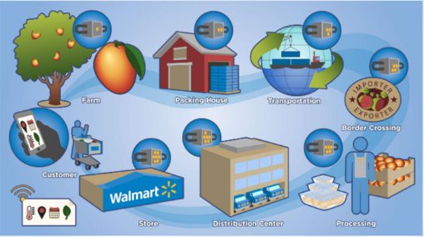
_____________________________________________________________________________________________
Project: Blockchain at Walmart: Tracking Food from Farm to Fork
Pre-Project Activities
- Review the Blockchain PowerPoint – bkavass.weebly.com

- Read the article on “Blockchain at Walmart: Tracking Food from Farm to Fork” and answer the following questions:
  - Provide 2 examples of food-related concerns
  - Why does it take so long to trace the source of food source illnesses?
  - Explain how blockchain can bring traceability and transparency to a supply chain
  - What improvements can blockchain bring to the food industry?
  - According to IBM, what are the 3 main costs that affect a food supply chain?
  - How is Wal-Mart improving their supply chain through machine learning?

- Watch the video - Genius of Things: Blockchain and Food Safety with IBM and Walmart - https://www.youtube.com/watch?v=MMOF0G_2H0A&feature=emb_logo
  - As you are watching the video, write down at least 3 points that you can use in your research

- Watch Video - Food: Tracing Fresh Seafood From the Moment It’s Caught - https://www.ibm.com/blockchain/what-is-blockchain
  - As you are watching the video, write down at least 3 points that you can use in your research

Project Activities

- Research Walmart’s use of blockchain to provide traceability and transparency in their food supply chain

- Research the role of IBM in Walmart’s use of blockchain

- Create a presentation (software of your choice) that includes the following:
- Description of the trend
- Impact and implications for supply chains
- Examples of how various industries are responding to the trend
- Explain how this trend will benefit consumers
- Describe what factors must be considered before utilizing this trend (include a cost-benefit analysis)
- Your opinion of what impact the Covid-19 pandemic will have on future use of blockchain. Describe a particular industry that you think will be impacted and describe how and why.

