Name _________________________________ Class _____
PROJECT: BUYING AND PRICING PRODUCTS
You are to assume the role of a buyer for a small boutique in Memphis, Tennessee. You have been allotted $10,000 to purchase a new line of handbags for your boutique. It is your job to buy the handbags, price them and figure the profit margin for the handbags. Before you begin the buying process, you must write a brief analysis of the market in which you are competing.
STEP 1 – Market Analysis
As a buyer it is important to understand the market in which you are competing. Your market analysis should identify important issues and concerns regarding your boutique, your competition, your customer, and your products. Your market analysis should be written in report form, with proper grammar and punctuation and should be approximately 2 pages typed (MS Word 2016), and double-spaced.
Your market analysis should answer the following questions:
1. Who is the target market for your handbag line?
• What are the common characteristics of your customers (education level, income level, age, gender, lifestyle, etc.)?
• What are the needs and wants of your customers?
2. What is the demand for your product?
• Is the demand for your product higher at certain times of the year?
• Is the demand based upon the sale of other products?
3. Who is your competition?
• Do you compete with large department stores or other small boutiques?
• Do they use price or non-price competition and how do they use it? (Ex. Do you offer gift wrapping vs. lowering your prices?)
4. What is your overall marketing strategy for your boutique?
• You need to explain the 4 P’s of Marketing:
• Product – Explain your line of purses (style, image, etc.)
• Place – Where in your boutique would you place your handbag line?
• Price – What is the price range of your handbag line?
• Promotion – How would you draw attention to and promote your handbag line both inside and outside your store?

STEP II: Costing the Handbags
As a buyer, you must purchase the handbags for your boutique. You have been allotted $10,000 for purchases. You must decide upon the handbags you wish to purchase and the quantity of each.
1. Choose the handbags from catalogues or the Internet. (Must include thumbprint photo of handbag on your spreadsheet under Description)
2. Assume the retail price, on the Internet or in the catalogue, is the cost you will have to pay for the handbags. (Retail price will be the buyer’s cost)
3. Make a spreadsheet on Excel named “COST” documenting the brand, style, color, description, cost, quantity, and total cost for each purse you wish to purchase.
4. You need to add a cell at the bottom of the spreadsheet for total costs of your purchases. Purchases should total between $9,500 and $10,000.
Brand | Style | Color | Description | Cost | Quantity | Total Cost
Coach | Micro Zoe Crossbody | Pink | 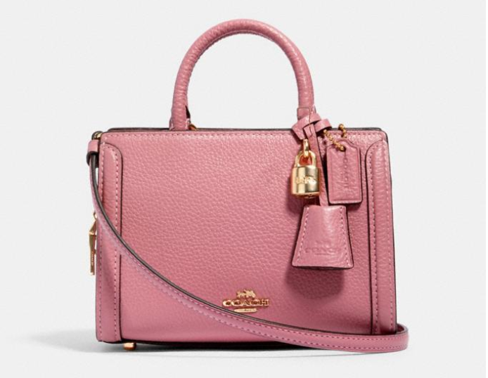 | $75.00 | 10 | $750.00
Total Cost of Purchases (must NOT exceed $10,000)

STEP III: Pricing the Handbags
It is your job as buyer to price the handbags in order to make a profit. You need to come up with a pricing scheme to create a $10,000 gross profit for your store. You may choose one of two options—markup based on cost or markup based on retail price. Select only ONE strategy for all handbags.
Add this to your Excel spreadsheet AS A SEPARATE WORKSHEET named “PRICING” with the following columns: Brand, Style, Color, Cost, Quantity, Dollar Markup (you will have to decide what the market is willing to pay – this amount does not have to be the same on each brand/style), selling price, percent of markup, and margin/profit.

Assignment must be emailed to kavasschs@gmail.com by the due date. Assignment is worth 100 points (Rubric – Project without Presentation).

