CAREER RESEARCH PROJECT
Supply Chain – Transportation – Logistics - Marketing

OBJECTIVE(S): Research and compare various aspects of 3 different careers in supply chain management. Present your research in a MS Excel 2019 spreadsheet.

TN CTE STATE STANDARD(S): Career Investigation #3
Compile and analyze real-time and projected labor market data from public sources such as the U.S. Bureau of Labor Statistics to investigate local and regional occupational opportunities and trends in the field of supply chain. Utilizing Microsoft Excel, synthesize collected data to develop a graphic illustration comparing occupations by education requirements, job availability, job projections, salaries, and benefits for the local community, the state, and the nation.

MATERIALS: Career Project Task Organizer
Computer Access to MS Excel 2019 and Internet

DUE DATE: _________________________________

GRADE: 100 points (counts as a Project Grade – rubric attached)

Scenario:

“The process of sourcing materials, manufacturing goods and then transporting those products to market is at the heart of supply chain. The field is expanding so rapidly that new jobs/roles are being developed every year. It is important to remember that job definitions/roles vary by industry and even by company. For example, a buyer at a manufacturing firm might perform different functions than a buyer in a retail organization. A demand planner at one company might focus on forecasting of product, while a demand planner at another might have more of a production planning function.”
(Source: SupplyChain4Me)

There are 7 primary functional areas of supply chain management: Purchasing, Manufacturing, Inventory Management, Marketing, Warehousing, Transportation, and Customer Service. You are tasked with selecting jobs/roles from 3 different functional areas and presenting your research on various aspects of said job/role in a MS Excel 2016 spreadsheet.

Directions:

- Review the attachment – “7 Areas of Supply Chain”
- Select 2 of the 7 functional areas of supply chain management and select 1 career of “your choice”
- Go to The Occupational Outlook Handbook (http://www.bls.gov/ooh/home.htm) and search for the 3 job/role titles you selected. (NOTE: If you cannot find that exact job title, find one that is similar.)
- Complete the research using the Career Project Task Organizer
- Type up your Career Project Task Organizer using MS Excel 2016
- Complete an Analysis Summary for each career
- Upload assignment to MS Teams

Format:

- Download the “Career Research Project Task Organizer” from my website (bkavass.weebly.com)

- Spreadsheet must contain a HEADER at the top of each page with your name and class period

- Each page must include your header row

- Content for each career field – please use the Task Organizer to research the following categories. ALL categories must be completed for each career field.

- Job Summary
- What They Do
- Work Environment
- How to Become One
- Pay
- Job Outlook
- Similar Occupations
- Contacts for More Information

- Analysis Summary – this is your opportunity to state your views on these 3 occupations. For each career field that you researched, answer the following questions in complete sentences.

- Are you still interested in this career?
- What did you learn about the career field that you did not know prior to starting this project?
- What steps will you have to take to start a career in this field?

Grade – Research paper is worth 100 points as a Project and will be graded based on:

RESEARCH PAPER RUBRIC
CATEGORY | POSSIBLE  POINTS | POINTS  ASSIGNED
Career Research  - Includes all information requested  - Well-researched and accurate material  - Clearly and orderly prepared  - Summary paragraphs reflects research | 60
Project Task Organizer  - Includes all information requested  - Format – readable and presentable  - Grammar and spelling | 30
Instructions  - Followed all instructions  - Turned project in on time | 10
TOTAL POINTS ASSIGNED:

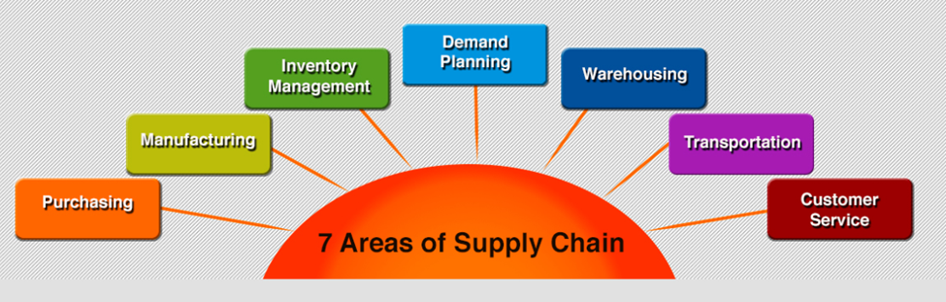

CAREER PLANNING
SUPPLY CHAIN FUNCTION | DESCRIPTION | CAREERS
Customer Service | The process of ensuring customer satisfaction with a product or service. Often, customer service takes place while performing a transaction for the customer, such as making a sale or returning an item. Customer service can take the form of an in-person interaction, a phone call, self-service systems, or by other means. | - Customer Supply Strategy Development  - Customer Service Supervisor  - Customer Service Analyst  - Replenishment Planner  - Customer Relation Specialist  - Customer Account Representative
Demand Planning | The process of forecasting customer demand to drive execution of such demand by corporate supply chain and business management. | - Sales & Operation Manager  - Manager, Demand Planning  - Director, Demand Planning
Inventory Management | The objective of inventory management is to provide uninterrupted production, sales, and/or customer-service levels at the minimum cost. Since for many companies inventory is the largest item in the current assets category, inventory problems can and do contribute to losses or even business failures. | - Senior Inventory Analyst  - Inventory Control Analyst  - Inventory Analyst-Retail  - Inventory Analyst
Manufacturing | The production of merchandise for use or sale using labor and machines, tools, chemical and biological processing, or formulation. The term may refer to a range of human activity, from handicraft to high tech, but is most commonly applied to industrial production, in which raw materials are transformed into finished goods on a large scale. Such finished goods may be used for manufacturing other, more complex products, such as aircraft, household appliances or automobiles, or sold to wholesalers, who in turn sell them to retailers, who then sell them to end users and consumers. | - Unit Production Manager  - Total Productive Maintenance (TPM) Implementation Manager  - Supply Chain Manager  - Plant Manager  - Plant Controller  - Master Planner  - Manager Operations  - Machine Operator A  - Extrusion Process Equipment Engineer  - Corporate Industrial Engineering Manager  - Capacity Planner
Purchasing | The activity of acquiring goods or services to accomplish the goals of an organization. | - Sourcing Analyst  - Senior Sustainable Sourcing Manager  - Global Procurement Category Manager  - Commodity Manager  - Category Manager Group Procurement  - Associate Vendor Performance Manager
Transportation | The movement of people, animals and goods from one location to another. Modes of transport include air, rail, road, water, cable, pipeline and space. The field can be divided into infrastructure, vehicles and operations. | - Transportation Coordinator  - Sr. Transportation Analyst  - Routing Manager  - Logistics Broker  - Logistics Analyst 2  - Logistics Analyst  - Load Planner  - International Supply Chain Specialist  - Intermodal Coordinator  - Freight Audit and Payment Supervisor
Warehousing | Performance of administrative and physical functions associated with storage of goods and materials. These functions include receipt, identification, inspection, verification, putting away, retrieval for issue, etc. | - Warehouse Productivity Manager  - Supply Chain Manager Warehouse Operations  - Regional Logistics Director  - Logistics Manager  - Inventory Control  - Industrial Engineer  - Forklift Driver

Source: https://www.supplychain4me.com/7-areas-of-supply-chain

