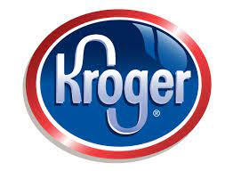
PROJECT: DISTRIBUTION CENTER DESIGN FOR THE
FOOD INDUSTRY

Course: Supply Chain Management I: Warehousing and Distribution

Objective(s):
- Student will analyze common design criteria for various types of warehouses/distribution centers
- Student will determine types of equipment needed for a distribution center and any type of specialization needed for the food industry
- Student will examine value-added services and possible disruptions in the supply chain – determine how to offset disruptions
- Student will design a Customer Fulfillment Center for Kroger using MS Excel 2019
- Student will simulate work of a distribution center manager by planning for the shipment and return processing of a product

TN State CTE Standards:
Warehousing #7
Compare and contrast the warehousing requirements for a variety of different products including items such as perishable foods, hazardous chemicals, large items like furniture and appliances, school supplies, seasonal items, and subassemblies for the manufacture of a given product.

Warehousing #8
Write an informative report describing different warehouse layouts and equipment used to move materials in each, classifying equipment according to type and purpose (including but not limited to powered industrial vehicle, sortation equipment, conveyors, automatic storage, and retrieval systems, etc.). Differentiate between bulk and rack storage and indicate situations when each is employed. List the three categories of aisle spacing and describe the advantages and disadvantages of each.

Problem Solving #18
Solve given problems related to transportation of goods and warehousing by evaluating data and presenting solutions or recommending appropriate decisions. Use spreadsheets and/or other software in calculating “what if” scenarios as appropriate. Types of problems should include scenarios such as: a. selecting routes and modes of transportation between a distribution center and various markets; b. calculating the carbon footprint of similar products shipped from different locations and by different modes of transportation; c. optimizing warehouse usage; d. maximizing trailers for shipping e. comparing offsite vs. onsite warehousing f. planning for the moving and handling of hazardous goods; g. analyzing the impact of natural disasters on supply chain; o forecasting potential threats related to the geography of a company’s supply base; o designing of contingency plans in times of natural disasters; and h. developing strategies for working toward the sustainable use of specific materials and modes of transportation.

Suggested Resources:
Technical Warehouse Manual, Interlake Mecalux, https://www.interlakemecalux.com/warehouse-manual
Planning a Warehouse Network and Design: Key Factors to Consider, Logistics Bureau, https://www.logisticsbureau.com/warehouse-design-key-factors-to-consider/
Planning Your Warehouse Layout – How to Set Up Efficient Storage, Packing & Shipping Areas, FitSmallBusiness.com, https://fitsmallbusiness.com/warehouse-layout/
Warehouse Layout & Product Flow Options | Total Warehouse Tutorials with REB, https://www.youtube.com/watch?v=0OeStxbzKsM
Ultimate Warehouse Equipment Checklist - https://www.alliedcaster.com/wp-content/uploads/2019/05/Ultimate-Warehouse-Checklist.pdf

Background Information
Kroger was founded in 1883 by Barney Kroger in Cincinnati, Ohio. Today, Kroger has over 2,700 stores in 35 states, 44 distribution centers, and 35 food manufacturing facilities with sales of more than $122 billion. Kroger is ranked as one of the world’s largest retailers.
Kroger has decided to open a Customer Fulfillment Center in the Greater Memphis area—in Arlington, TN. You are tasked with securing a location in Arlington and designing the new distribution center. Details for the new distribution center are provided on the following page.

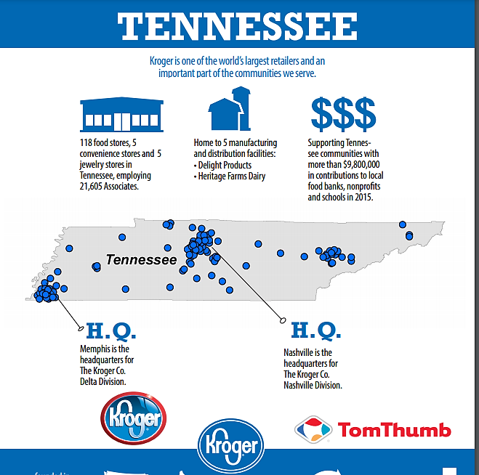
PRE-PROJECT ACTIVITIES:
- Review “Warehousing Management PowerPoint”
- Read the article “Kroger opens first Customer Fulfilment Center, plans to enhance Kroger Delivery”
- Watch the video “Behind the scenes of the robots packing your shopping-Ocado Technology” at https://www.youtube.com/watch?v=6KLHuLgbBRg

FIELD TRIPS/GUEST SPEAKERS: Kroger Delta Distribution Center, Memphis, TN

PROJECT REQUIREMENTS:

Part I - Complete the table on types of warehouses and their common design criteria (attached)
(Worth 25 points)
Part II – Create a flow chart for the processing of incoming goods and materials using standard industry protocols and procedures—include processes for dealing with damaged, incorrect, and incomplete orders (Worth 30 points)
Part III – Create a list of the equipment requirements – list any specialized equipment that might be required for a food distribution warehouse – include photos of the types of equipment (Worth 40 points)
Part IV – Determine and describe your Warehouse Management System to track inventory (Worth 30 points)
Part V – Describe types of value-added services that can be included in your warehouse to provide a competitive advantage (Worth 20 points)
Part VI – Describe possible supply chain disruptions and how you would deal with them (Worth 20 points)
Part VII – Examine the Arlington, TN area using Google Maps and decide on an exact location for the new Customer Fulfillment Center – explain the reasoning behind the site selected
Part VIII – Complete the Warehouse Layout and Design (attached) (Worth 100 points)
Part IX – Plan for the shipment and return of product (work with Distribution Manager at Kroger) (Worth 50 points)
Part X – Present your project to the Distribution Manager at Kroger Delta Distribution Center (Worth 20 points)

PART I - Warehouse Types
Complete the table for the 3 types of warehouses. Section is worth 60 points.

Type | Purpose | Characteristics | Common Design Criteria
Distribution
Fulfillment Center
Contract, 3PL

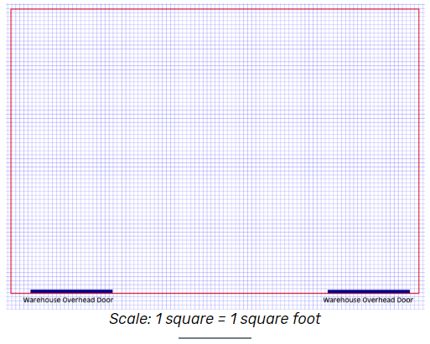
You have been tasked with designing a distribution warehouse for a new Customer Fulfillment Center for Kroger opening in Arlington, TN. They will require a minimum of 100,000 sq. ft, cross-docking capabilities, cold storage area, returns area, one office, one lounge with restrooms, and equipment storage.
(Assignment is worth 100 points).

PART I - Plan your space utilization by addressing the following questions:

- Warehouse Flow-Through
  - Shape – U, L, or I
  - Receiving and Shipping – Same Side or Opposite Sides of Building
  - How many dock doors for receiving and how many for shipping?
  - Cross-docking?

- Equipment and Surrounding Workspace
  - What are your key units?
  - For Pallets, what are the dimensions?
  - For Shelving, what are the dimensions?
  - Are you going to use conveyors?
  - Do you need assembly stations?
  - What type of automated equipment will you use?
  - What equipment storage do you need?

- Production Zones and Workflow Areas
  - How wide are your aisles?
  - Is traffic flow multi- or one-directional?
  - How much workflow areas are needed around assembly and/or return stations?

- Storage Areas
  - What are you storing?
  - What equipment is needed to move items in and out of storage areas?

NOTE: For measurements on shelving, pallets, equipment, go to www.uline.com

PART VIII: Warehouse design and layout

PART II - On a piece of graph paper, sketch out your proposed distribution warehouse.
- Include your inbound area—receiving and storage – unpacking, inspection, and prep area for put-away
- Include your outbound area—order picking, inspection, packing, and shipping
- Include an area to deal with returns or defective products
- Include an area for equipment storage, an office area, and a lounge with restrooms
- Indicate the dimensions of pallets, shelving, conveyor belts, packing tables, workstations, etc.

PART III - Use MS Excel 2019 to create your proposed Customer Fulfillment Center on the computer.
- Email completed project to kavasschs@gmail.com

