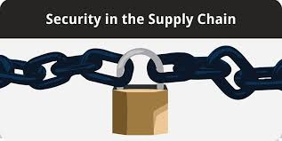
Name: __________________ Class: _____
Project: Examine Supply Chain Management Risk
NCSC works with its partners to assess and mitigate the activities of foreign intelligence entities and other adversaries who attempt to compromise the supply chains of our government and industry. These adversaries exploit supply chain vulnerabilities to steal America’s intellectual property, corrupt our software, surveil our critical infrastructure, and carry out other malicious activities. They infiltrate trusted suppliers and vendors to target equipment, systems, and information used every day by the government, businesses, and individuals. The cost to our nation comes not only in lost innovation, jobs, and economic advantage, but also in reduced U.S. military strength.

Directions
- Using the National Counterintelligence and Security Center (NCSC) website (https://www.dni.gov/index.php/ncsc-what-we-do/ncsc-supply-chain-threats), research supply chain security risks and how companies should address safety and security within their supply chain channels.

- Look at the following supply chains security risks:
  - Cyber Security
  - Insider Threats
  - Physical Security
  - Economic Threats
  - Personnel Threats

- Provide examples of how NCSC works to raise awareness about supply chain threats, while providing resources to mitigate risks.

- Create a PowerPoint Presentation of your research including your opinion on how companies can avoid supply chain security risks.

- Present your findings to the class.

______________________________________________________________________________________

Due Date - _____________

Grading
Project will be graded using the Project with Presentation Rubric and will be worth 100 points.

