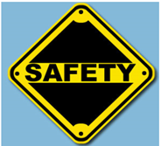
SAFETY UNIT – Find the Hazards Project

Name ___________________________ Class ____

Directions: Work together in your group to find the hazards in your assigned location. Complete the chart below and then be ready to present to the class. Your location will be posted on the Promethean Board and you can use the online pen to circle your hazards for the class. Assignment is worth 50 points.

Location: _______________________________

Scenario | Hazard(s) | Possible Solution

Source: https://www.cdc.gov/niosh/talkingsafety/states/tn/2015-157/pdfs/Talking_Safety_TN.pdf

